

321 East Ohio Street, Marquette MI 49855
906.226.5100
www.maresa.org

SCHOOL DISTRICT/LOCAL CONTACT NUMBER: | Choose an item.

MET MEMO
Click here to enter a date.

TO: | Click here to enter text.

FROM: | Tammy Nyen, Ed.D., Executive Director of Special Education

SUBJECT: | Information Needed to Determine Educational Eligibility for the Family Support Subsidy Program

Student Name: |  |  | Date of Birth: |  |  | SS#/ID:

The latest MET report recommends this student is eligible for special education services under the eligibility category of:

Cognitive Impairment (CI) R340.1705

If the eligibility category is cognitive impairment, does the latest intellectual assessment show development at a rate of 4.5 or more standard deviations below the mean (previously defined as severely mentally impaired)?
Yes No

Severe Multiple Impairment (SXI) R340.1714
Autism Spectrum Disorder R340.1715

If the student’s educational eligibility category is autism, R340.1715, please verify programming by checking one of the following options:

Programs for Students with Severe Cognitive Impairment R340.1738.
Programs for Students with Severe Multiple Impairments R340.1748.
Programs for Students with Autism Spectrum Disorder R340.1758.
Student’s resource room program (R340.1749a or R340.1749b) meets the requirements of special education rule number R340.1758.
Student’s ECDD program meets the requirements of special education rule number 340.1758.
Programs for students (all impairments) R340.1832e. The student is receiving special education services through an approved Intermediate School District (ISD) plan. This plan also meets the requirements of special education rule number 340.1758.
Student’s educational programming does not meet any of the above criteria.

If you have any questions concerning this information, please contact the local school district special education contact person, , at .

Sincerely,
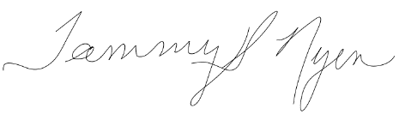
Tammy Nyen, Ed.D.
Executive Director of Special Education

