SCHOOL DISTRICT/LOCAL CONTACT NUMBER:

Physician/Licensed Practitioner*:
Address:
Student Name:
DOB |  |  |  |  | IEP Date:

Dear:
In accordance with Michigan’s School Based Medicaid procedures, we are seeking your assistance in determining the health care needs of the student listed above relative to his/her personal care needs as referenced in his/her Individualized Educational Plan (IEP). The checked list below indicates the personal care services we feel are necessary to provide throughout the school day.
Personal Care Script
Please review the list below. If you are in agreement with our instructional aides providing these services for the above named student, please sign & date below and return this form to:
☐ Eating/Feeding | ☐ Meal Preparation
☐ Grooming | ☐ Bathing
☐ Ambulation | ☐ Assistance with self-administered medication
☐ Mobility/Positioning | ☐ Toileting
☐ Muscle Strengthening | ☐ Transferring
☐ Medical Equipment Maintenance | ☐ Personal Hygiene
☐ Health Related Functions through hands on Assistance, supervision and Cueing | ☐ Maintaining Continence
 | ☐ Skin Care
☐ Respiratory Assistance | ☐ Redirection and Assistance for behavior
☐ Dressing | ☐ Intervention for Seizure Disorder
☐ | ☐
Sincerely,
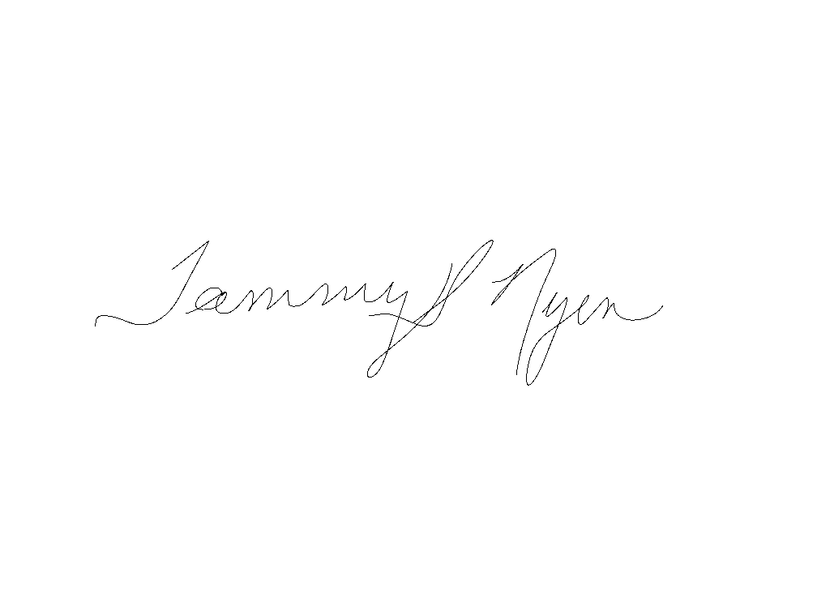
Tammy Nyen, Ed.D, Executive Director of Special Education

I agree that the student listed above should be receiving the services checked above.

Physician/Other Licensed Practitioner ’s Signature NPI # Date
Name Printed

* Licensed practitioners operating within the scope of their practice, including Registered Nurses (RN), Occupational Therapists (OT), Physical Therapists (PT), Master of Social Work (MSW) and Speech-language Pathologists (SLP). This prescription is good for one year from the start date of the IEP.

