

**Sub-recipient Review Process Training Manual**

Revised 09/2013

Contents

Submission 3

Common Documents 3

Review Contacts 5

Program Documents 7

Compliance 10

Compliance Plan 10

Completion Evidence 15

Acknowledge Findings Package 21

Documentation 23

Program Documents 23

Q&A 25

FAQ 28

Best Practices 30

Communication 32

My Pending Tasks 32

Email Log 34

# Submission

## Common Documents

Common and office documents can be submitted by the sub-recipients prior to the scheduling of the review, before the document list has been established during Scheduling. Only electronic documents can be submitted on this screen.

To access this functionality, navigate to the following menu:

**Submission → Common Documents**

This screen has the following functionality: Review, Upload.

|  |  |
| --- | --- |
| Predecessor | Scheduling |
| Who | Sub-Recipient User |
| When | Review Process |
| Subsequent | Review Document |

Review

In this mode, you can view the common documents uploaded to GEMS\MARS. You cannot make any changes in this mode.

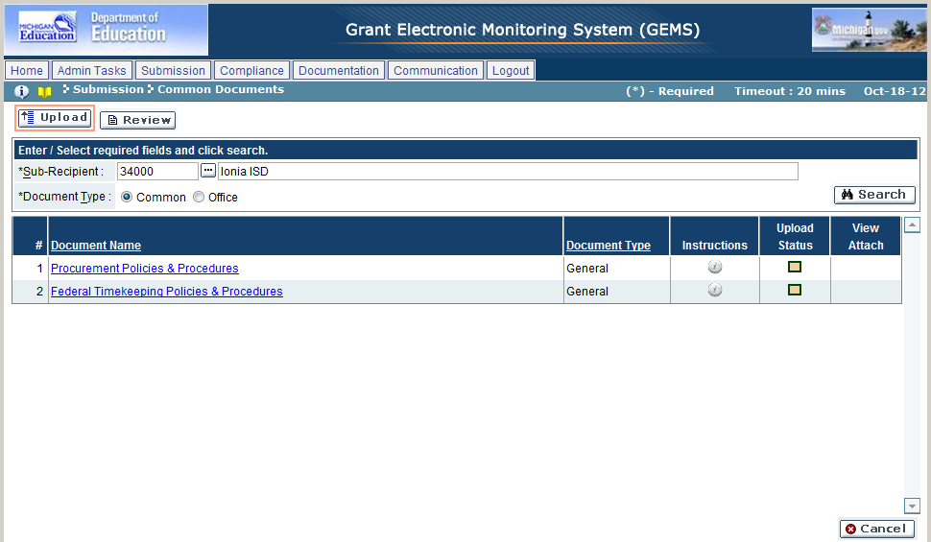

1. Click on ‘Review’ mode.
2. Enter the search criteria, as per the following:

| Field Name | Action |
| --- | --- |
| Sub-Recipient | Select the desired sub-recipient/building from the look-up |
| Document Type | Select the desired document type (Common/Office) |

1. Click on the ‘Search’ button.
2. The system will display the list of documents selected above.
3. Click the View Attachment icon () to view the attachment.

Upload

In this mode, you can upload electronic copies of common and office documents as part of the review.

1. Click on ‘Upload’ mode.
2. Enter the search criteria as per the Review mode.
3. Click on the name of the document to open the Attachments window.
4. Make changes to the fields as per the following:

| Field Name | Action |
| --- | --- |
| Title | Enter the title of the document being uploaded |
| Attach | Click on the ‘Browse’ button to select a file to be uploaded |
| Del | Click on the ‘X’ icon to mark the record for deletion |

1. Once changed, click on ‘OK’ to save or ‘Cancel’ to discard the changes.

Troubleshooting

| **#** | **Error** | **Description** | **Corrective Action** |
| --- | --- | --- | --- |
| 1 | Error Message: <Fieldname> cannot be empty | <Fieldname> is blank | The required fields are marked by asterisk *. When one of these fields is not entered, the system prompts with the above error message. Please enter / select value into the field and retry the operation. |

## Review Contacts

Review contacts are the team of individuals set up during the Scheduling phase, noted as being part of the on-site review. On this screen, the sub-recipient can update and change this information. This screen should be completed prior to completing the Review Documents screen.

To access this functionality, navigate to the following menu:

**Submission → Review Contacts**

This screen has the following functionality: Review, Assign.

|  |  |
| --- | --- |
| Predecessor | Review Documents |
| Who | Sub-Recipient User |
| When | Review Process |
| Subsequent |  |

Review

In this mode, you can view all the individuals designated as being part of the on-site review. You cannot make any changes in this mode.

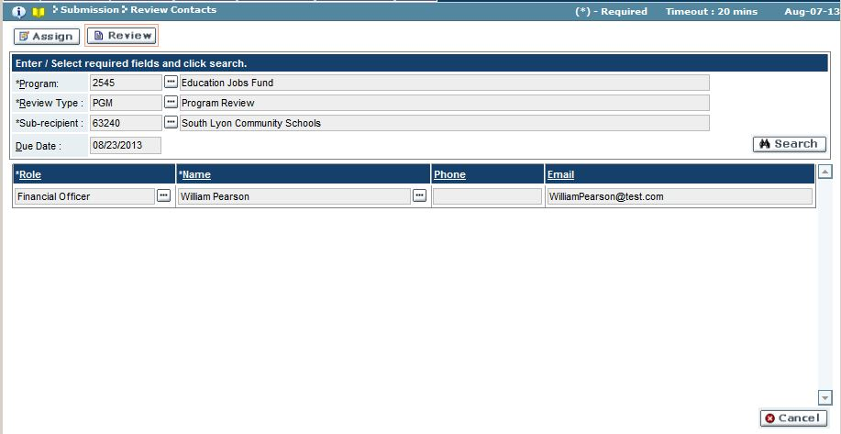

1. Click on ‘Review’ mode.
2. Enter the search criteria, as per the following:

| Field Name | Action |
| --- | --- |
| Program | Select the desired program from the look-up |
| Review Type | Select the review type from the look-up |
| Sub-Recipient | Select the desired sub-recipient from the look-up |

1. Click on the ‘Search’ button.
2. The system will display the list of sub-recipient review contacts assigned during the Scheduling stage.

Assign

In this mode, you can edit the names and roles of the members to be involved in the on-site review.

1. Click on ‘Upload’ mode.
2. Enter the search criteria as per the Review mode.
3. Make changes to the fields as per the following:

| Field Name | Action |
| --- | --- |
| Role | Select the desired role from the look-up |
| Name | Select the desired review role from the look-up, or enter in the name |
| Phone | Enter in the phone number, if not auto-populated when an individual’s name was selected from the above look-up |
| Email | Enter in the email address, if not auto-populated when an individual’s name was selected from the name look-up |
| Del. | Click on the ‘X’ icon to mark the record for deletion |

1. Once changed, click on ‘Save’ to save or ‘Cancel’ to discard the changes.

Troubleshooting

| **#** | **Error** | **Description** | **Corrective Action** |
| --- | --- | --- | --- |
| 1 | Error Message: <Fieldname> cannot be empty | <Fieldname> is blank | The required fields are marked by asterisk *. When one of these fields is not entered, the system prompts with the above error message. Please enter / select value into the field and retry the operation. |

## Program Documents

Review documents include common, office, and program documents. This screen can only be accessed once the document list has been established and the review has been scheduled. Files submitted on this screen can be either electronically added or noted as received as a hard copy.

To access this functionality, navigate to the following menu:

**Submission → Review Documents**

This screen has the following functionality: Review, Upload.

|  |  |
| --- | --- |
| Predecessor | Common Document |
| Who | Sub-Recipient User |
| When | Review Process |
| Subsequent | Review Contacts |

Review

In this mode, you can view all the documents uploaded to GEMS\MARS. You cannot make any changes in this mode.

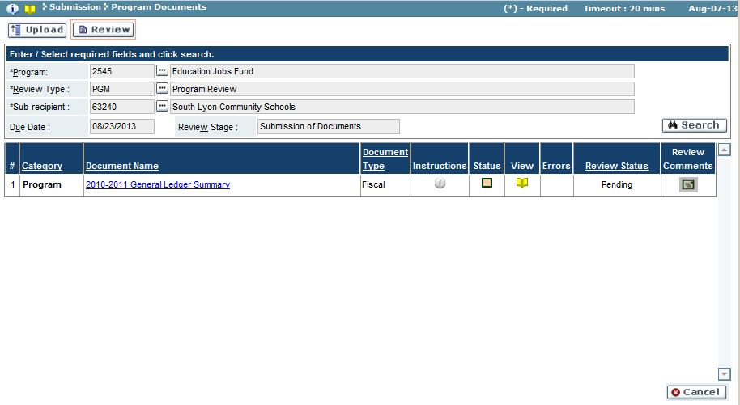

1. Click on ‘Review’ mode.
2. Enter the search criteria, as per the following:

| Field Name | Action |
| --- | --- |
| Sub-Recipient | Select the desired sub-recipient/building from the look-up |
| Document Type | Select the desired document type (Common/Office) |

1. Click on the ‘Search’ button.
2. The system will display the list of documents selected above.
3. Click the View Attachment icon () to view the attachment. Documents with a Hard Copy icon () were submitted as hard copies.

Upload

In this mode, you can upload electronic copies of common, office, and program documents, as well as note these documents as to be submitted as a hard copy. Documents uploaded to GEMS\MARS but not submitted prior to the due date will automatically be promoted to the next stage when that date arrives.

1. Click on ‘Upload’ mode.
2. Enter the search criteria as per the Review mode.
3. Click on the name of the document to open the Attachments window.
4. Make changes to the fields as per the following:

| Field Name | Action |
| --- | --- |
| Title | Enter the title of the document being uploaded |
| Document Upload Type | Select the appropriate option (Electronic/Hard Copy) |
| Attach | Click on the ‘Browse’ button to select a file to be uploaded, if the above selected is ‘Electronic’ |
| Del | Click on the delete **X** icon to mark the record for deletion |

1. Once changed, click on ‘OK’ to save or ‘Cancel’ to discard the changes.
2. Repeat steps 3-5 for each document returned in the search results.
3. Once changed, click on ‘Validate’ to check for errors.

* An error check will be performed against the Document List as well as the Review Team contacts. Click on the ‘Errors’ button to view the list of items needing to be addressed prior to validation.

1. When all documents have been uploaded or marked as hard copy, click ‘Submit’ to submit the documents for review, or ‘Cancel’ to discard the changes.

Troubleshooting

| **#** | **Error** | **Description** | **Corrective Action** |
| --- | --- | --- | --- |
| 1 | Error Message: <Fieldname> cannot be empty | <Fieldname> is blank | The required fields are marked by asterisk *. When one of these fields is not entered, the system prompts with the above error message. Please enter / select value into the field and retry the operation. |

# Compliance

## Compliance Plan

A compliance plan is an outline of how a sub-recipient will resolve issues with items that were found to be out of compliance during the Assign Findings stage. Sub-recipients can provide the steps they plan to take to come into compliance, as well as assign a time period and individual assigned to the task. Compliance plans need to be submitted for each out-of-compliance item, and can be submitted on a case-by-case basis.

To access this functionality, navigate to the following menu:

**Compliance → Compliance Plan**

This screen has the following functionality: Review, Setup.

|  |  |
| --- | --- |
| Predecessor | Report |
| Who | Sub-Recipient User |
| When | Review Process |
| Subsequent | Approve Compliance Plan |

Review

In this mode, you can view the citations, findings, and action items given to the review documents during the Assign Findings stage. You cannot make any changes in this mode.

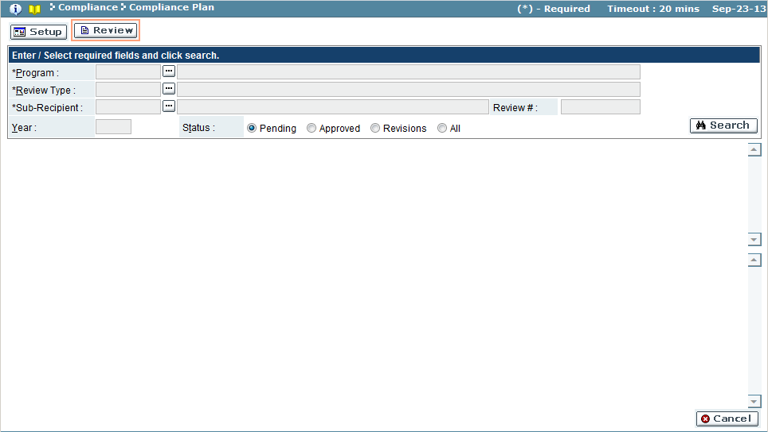

| Field Name | Action |
| --- | --- |
| Program | Select the program from the look-up |
| Review Type | Select the review type from the look-up |
| Sub-Recipient/Sponsor | Select the sub-recipient/sponsor from the look-up |
| Status | Select the status (Pending/Approved/Revisions/Rejected/All) |

Setup

In this mode, you can create and edit compliance plan information, and select which compliance plans to submit for approval.

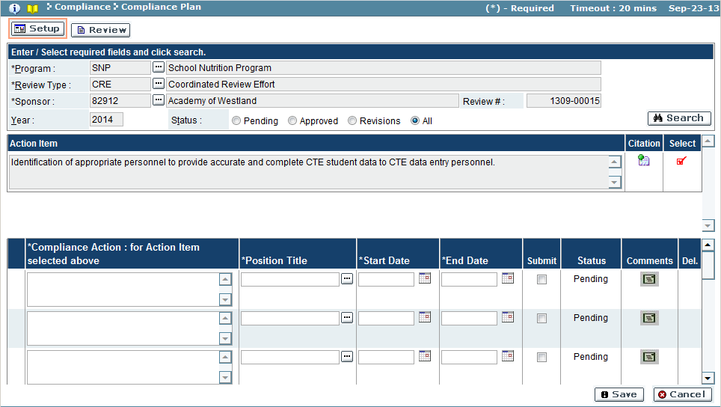

| Field Name | Action |
| --- | --- |
| Compliance Action | Detailed information on how the citation will be resolved to bring the item into compliance |
| Position Title | Position title responsible for action item |
| Start Date | start date (formatted as MM/DD/YYYY or select a date from the calendar  icon) |
| End Date | ending date (formatted as MM/DD/YYYY , or select a date from the calendar  icon) |
| Submit | A check the box indicates that the compliance plan(s) listed will be submitted for approval when the page is saved |
| Status | Status of the compliance action |
| Comments | If comments  icon is yellow, view the comments regarding compliance action |
| Del. | If a compliance action exists, ‘**X**’ icon will appear, allowing item to be deleted |

1. Use the search feature to view the sub-recipient/sponsor’s document review findings.
2. To start a compliance plan for the action item, click the show status icon in the Select column, to select an action item. A selected action item will display the selected icon.
3. Enter a detailed compliance action plan for the selected action item.
4. Use the look-up function to select the position title responsible for the compliance plan.
5. Enter the starting and ending dates in which the compliance plan will be completed.
6. Place a check in the box of the Submit column to submit the compliance plan for approval.

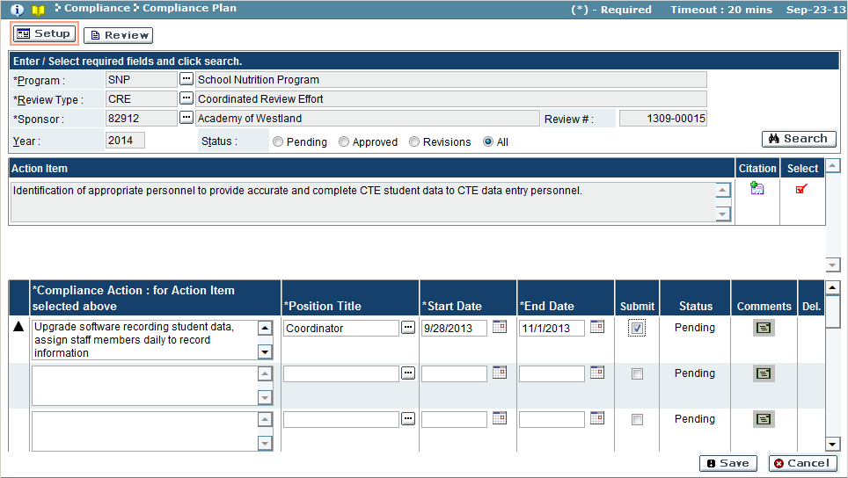

1. Click ‘Save’ button to save the compliance action item (‘Cancel’ will discard changes).

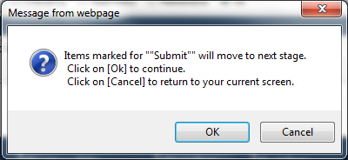

1. Click ‘OK’ button to submit compliance actions (‘Cancel’ button will discard submission).
2. If the save is completed, a confirmation window will appear stating the compliance actions will be moved to the next stage, Approve Compliance Plan. Click ‘OK’ to close confirmation window.

Troubleshooting

| **#** | **Error** | **Description** | **Corrective Action** |
| --- | --- | --- | --- |
| 1 | Error Message: <Fieldname> cannot be empty | <Fieldname> is blank | The required fields are marked by asterisk *. When one of these fields is not entered, the system prompts with the above error message. Please enter / select value into the field and retry the operation. |

## Completion Evidence

Completion evidence provides proof that the compliance plans were followed through with and that the designated item is now in compliance. Like compliance plans, completion evidence can be submitted on a case-by-case basis.

To access this functionality, navigate to the following menu:

**Compliance → Completion Evidence**

This screen has the following functionality: Review, Setup.

|  |  |
| --- | --- |
| Predecessor | Approve Compliance Plan |
| Who | Sub-Recipient User |
| When | Review Process |
| Subsequent | Approve Completion Evidence |

Review

In this mode, you can view the completion evidence that has been submitted, as it sits in the pending, approved, revisions, or rejected stage. You cannot make any changes in this mode.

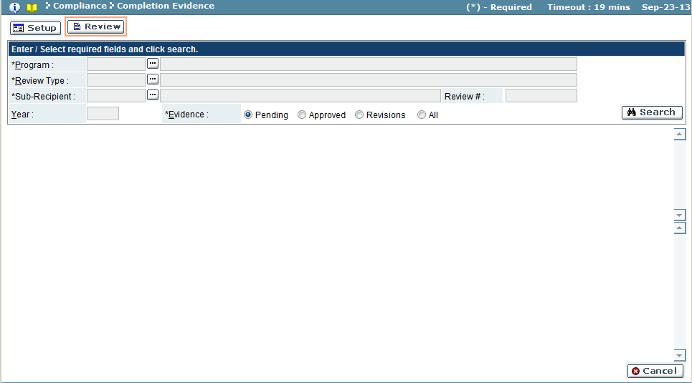

| Field Name | Action |
| --- | --- |
| Program | Select the program from the look-up |
| Review Type | Select the review type from the look-up |
| Sub-Recipient/Sponsor | Select the sub-recipient/sponsor from the lookup |
| Evidence | Select the status (Pending/Approved/Revisions/Rejected/All) |

Setup

In this mode, you can create and edit completion evidence information, and select which evidence to submit for approval. This screen is used to create evidence for the compliance action item, as well as to make revisions to existing evidence that had been previously reviewed and rejected.

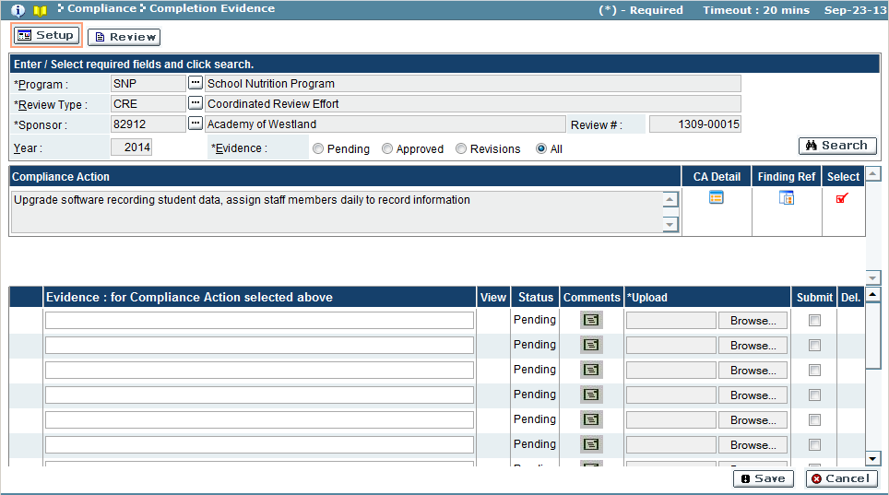

| Field Name | Description |
| --- | --- |
| *Compliance Action Results Pane* | |
| Compliance Action | Compliance action plan submitted |
| CA Detail | Compliance action details, click the details  icon to view |
| Finding Ref | Finding reference details, click the details  icon to view |
| Select | Show selection icon, when clicked will display the results in the evidence results pane. Icon will change to  when record is selected for viewing |
| *Evidence Results Pane* | |
| Evidence | Detailed information on how the compliance plan was adhered to, bringing the item into compliance |
| View | If attachment  icon exists, document can be viewed |
| Status | Approval status of the evidence (Pending until evidence submitted) |
| Comments | If the comment  icon is yellow, click to view the approval comments |
| Upload | Documents related to the evidence |
| Submit | A check in the box indicates that the completion evidence listed will be submitted for approval when the page is saved |
| Del. | If an evidence record exists, the ‘**X**’ icon is visible, allowing deletion allowing deletion of the record, if necessary |

1. Use the search feature to view the sub-recipient/sponsor’s document review findings.
2. Click on the selectionicon to select an action item to add an evidence record to. The icon will change to the selected  icon when an action item is selected.

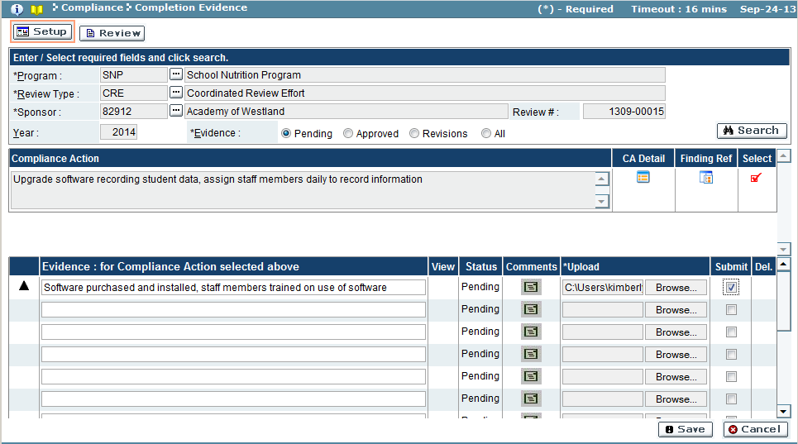

1. Insert a brief description of the evidence
2. Upload a document using the ‘Browse’ button:

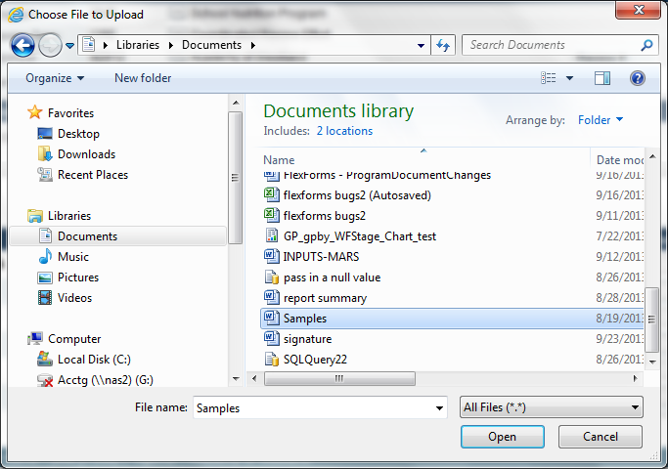

* 1. The ‘Choose a File to Upload’ file directory window opens. Navigate to the document to upload and select it. Click ‘Open’ to upload the document (‘Cancel’ button will discard the document), returning to completion evidence screen.

1. Repeat as necessary to upload each evidence document for each compliance action.
2. To submit the evidence for approval, place a check in the box for each evidence record in the Submit column (If Submit box is not checked, documents will be saved but not sent for approval).
3. Click ‘Save’ button to save and send the evidence for approval (‘Cancel’ button will discard changes).
4. A confirmation window will appear:

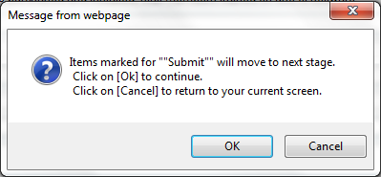

* 1. Click ‘OK’ button to submit the evidence and promote to the next stage – Approve Completion Evidence (‘Cancel’ will discard submission).

1. If the submission was completed, a confirmation window will appear. Click ‘OK’ button to close window.

Troubleshooting

| **#** | **Error** | **Description** | **Corrective Action** |
| --- | --- | --- | --- |
| 1 | Error Message: <Fieldname> cannot be empty | <Fieldname> is blank | The required fields are marked by asterisk *. When one of these fields is not entered, the system prompts with the above error message. Please enter / select value into the field and retry the operation. |

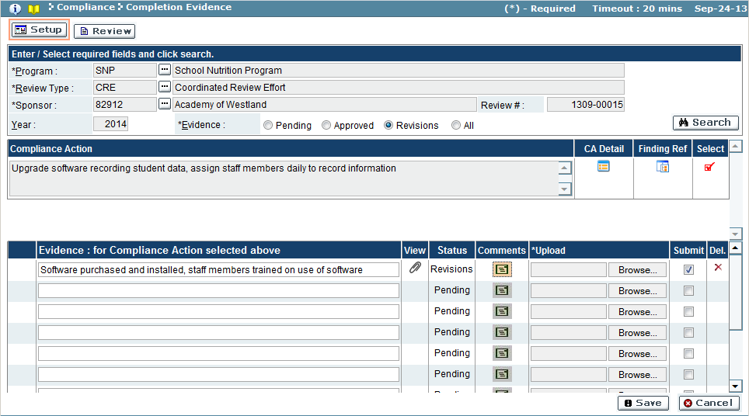

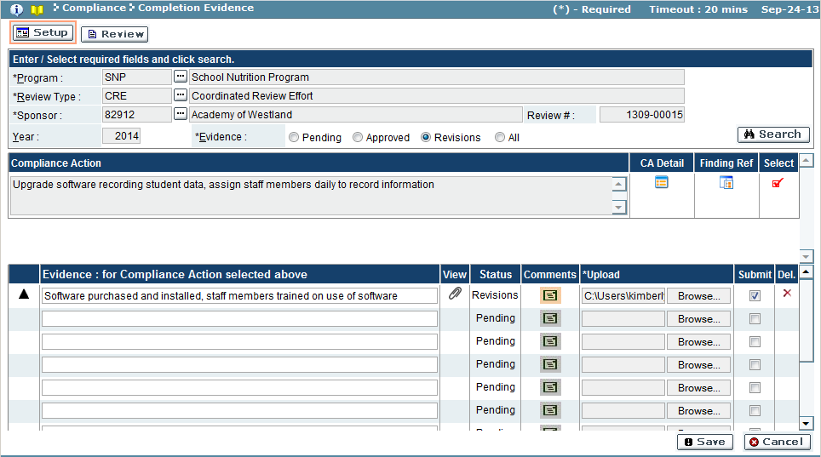

## Acknowledge Findings Package

Once a findings package is completed, the sub-recipient/sponsor will need to acknowledge the findings package. The findings package can be downloaded for viewing, and the user assigned to acknowledge the package can submit their signature for acknowledging their receipt of the findings.

To access this functionality, navigate to the following menu:

**Compliance → Acknowledge Findings Package**

This screen has the following functionality: Review, Acknowledge.

|  |  |
| --- | --- |
| Predecessor | Create Findings Package |
| Who | Sub-Recipient User |
| When | Review Process |
| Subsequent | Compliance Plan |

Review

In this mode, the findings packages created for a review can be viewed. Acknowledged packages will display who acknowledged the package and when. You cannot make any changes in this mode.

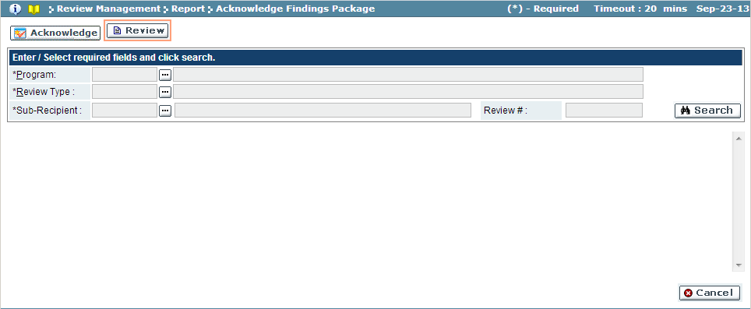

| Field Name | Action |
| --- | --- |
| Program | Select the program from the look-up |
| Review Type | Select the review type from the look-up |
| Sub-Recipient/Sponsor | Select the sub-recipient from the look-up |

Acknowledge

In this mode, the findings packages are acknowledged as viewed.

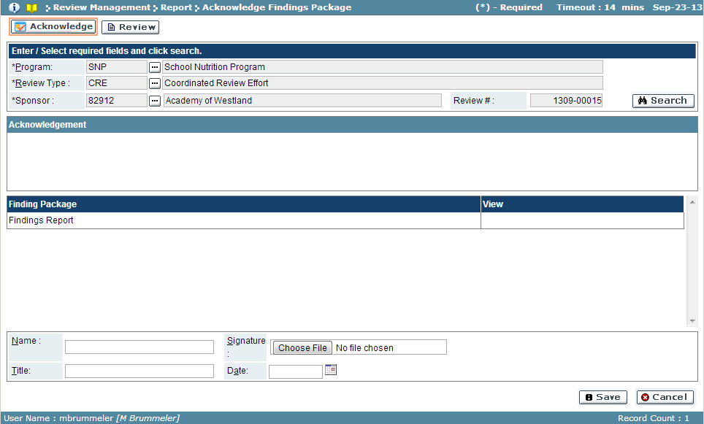

| Field Name | Description |
| --- | --- |
| Finding Package | Findings Report name |
| View | Click attachment  icon to view the findings report |
| Name | Enter name of the person acknowledging findings report |
| Title | Enter the title/position of the person acknowledging findings report |
| Date | Enter the date the report is acknowledged |
| Signature | User the ‘Choose File’ button to upload the signature file |

* 1. Use the search feature to view findings package.
  2. Click the attachment  icon to download the findings package.
  3. To acknowledge findings, enter the name, title and date.
  4. Use the ‘Choose File’ button to upload the signature file.

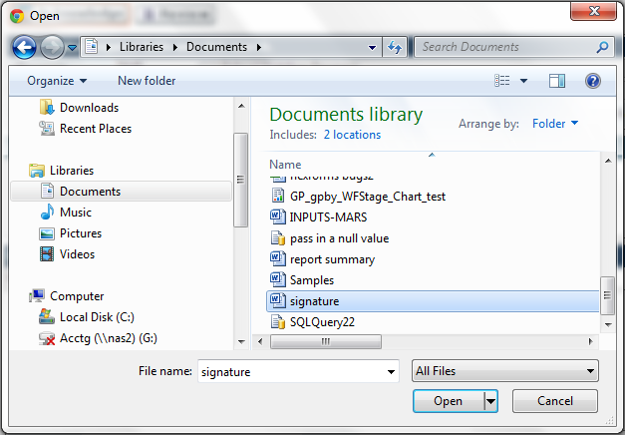

* + 1. Browse to file location, click on file and click ‘Open’ button to upload file (‘Cancel’ button will discard upload) and return to Acknowledge Findings Package screen.
  1. Click ‘Save’ button to acknowledge package (‘Cancel’ button will cancel).

# Documentation

## Program Documents

Program Documents are used to provide sub-recipients with additional information which can aid them in the review process.

To access this functionality, navigate to the following menu:

**Documentation → Program Documents**

|  |  |
| --- | --- |
| Predecessor |  |
| Who | Sub-Recipient User |
| When | as needed |
| Subsequent |  |

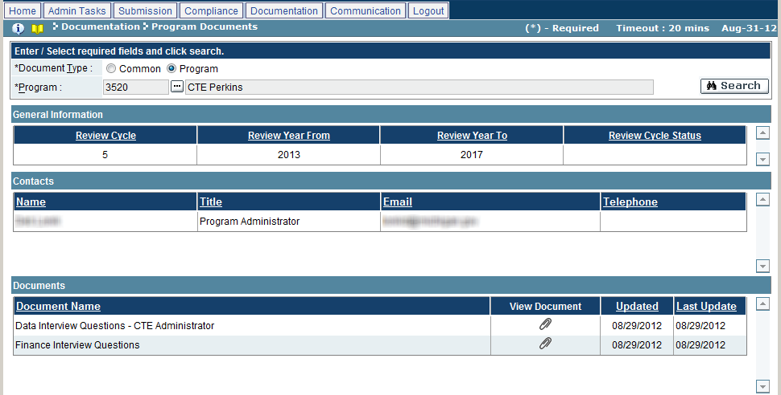

1. Enter the search criteria, as per the following:

| Field Name | Action |
| --- | --- |
| Document Type | Select the desired document type (Common/Program) |
| Program | Select the desired program from the look-up, if the above selected is ‘Program’ |

1. Click on the ‘Search’ button.
2. The system will display the list of program documents selected above.
3. Click the  icon to view the attachment.

Troubleshooting

| **#** | **Error** | **Description** | **Corrective Action** |
| --- | --- | --- | --- |
| 1 | Error Message: <Fieldname> cannot be empty | <Fieldname> is blank | The required fields are marked by asterisk *. When one of these fields is not entered, the system prompts with the above error message. Please enter / select value into the field and retry the operation. |

## Q&A

The Q&A screen is used to ask questions related to GEMS\MARS. Questions can be either general, or relating to a specific program, and can be further classified by category. Answers to questions can also be viewed on this screen.

To access this functionality, navigate to the following menu:

**Documentation → Q&A**

This screen has the following functionality: Review, Delete, Change, Add.

|  |  |
| --- | --- |
| Predecessor |  |
| Who | Sub-Recipient User |
| When | as needed |
| Subsequent |  |

Review

In this mode, you can view questions submitted to the GEMS. You cannot make any changes in this mode.

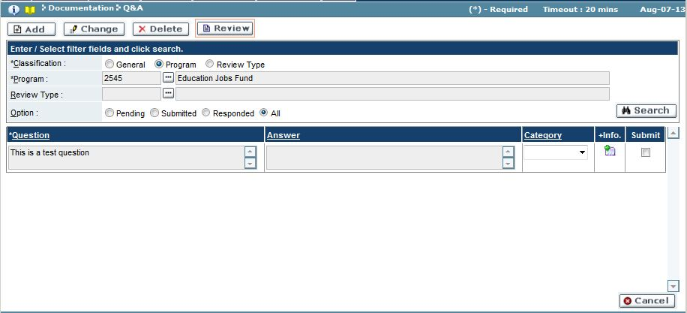

1. Click on ‘Review’ mode.
2. Enter the search criteria, as per the following:

| Field Name | Action |
| --- | --- |
| Classification | Select the desired question classification (General/Program) |
| Program | Select the desired program from the look-up, if the above selected is ‘Program’ |
| Review Type | Select the desired program from the look-up, if the above selected is ‘Review Type’ |
| Option | Select the desired question status (Pending/Submitted/Responded/All) |

1. Click the ‘Search’ button.
2. The system will display the list of submitted questions along with any answers that may have been provided.

Delete

In this mode, you can delete questions submitted to GEMS\MAR, which are sitting in the Pending stage.

1. Click on ‘Delete’ mode.
2. Enter the search criteria as per the Review mode.
3. You can delete a question by clicking on the ‘X’ icon.
4. Once changed, click on ‘OK’ to save or ‘Cancel’ to discard the changes.

Change

In this mode, you can edit questions submitted to the GEMS, which are sitting in the Pending stage.

1. Click on ‘Change’ mode.
2. Enter the search criteria as per the Review mode.
3. You can edit the question text in the Question field.
4. Click the checkbox in the Submit column to mark the selected question for submission.
5. Once changed, click on ‘Save’ to save or ‘Cancel’ to discard the changes.

Add

In this mode, you can ask a question, and view related answers, associated with the GEMS. Questions submitted can be added to the list of frequently asked questions.

1. Click on ‘Add’ mode.
2. Enter the search criteria as per the Review mode.
3. Make changes to the fields as per the following:

| Field Name | Action |
| --- | --- |
| Question | Enter the desired question text |
| Submit | Click the checkboxes to mark the question for submission |

1. Once changed, click on ‘Save’ to save or ‘Cancel’ to discard the changes.

Troubleshooting

| **#** | **Error** | **Description** | **Corrective Action** |
| --- | --- | --- | --- |
| 1 | Error Message: <Fieldname> cannot be empty | <Fieldname> is blank | The required fields are marked by asterisk *. When one of these fields is not entered, the system prompts with the above error message. Please enter / select value into the field and retry the operation. |

## FAQ

The FAQ screen is used to view a list of frequently asked questions. Questions and answers are grouped by classification and category, and are comprised of question submitted via the Q&A screen as well as other sources.

To access this functionality, navigate to the following menu:

**Documentation → FAQ**

|  |  |
| --- | --- |
| Predecessor |  |
| Who | Sub-Recipient User |
| When | as needed |
| Subsequent |  |

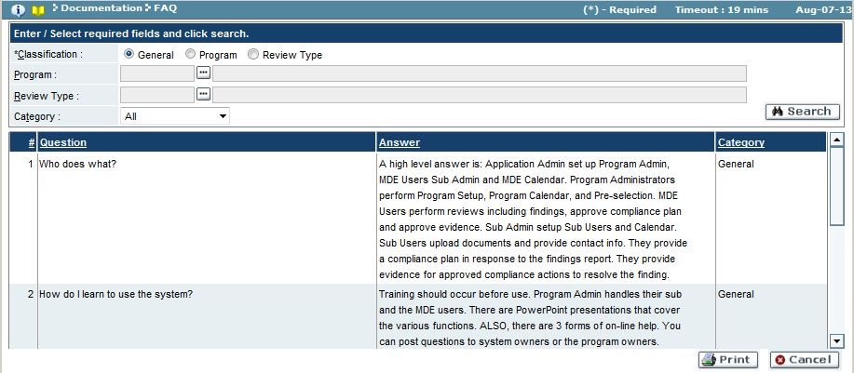

1. Enter the search criteria, as per the following:

| Field Name | Action |
| --- | --- |
| Classification | Select the desired question classification (General/Program) |
| Program | Select the desired program from the look-up, if the above selected is ‘Program’ |
| Review Type | Select the desired review type from the look-up, if the above selected is ‘Review Type’ |
| Category | Select the desired question category from the dropdown |

1. Click on the ‘Search’ button.
2. The system will display the list of frequently asked questions selected above.

Troubleshooting

| **#** | **Error** | **Description** | **Corrective Action** |
| --- | --- | --- | --- |
| 1 | Error Message: <Fieldname> cannot be empty | <Fieldname> is blank | The required fields are marked by asterisk *. When one of these fields is not entered, the system prompts with the above error message. Please enter / select value into the field and retry the operation. |

## Best Practices

The Best Practices screen is used to view best practices documents to the GEMS. Best practices documents serve as examples of ideal documents which are to be used as models for completing the Submission stage.

To access this functionality, navigate to the following menu:

**Documentation → Best Practices**

This screen has the following functionality: Review.

|  |  |
| --- | --- |
| Predecessor |  |
| Who | Sub-Recipient User |
| When | as needed |
| Subsequent |  |

Review

In this mode, you can view the list of best practices documents which have been uploaded to the GEMS. You cannot make any changes in this mode.

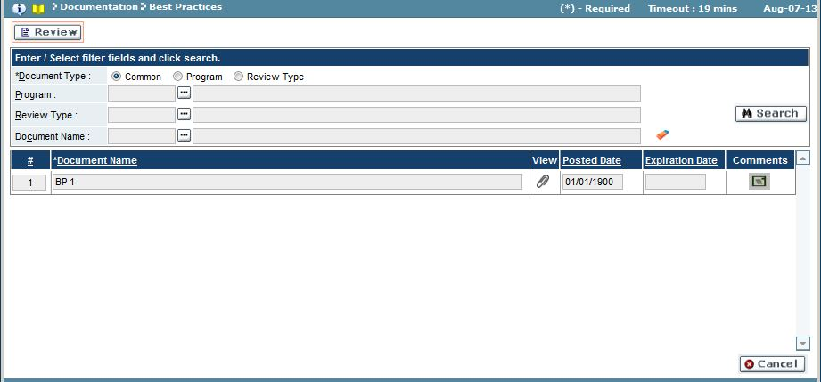

1. Click on ‘Review’ mode.
2. Enter the search criteria, as per the following:

| Field Name | Action |
| --- | --- |
| Document Type | Select the desired document type (Common/Program) |
| Program | Select the desired program from the look-up, if the above selected is ‘Program’ |
| Review Type | Select the desired program from the look-up, if the above selected is ‘Review Type’ |
| Document Name | Select the desired document from the look-up |

1. Click the ‘Search’ button.
2. The system will display the list of best practices documents selected above.
3. Click the  icon to view the attachment.
4. Click the  icon to view any associated comments.

Troubleshooting

| **#** | **Error** | **Description** | **Corrective Action** |
| --- | --- | --- | --- |
| 1 | Error Message: <Fieldname> cannot be empty | <Fieldname> is blank | The required fields are marked by asterisk *. When one of these fields is not entered, the system prompts with the above error message. Please enter / select value into the field and retry the operation. |

# Communication

## My Pending Tasks

My Pending Tasks displays all the items currently awaiting your action. The list of pending tasks will appear on the home screen, above the New Messages On this screen you can read and organize all pending tasks.

To access this functionality, navigate to the following menu:

**Home Screen → My Pending Tasks**

|  |  |
| --- | --- |
| Predecessor |  |
| Who | Sub-Recipient User |
| When | After login or as needed |
| Subsequent |  |

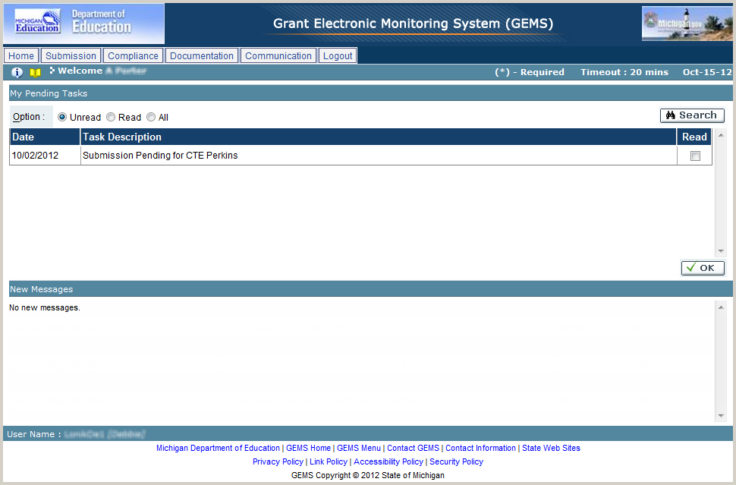

* 1. Enter the search criteria as per the following:

| Field Name | Action |
| --- | --- |
| Option | Select the desired view option (Unread/Read/All) |

* 1. Click on the ‘Search’ button.
  2. The system will display the list of pending tasks, as per the search criteria.
  3. Click on the checkbox next to any record to mark it as to be being read.
  4. Once changed, click on ‘OK’ to save.
  5. The selected tasks will be marked as read.

Troubleshooting

| **#** | **Error** | **Description** | **Corrective Action** |
| --- | --- | --- | --- |
| 1 | Cannot see task item in the list of my pending task | Item is not visible in the list because it’s not assigned to login user or has been marked as “read” | Change filter condition to read and click on search |

## Email Log

Email Log is the list of all the emails sent or received by the users to or from other users and sub-recipients regarding the GEMS process. In this screen you can view the emails sent or received by the users about the notifications and other communication between them.

To access this functionality, navigate to the following menu:

**Communication → Email Log**

|  |  |
| --- | --- |
| Predecessor |  |
| Who | Sub-Recipient User |
| When | As needed |
| Subsequent |  |

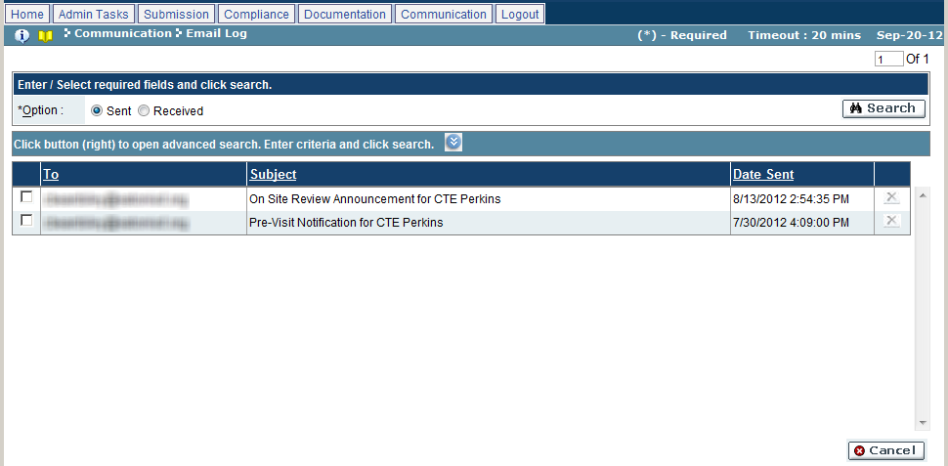

* 1. Enter the search criteria as per the following:

| Field Name | Action |
| --- | --- |
| Option | Select the desired view option (Sent/Received)  To refine the list, click on the  button and follow the next steps |

* 1. Click on the ‘Search’ button.
  2. The system will display the list of emails, as per the search criteria.
  3. Click on any record to view the sent or received email.
  4. To delete an email, click on the ‘X’ icon.
  5. Once changed, click on ‘OK’ to save or ‘Cancel’ to discard the changes.

Troubleshooting

| **#** | **Error** | **Description** | **Corrective Action** |
| --- | --- | --- | --- |
| 1 | Error Message: <Fieldname> cannot be empty | <Fieldname> is blank | The required fields are marked by asterisk *. When one of these fields is not entered, the system prompts with the above error message. Please enter / select value into the field and retry the operation. |