

**MDE Review Process Training Manual**

Revised 09/2013

Contents

Review Management 4

Administration 4

Pre-selection - Optional 4

Scheduling 16

Review 36

OSR Agenda 36

Assign Review Team 41

Desk/On-site Review 44

Team Document Status 49

Review Consolidation 53

Submit Documents 58

Offline Package 62

Monitoring Stage Status 65

Search Documents 68

Report 70

Assign Findings Team 70

Assign Findings 73

Approve Findings 79

View Findings Report 84

Create Findings Package 86

Acknowledge Findings Package 89

Search Findings 92

Events 95

Schedule Training 95

Update Participant Details 100

Late Claims 104

Amount Disregard 109

Seriously Deficient 114

Miscellaneous 119

Follow-up 123

Approve Compliance Plan 123

Approve Completion Evidence 127

Appeal Finding(s) 131

Intent to Terminate 139

Appeal Intent to Terminate 142

Documentation 146

Program Documents 146

Q&A Responses 149

FAQ 151

Best Practices 154

Communication 157

My Pending Tasks 157

Email Log 159

Print Notifications 161

# Review Management

## Administration

### Pre-selection - Optional

If Pre-selection is desired, it is setup once for each sub-recipient under a specific program. In this screen, you can view and change the pre-selected review year, change and add the contact information for the sub-recipient, and notify the sub-recipient of their pre-selection. All sub-recipients must be assigned a review year prior to any sub-recipient being notified.

To access this functionality, navigate to the following menu:

**Review Management → Administration → Pre-selection**

This screen has the following functionality: Review, Setup and Notify.

|  |  |
| --- | --- |
| Predecessor | Release Program |
| Who | Program Administrator |
| When | Beginning of review cycle |
| Subsequent | Scheduling |

Review

In this mode, you can view the review year, contacts, last review year, and notification status for various sub-recipients. You cannot make any changes in this mode.

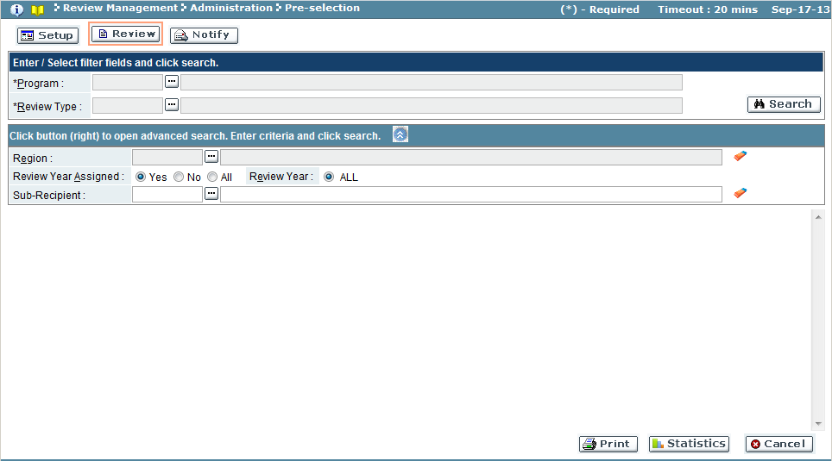

| Field Name | Action |
| --- | --- |
| Program | Select the desired program from the look-up (required field) |
| Review Type | Select the review type from the lookup (required field) |
| *Advanced Search Criteria*  To refine the search criteria, click the  button and follow the next steps | |
| Region | Select the region from the look-up |
| Review Year Assigned | Select whether the review year has been assigned |
| Review Year | Select the year of the assigned review, or select ALL |
| Sub-Recipient/Sponsor | Select the sub-recipient/sponsor from the look-up (wildcard % feature also available to enter a partial field value or code to search) |

1. Use the search feature to view the program. Use advanced search criteria as appropriate.
2. Click the **‘Search’** button.
3. The results pane will display records that meet the selected search criteria.

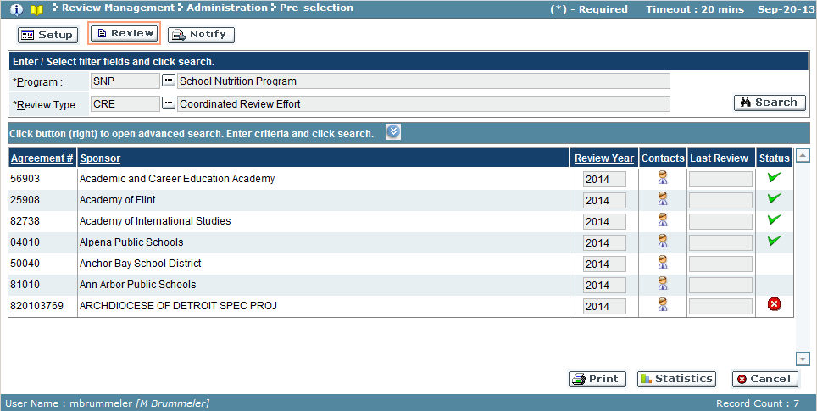

The results pane displays the following information for record meeting the search criteria.

| Field Name | Description |
| --- | --- |
| Code/Agreement # | Unique code related to Sub-Recipient/Sponsor for the program |
| Sub-Recipient/Sponsor | Sub-Recipient/Sponsor |
| Review Year | Year of the Review |
| Contacts | Contacts for Sub-Recipient/Sponsor. Click icon to open Contacts window. |
| Last Review | Date of the last review performed |
| Status | Checkmark icon signifies the Sub-Recipient/Sponsor has been notified |

Sub-Recipients/Sponsor Contacts Window

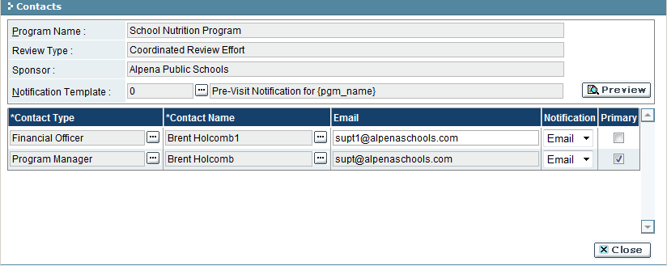

| Field Name | Description |
| --- | --- |
| Program Name | Program opened for viewing |
| Review Type | Program’s review type |
| Sub-Recipient/Sponsor | Sub-Recipient/Sponsor opened for viewing |
| Notification Template | Template used to notify sub-recipient/sponsor of the pre-selection. |
| Contact Type | Contact type for the contact record |
| Contact Name | Sub-recipient/sponsor’s assigned contact person for the contact type |
| Email | Email address for the contact |
| Notification | Default notification format used to communicate with contact |
| Primary | Checkmark signifies the contact is the primary contact for the sub-recipient/sponsor |

The ‘Preview’ button will display the notification template selected.

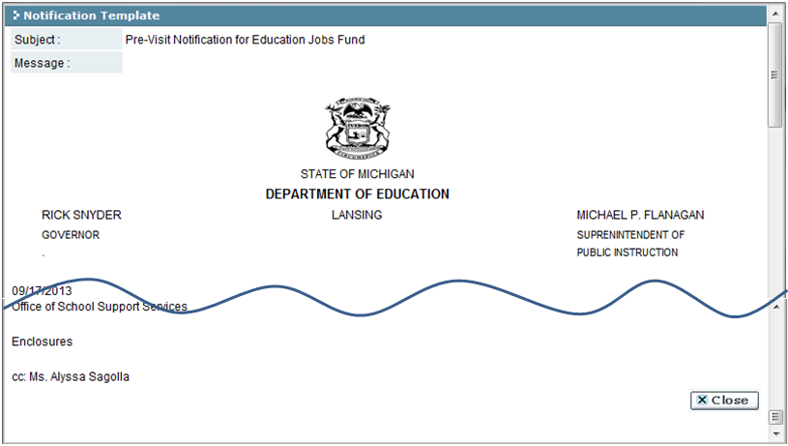

Click ‘Close’ button at bottom to close the Notification Template window.

Click ‘Close’ button to close the Contacts window.

The ‘Statistics’ button will give a summary of sub-recipients/sponsors by year and by stage for the program.

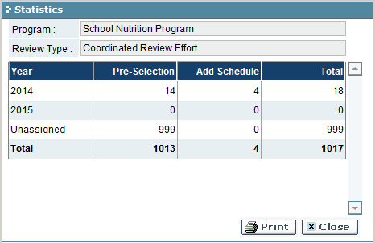

| Field Name | Description |
| --- | --- |
| Year | Review year |
| Pre-Selection | Number of sub-recipients/sponsors at the Pre-Selection stage |
| Add Schedule | Number of sub-recipients/sponsors at the Scheduling stage |
| Total | Total sub-recipients/sponsors for the review year |

Click ‘Print’ to print the statistics.  
Click ‘Close’ to close the Statistics window.

Setup

In this mode, you can set the review year and contact information for a sub-recipient/sponsor that has not been notified of pre-selection.

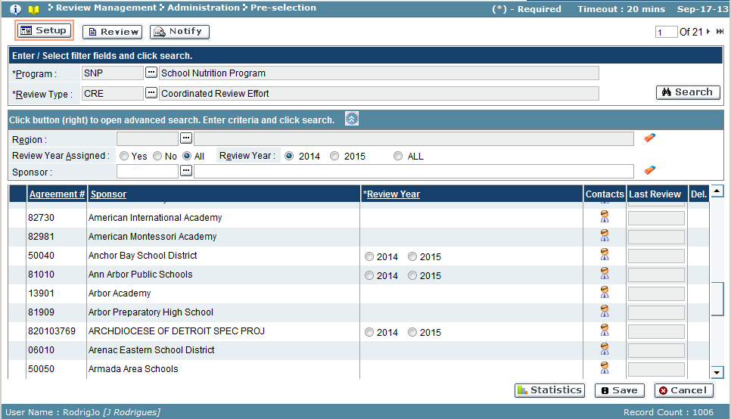

1. Use the search feature to open the program for pre-selection. Use advanced search criteria as appropriate.

*HINT:* Top right corner will display the # of pages for the program. Use the arrows to navigate through the pages of sub-recipients/sponsors.

Bottom right corner will display the total # of records that meet the search criteria.

1. Locate the sub-recipient/sponsor to set up. (Only records that display a year in the Review Year column can be modified).
2. Select year in the Review Year column.
3. Click the Contacts icon () for the sub-recipient/sponsors row. The Contacts window opens:

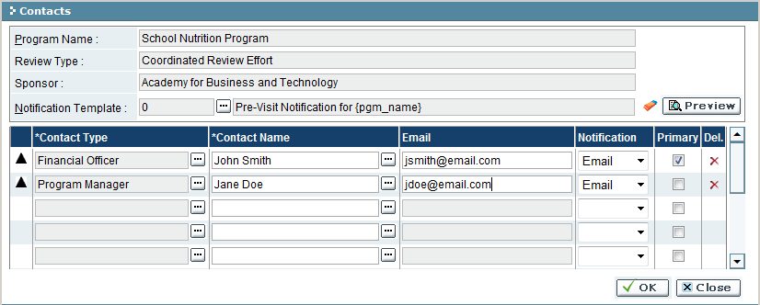

| Field Name | Action |
| --- | --- |
| Notification Template | Select the desired template from the look-up (required field) |
| Contact Type | Select the desired contact type from the look-up (required field) |
| Contact Name | Select an existing sub-recipient/sponsor’s contact using the look-up, or enter a new contact name (required field) |
| Email | Add a new email (or change existing ) address for contact |
| Notification | Select the type of notification for contact (email, letter, both) |
| Primary | Check the box to indicate that the contact will be the primary contact on the notification |
| Del. | Use button to remove the contact record (optional) |

1. Select the Notification Template the sub-recipient/sponsor will receive.
   1. Click the ‘Preview’ button to view the notification template (optional)
2. Set up the contact records
3. To save changes to Contacts, click ‘OK’ button (‘Close’ will discard changes and close window) to return to Setup screen.
   1. Each sub-recipient/sponsor record that was modified will have on the left side of record.

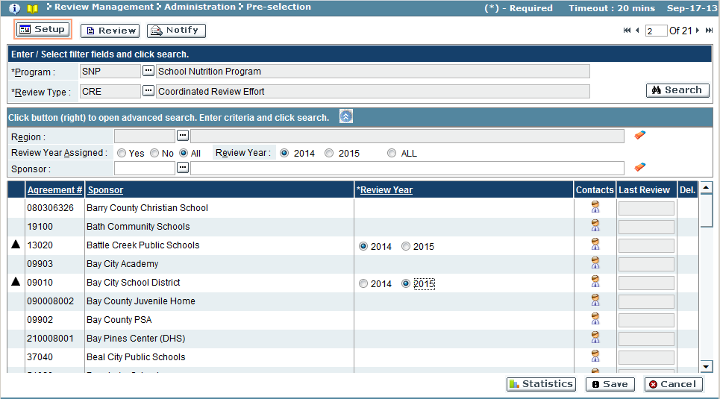

1. To save changes to program, click ‘Save’ button.
   1. Errors found during save must be corrected before continuing to the next mode. Sub-recipients/sponsors with an error will have on the left side of the record. Make corrections as recommended by error messaging.
2. Upon successful save, the modified sub-recipients will be moved to the next stage – Scheduling.
3. Use the ‘Statistics’ button to see the changes made to counts.

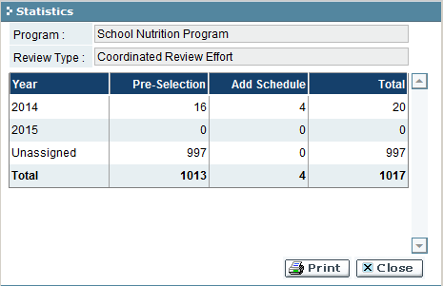

Notify

In this mode, the sub-recipients/sponsors modified for a program in the Setup mode will be modified for notification.

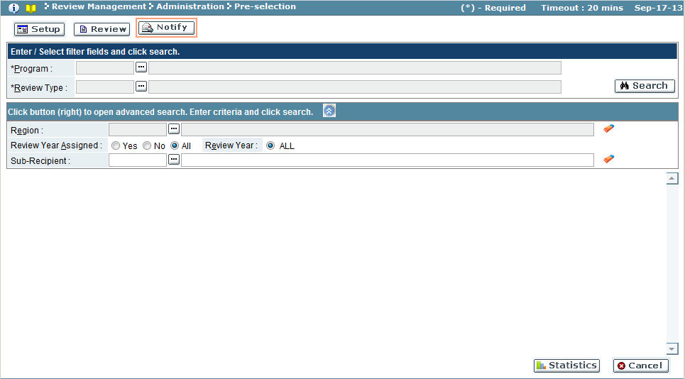

1. Use the search feature to open the program for pre-selection. Use advanced search criteria as appropriate.
2. Records modified in Setup mode will appear for the search criteria.
   1. Bottom left corner of screen will display the total records that meet criteria.
3. Select the checkbox in the Notify column for each sub-recipient/sponsor to be notified.
4. Each sub-recipient/sponsor record that was modified will have on the left side of record.

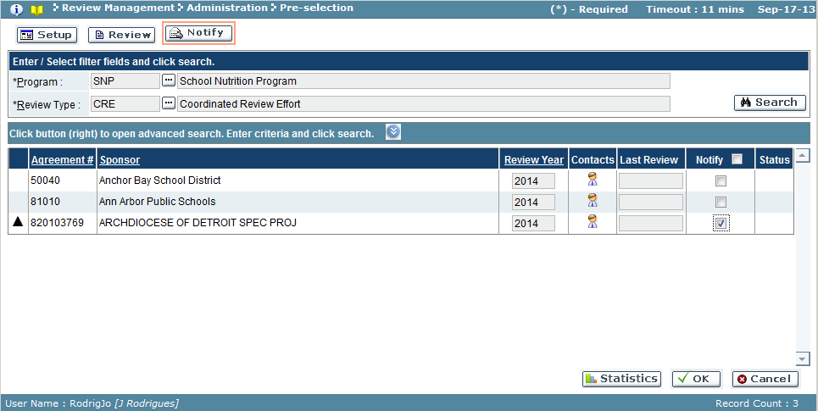

1. To notify sub-recipients/sponsors, click ‘OK’ button (‘Cancel’ will discard changes).
2. The system performs a validation on records before executing notifications.
3. If an error was found, a window appears with the message:

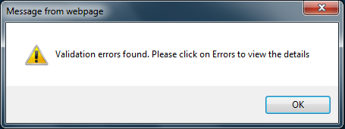

* 1. Click ‘OK’ button to return to Notify screen.

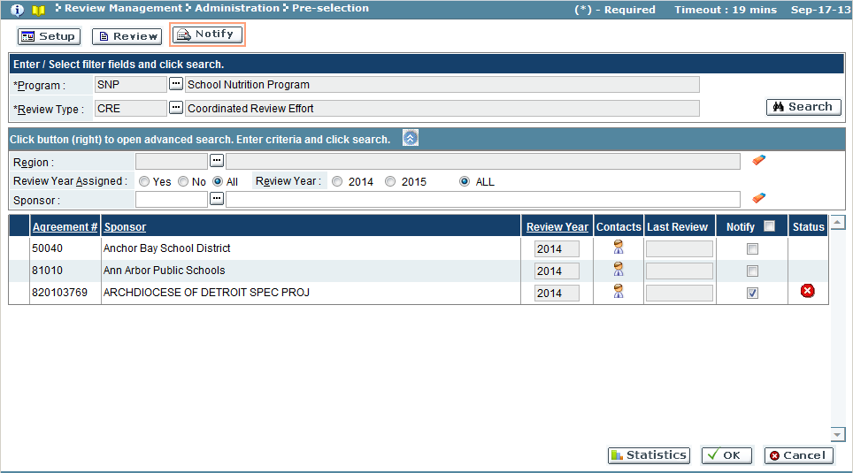

* 1. Locate the record(s) with  in the Status column. Click icon to view the error message.

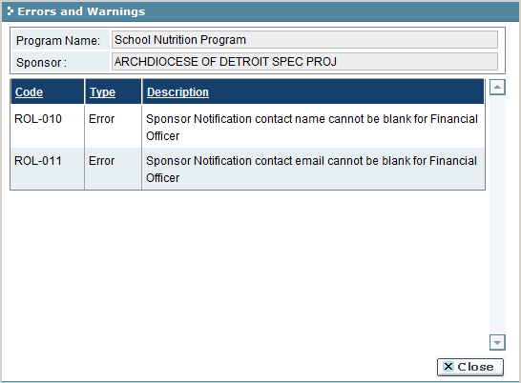

* 1. Return to the Setup mode and correct the sub-recipient/sponsor record(s), and save the program.
  2. Return to the Notify mode and repeat the Notify steps 1-5.

1. If the validation was error-free, the system will notify the sub-recipients/sponsors and a confirmation message will appear:

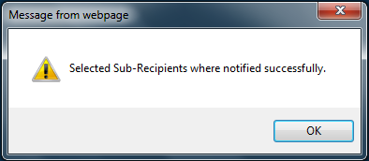

Troubleshooting

| **#** | **Error** | **Description** | **Corrective Action** |
| --- | --- | --- | --- |
| 1 | Error Message: <Fieldname> cannot be empty | <Fieldname> is blank | The required fields are marked by asterisk *. When one of these fields is not entered, the system prompts with the above error message. Please enter / select value into the field and retry the operation. |
| 2 | Row <#>: Sub-Recipient/Sponsor Name: <Fieldname> Please select review year. | Review year not selected for sub-recipient/sponsor | Select a review year for the sub-recipient/sponsor. If a year is not available, the record is not able to be modified at this stage. |
| 3 | Sponsor notification contact name cannot be blank for <contact type> | Contact name is blank for the specified contact type | Enter a contact name for the contact record |
| 4 | Sponsor notification contact email cannot be blank for <contact type> | Contact email is blank for the specified contact type | Enter a contact email address for the contact record |

### Scheduling

Scheduling is the setup for a review for each sub-recipient/sponsor under a specific program. In this screen, you can add the list of documents requested as part of the review, add or change the review contact information (including review team) and schedule the actual review date. Additionally, you can view any attached risk assessment information and schedule sub-recipients for out-of-cycle reviews. All sub-recipients must be been notified during Pre-selection in order for the review to be scheduled. Reviews can also be set as announced and un-announced for each sub-recipient/sponsor. Additionally, sub-recipients/sponsors can be designated as out-of-cycle for an additional review and those whose review have been scheduled but have not gone through the review process can be rescheduled for a different date.

To access this functionality, navigate to the following menu:

**Review Management → Administration → Scheduling**

This screen has the following functionality: Review, Setup and Print.

|  |  |
| --- | --- |
| Predecessor | Pre-selection (optional) |
| Who | Program Administrator |
| When | As needed |
| Subsequent | Assign Review Team |

Review

In this mode, you can view the date of last review, risk rating, list of requested documents, contacts, review dates, whether the review is out-of-cycle, and whether the review has been scheduled for various sub-recipients. You cannot make any changes in this mode.

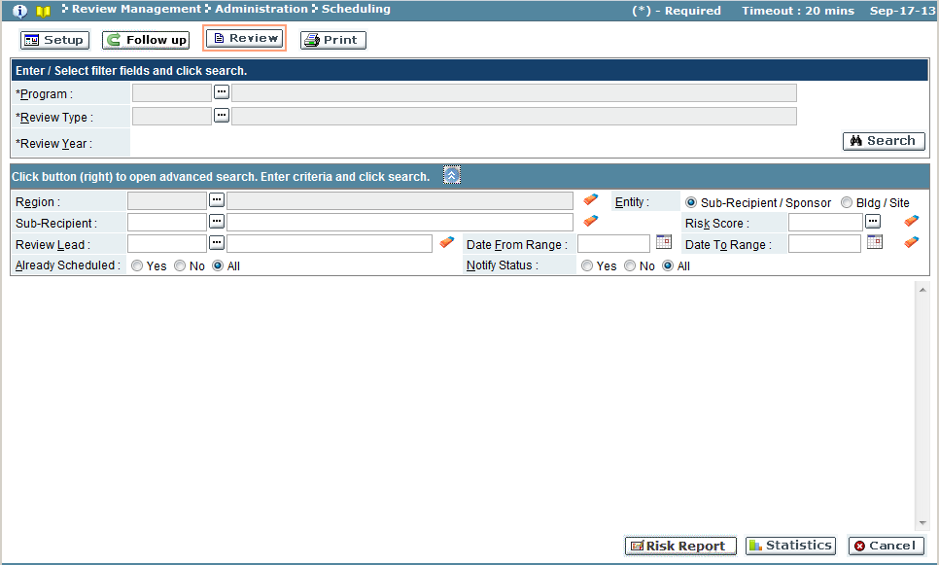

| Field Name | Action |
| --- | --- |
| Program | Select program from the look-up (required field) |
| Review Type | Select the review type for the program (required field) |
| Review Year | Select the review year (required field) |
| *Advanced Search Criteria*  To refine the search criteria, click the  button and follow the next steps | |
| Region | Select the region from the look-up |
| Entity | Select either Sub-Recipient/Sponsor or Bldg/Site |
| Sub-Recipient/Sponsor | Select the sub-recipient from the look-up (wildcard % feature also available to enter a partial field value or code to search) |
| Risk Score | Select the risk score from the look-up |
| Review Lead | Select the review lead from the look-up (wildcard % feature also available to enter a partial field value or code to search) |
| Date From Range | Start date (use MM/DD/YYYY format, or use calendar icon) |
| Date To Range | End date (use MM/DD/YYYY format, or use calendar icon) |
| Already Scheduled | Yes, scheduled / No, not scheduled / All, any records |
| Notify Status | Yes, notified / No, not notified / All, any notification status |

* 1. Use the search feature to view the program.
  2. The sub-recipient/sponsor(s) with scheduled reviews set appear for review.

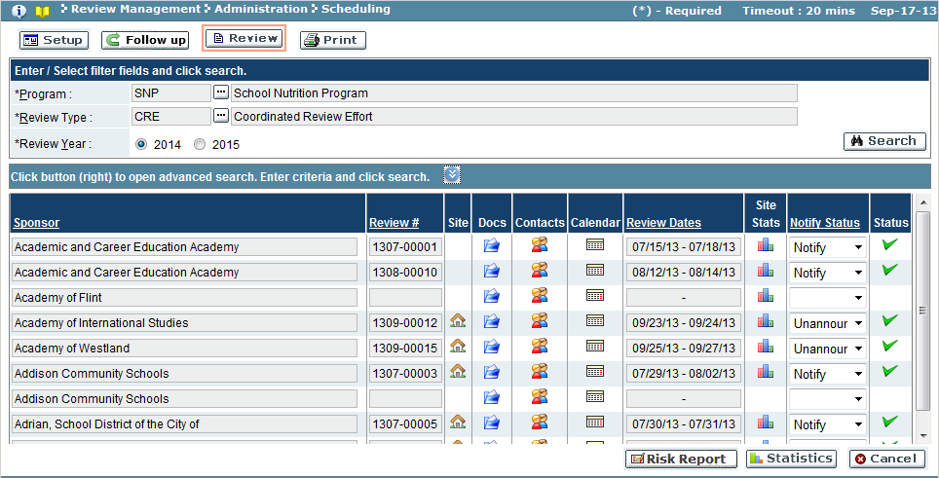

| Field Name | Description |
| --- | --- |
| Sub-Recipient/Sponsor | Sub-recipient/sponsor name |
| Review # | Review # assigned to sub-recipient/sponsor  *HINT: Hovering over a Review #, will give a comment regarding the status of review (Regular, Add Schedule, Follow-Up)* |
| Site | icon, if displayed will list all buildings/sites related to sub-recipient/sponsor for this program review year |
| Docs | icon will display all the documents related to the sub-recipient/sponsor for this program review year |
| Contacts | icon will display the sub-recipients/sponsor’s notification template, notification contacts, the review team members and sub-recipient/sponsor roles |
| Calendar | icon will display a color-coded calendar of various events, such as holidays, weekends, review dates, meetings |
| Review Dates | The range of dates in which the review will be conducted |
| Site Stats | The summary of scheduled and unannounced reviews, minimum number of reviews required, number scheduled, held and pending for the sub-recipient/sponsor for the program review year |
| Notify Status | Type of notification sent to the sub-recipient/sponsor for the program review year (Notify, notification sent / Unannounced, no notification sent / null, no reviews scheduled) |
| Status | Checkmark denotes the sub-recipient/sponsor was notified |

*NOTE:* Please see Scheduling - Setup section for detailed information regarding the SITE,

DOCS, CONTACTS and CALENDAR icons.

The ‘Risk Report’ button will open the risk report window for the program.

*NOTE:* This feature only appears if the program had the Risk documents uploaded from

an external source.

The ‘Statistics’ button will give a summary of sub-recipients/sponsors by year and by stage for the program.

Setup

In this mode, you will schedule a sub-recipients/sponsor’s review for the program review year. Reviews can also be set as announced and un-announced for each sub-recipient/sponsor. For each sub-recipient/sponsor this screen will allow documents to be assigned (as per the review), contacts defined, and selection of review date(s). Additionally, sub-recipients/sponsors can be designated as out-of-cycle for an additional review and those whose review have been scheduled but have not gone through the review process can be rescheduled for a different date.

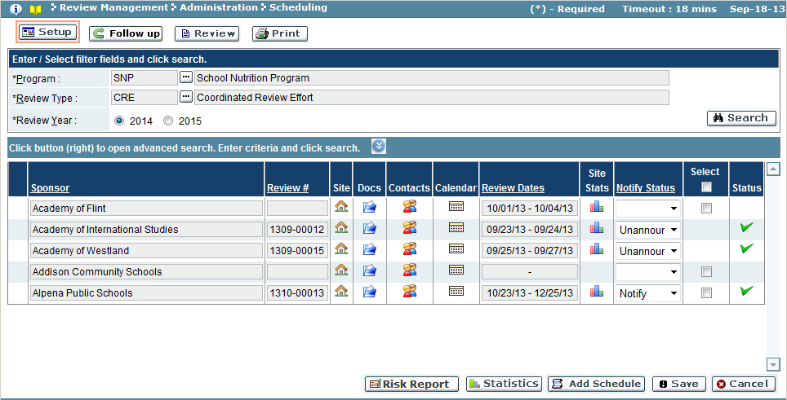

‘Add Schedule’ button allows sub-recipients/sponsors to be added to the scheduling, if they have not been through the pre-selection step (also referred to as out-of-cycle).

* + 1. Use the search feature to locate the program.
    2. Records meeting search criteria appear.

a. Add out-of-cycle sub-recipients/sponsors, if required (*See Add Out-of-Cycle Review*).

* + 1. Locate the sub-recipient/sponsor to schedule and set up review information.

a. Select  Buildings/Sites to be reviewed (*See Add Sites*).

b. Select  Review Documents to be used in review (*See Add Documents*).

c. Assign  Contacts for notification, review team and sub-recipient/sponsor roles (*See*

*Add Contacts*).

d. Schedule  Review Dates or type dates into Review Dates field (*See Add Review Dates*).

e. Preview Statistics  on the sub-recipient’s/sponsor’s reviews (*See Review Statistics*).

f. Select how the sub-recipient/sponsor will be notified (Unannounced – no notification will be sent, Notify – send notification)

g. Place a checkmark in the box of the Select column to flag the changes made to sub-recipient/sponsor.

* + 1. Click ‘Save’ button to commit review(s) for the program (‘Cancel’ will discard review changes made to sub-recipients/sponsors).
  1. The system will validate the changes before committing changes.
     1. If the changes were correct:

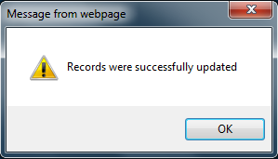

a. Click ‘OK’ button to close the message.

b. Sub-recipients/sponsors scheduled for review will be promoted to the stage Submission.

* + 1. If errors exist, a notification message will appear:

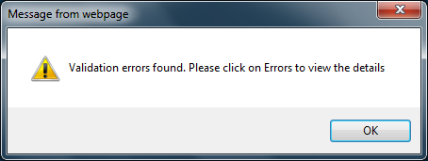

a. Click ‘OK’ to close the message.

b. Locate the record with the error  icon in the Status field.

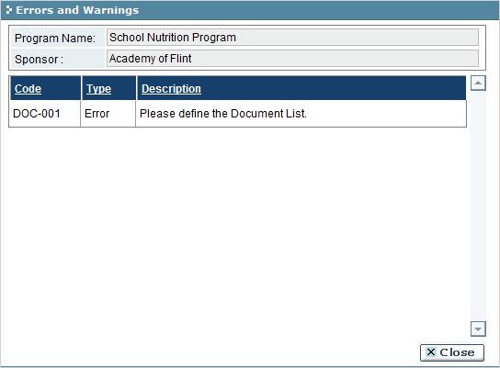

c. Click on the icon to view the errors. Click ‘Close’ button to close window.

d. Make the appropriate changes required by error message(s) before attempting to save scheduled reviews.

*Scheduling Settings*

*Add Out-of-Cycle Review*

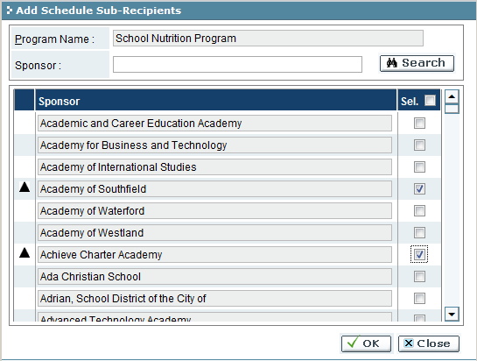

| Field Name | Description |
| --- | --- |
| Sub-Recipient/Sponsor | Sub-Recipients/Sponsors |
| Sel. | Checkmark in the box signifies the sub-recipient/sponsor to be added to scheduling |

1. Click ‘Add Schedule’ button.
2. Add Schedule Sub-Recipients/Sponsor (out-of-cycle) window opens.
3. Use Search feature to narrow results, if necessary.
4. Place a checkmark in the box for the Sel. column for the sub-recipient/sponsor to add to schedule
5. Click ‘OK’ button to accept change (‘Cancel’ button to discard change) and return to scheduling screen.
   * 1. A confirmation message will appear if the sub-recipient/sponsor was successfully added for scheduling.

*Add Sites*

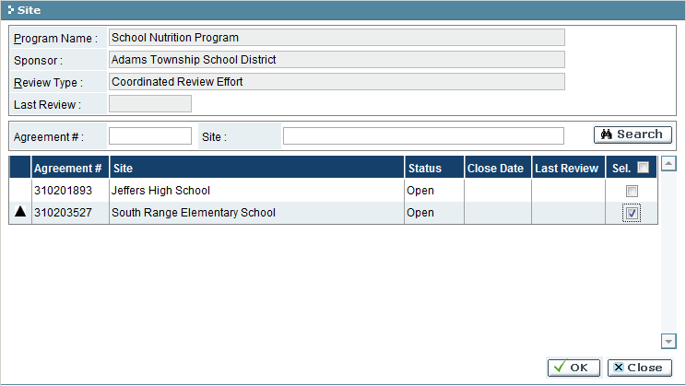

| Field Name | Description |
| --- | --- |
| Agreement #/Code | Unique code related to the building/site |
| Building/Site | Building/site(s) that are a child to the sub-recipient/sponsor |
| Status | Status of the building/site |
| Close Date | Close date |
| Last Review | Date of the last review performed for building/site |
| Sel. | Checkmark in the box signifies the building/site will be added to scheduling |

* 1. Click the building  icon to open the Site window.
  2. Use the search feature to limit the number of sites/buildings displayed, if necessary.
  3. Place a checkmark in Sel. column to create an additional review record for the building/site(s)
  4. Click ‘OK’ to accept the changes (‘Close’ will discard changes) and return to Setup screen.
     1. A confirmation message will appear if the changes were accepted by the system. Click ‘OK’ to close message.

*Add Documents*

Pre-defined documents can be added to a sub-recipient’s/sponsor’s review, or new (ad-hoc) documents can be added.

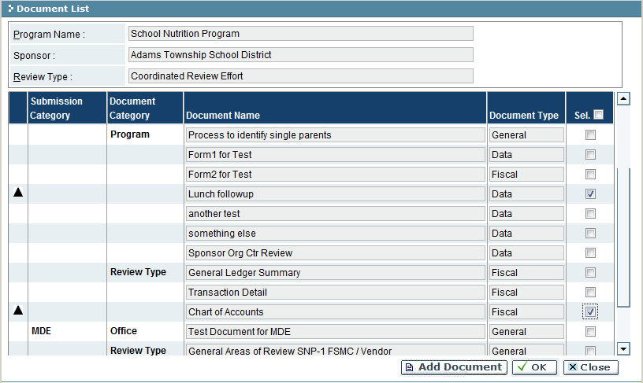

| Field Name | Description |
| --- | --- |
| Submission Category | Submission category of the document (Sub-Recipient/Sponsor, MDE, etc.) |
| Document Category | Document category (Common/Program/Review Type/Office/Sub-Recipient/Sponsor) |
| Document Name | Name of the document |
| Document Type | Document type (General/Data/Fiscal/Program) |
| Sel. | Checkmark in the box signifies the building/site will be added to scheduling |

*Add pre-defined documents*

1. Locate the document to add
2. Place a checkmark in the box of the Sel. column for the document.
3. Click ‘OK’ button to accept changes (‘Close’ will discard changes) and return to Scheduling screen.

*Add a new (ad-hoc) document*

1. Click **ADD DOCUMENT** button, Add Sub-Recipient/Sponsor window opens.

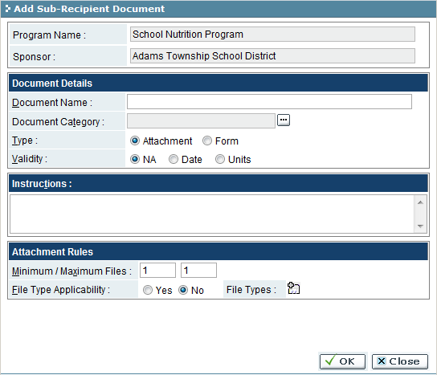

| Field Name | Action |
| --- | --- |
| Document Name | Enter a name for the document being added |
| Document Type | Select the category to be associated with the document from the look-up (General/Fiscal/Data/Program) |
| Validity   1. NA 2. Date 3. Unit | Select from the options of validity:   1. Not applicable 2. Enter the date in the format MM/DD/YYYY or select a date from the calendar 3. Enter the value, then select the corresponding radio button (Day/Month/Year) |
| Instructions | Enter any additional information that will be available accessible by sub-recipients |
| Minimum/Maximum Files | Enter the number of minimum and maximum files associated with the document |
| File Type Applicability | Select the restriction of file types on the document (Yes/No) |
| File Types   1. Sel. 2. Size Appl. 3. Max Size 4. Page Appl. 5. Pages Min/Max | If File Type Applicability = Yes, click the  button and select the types of files which can be submitted under this document and further restrictions:   1. Click the checkbox to include this file type 2. Restriction is set on the file size (Checked = Yes, Unchecked = No) 3. Enter the maximum file size allowed (if Size Appl. = Yes) 4. Restriction is set on the # of pages (Checked = Yes) (PDF only) 5. Enter the minimum and maximum number of pages allowed (PDF only) |

1. Fill out the applicable fields (as defined in the field table above).
2. Click OK button to add the document (CLOSE will discard changes) and return to the Document List window.
   * 1. A confirmation message will appear if the document was successfully added. Click ‘OK’ to accept message.
3. In the Document List window, the new document will appear under the Document Category “Sub-Recipient/Sponsor”.
4. Place a checkmark in the box of the Sel. column for the document.
5. Click ‘OK’ button to accept changes (‘Close’ will discard changes) and return to Scheduling screen.
   * 1. A confirmation message will appear if the changes were accepted by the system. Click ‘OK’ to close message

*Add Contacts*

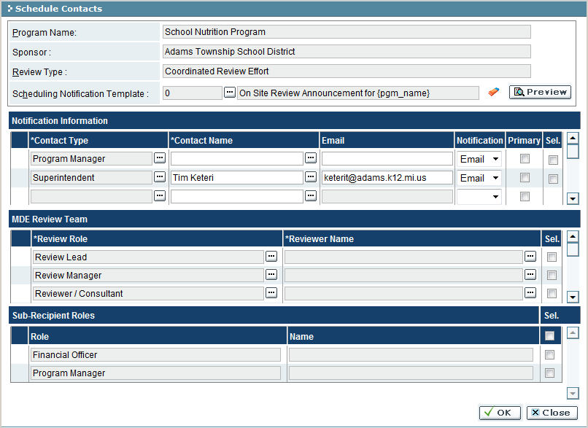

| Field Name | Description |
| --- | --- |
| Scheduling Notification Template | Select the desired template from the look-up. Use the ‘Preview’ button to view the notification template. |
| *Notification Information* | |
| Contact Type | Select contact type from the look-up (if contact type does not already exist for 1 record) (required field) |
| Contact Name | Select contact name from the look-up, or enter a new name to be added (required field if Contact Type is not null) |
| Email | Change the email, if necessary, or add a new email address if blank |
| Notification | Select the preferred type of notification from dropdown (Email/Letter/Both) |
| Primary | Check the box to indicate that the contact will be the primary contact on the notification (at least 1 contact must be selected as the primary contact) |
| Sel. | Place a checkmark into the box for contact to add as a notification contact. |
| *MDE Review Team* | |
| Review Role | Select review role from the look-up (if not role does not already exist) (Required: 1 Review Lead, 1 Review Manager) |
| Reviewer Name | Select the desired reviewer from the look-up (Required, if Review Role is not null) |
| Sel. | Place a checkmark into the box for contact to be assigned as reviewer |
| *Sub-Recipient/Sponsor Roles* | |
| Role | Sub-recipient/Sponsor contact role |
| Name | Person assigned to the contact role |
| Sel. | Place a checkmark into the box for the role that will be assigned as sub-recipient/sponsor contact |

1. Add contacts or modify contacts for each of the three sections of the window. (see field table above)
2. Click ‘OK’ button to save changes (‘Close’ button will discard changes) and return to Scheduling screen.
   * 1. A confirmation message will appear if the changes were accepted by system. Click ‘OK’ to close message.

*Add Review Dates*

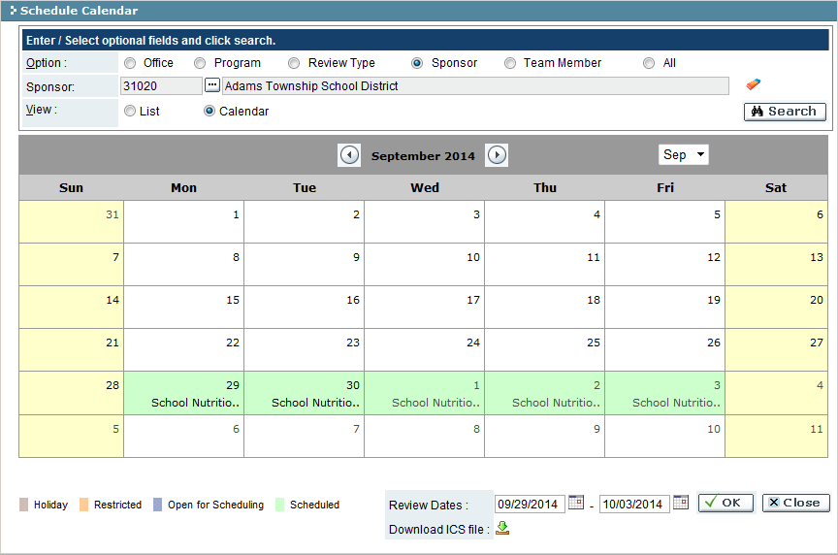

| Field Name | Description |
| --- | --- |
| Option | Viewing option for the calendar. Each option type is displayed color-coded |
| Sponsor | Sub-recipient/sponsor the calendar belongs to |
| View | Displays appointments in list or calendar format |
| Page Forward/Page Back icons | Use the icons to navigate a calendar month forward and backward |
| Month dropdown | Select the calendar month from drop-down instead of using paging icons |
| Review Dates | Start and end of the review date range (MM/DD/YYYY format) |
| Download ICS file | Icon will download an MS Outlook meeting notification |

1. Enter start and end dates in the Review Dates fields (mini calendar icons can be used to visually display dates to select).
2. Click the Download ICS File icon to create a meeting request (optional).
3. Click ‘OK’ button to accept changes (‘Close’ button will discard changes) and return to the Scheduling screen.
   * + - 1. A confirmation message will appear if the changes were accepted by the system. Click ‘OK’ to close message.
         2. On the Scheduling screen, the selected Review Dates will be populated.

*View Statistics*

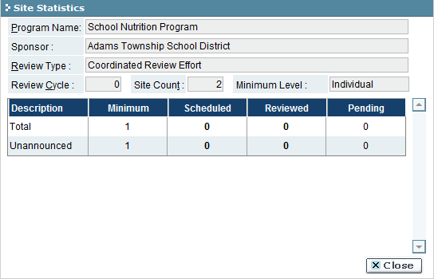

| Field Name | Description |
| --- | --- |
| Review Cycle | Review cycle for the sub-recipient/sponsor |
| Building/Site Count | Total number of buildings/sites for the sub-recipient/sponsor to be reviewed |
| Description | Description of the reviews (Total/Unannounced/Announced) |
| Minimum | Minimum number of reviews required for the sub-recipient/sponsor for the program review year |
| Scheduled | Number of reviews scheduled |
| Reviewed | Number of reviews completed |
| Pending | Number of reviews in pending status |

1. Click ‘Close’ button to close the window and return to Scheduling screen.

Follow up

In this mode, a follow up review may be set up. Follows are based on the findings of a completed review.

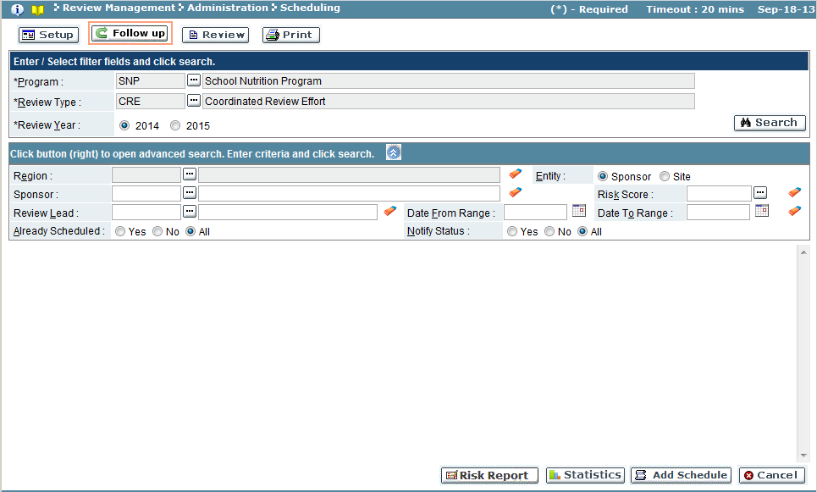

| Field Name | Action |
| --- | --- |
| Program | Select program from the look-up |
| Review Type | Select review type from the look-up |
| Review Year | Select review year |
| *Advanced Search Criteria*  To refine the search criteria, click the  button and follow the next steps | |
| Region | Select the region from the look-up |
| Entity | Select Sub-Recipient/Sponsor or Building/Site |
| Sub-Recipient/Sponsor | Select the sub-recipient/sponsor from the look-up |
| Risk Score | Select the risk score from the look-up |
| Review Lead | Select review lead |
| Date From/Date To | Select start and end dates for the review(s) |
| Already Scheduled | Select from Yes/No/All |
| Notify Status | Select from Yes/No/All |

1. Use the search feature to view the program.
2. If a sub-recipient/sponsor record is able to have a follow up added, a  will appear in the Follow Up column.

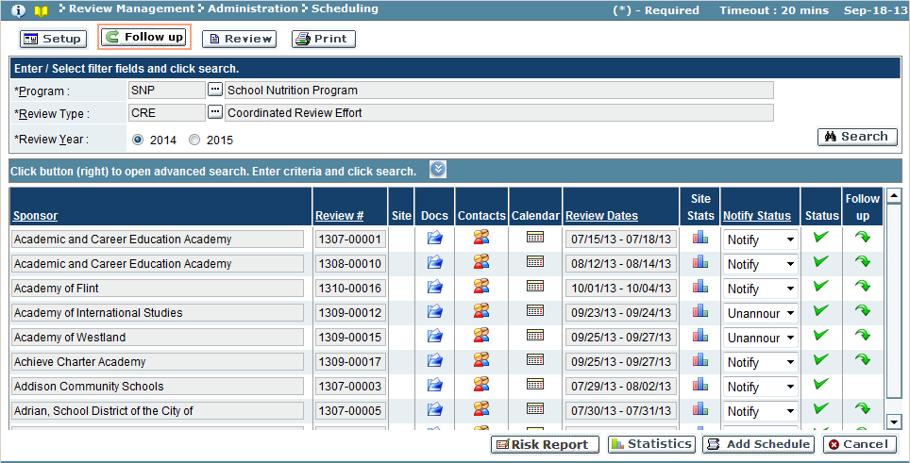

| Field Name | Description |
| --- | --- |
| Sub-Recipient/Sponsor | Sub-recipient/sponsor name |
| Review # | Review # assigned to sub-recipient/sponsor  *HINT: Hovering over a Review #, will give a comment regarding the status of review (Regular, Add Schedule, Follow-Up)* |
| Site | icon, if displayed will list all buildings/sites related to sub-recipient/sponsor for this program review year |
| Docs | icon will display all the documents related to the sub-recipient/sponsor for this program review year |
| Contacts | icon will display the sub-recipients/sponsor’s notification template, notification contacts, the review team members and sub-recipient/sponsor roles |
| Calendar | icon will display a color-coded calendar of various events, such as holidays, weekends, review dates, meetings |
| Review Dates | The range of dates in which the review will be conducted |
| Site Stats | The summary of scheduled and unannounced reviews, minimum number of reviews required, number scheduled, held and pending for the sub-recipient/sponsor for the program review year |
| Notify Status | Type of notification sent to the sub-recipient/sponsor for the program review year (Notify, notification sent / Unannounced, no notification sent / null, no reviews scheduled) |
| Status | Checkmark denotes the sub-recipient/sponsor was notified |
| Follow up | Arrow  denotes that a follow up review can be created |

1. To create a follow up review, click the green arrow  for the sub-recipient/sponsor.
2. The Follow Up window will appear:

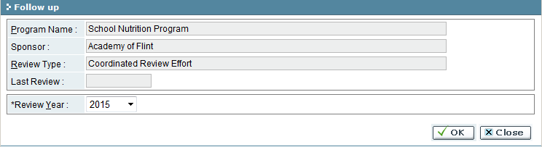

1. Select the Review Year from the drop down window.
2. Click the ‘OK’ button to save changes (‘Close’ button will discard changes).
   1. If the changes were accepted, a confirmation message will appear. Click ‘OK’ to close confirmation message.
3. On the Scheduling screen, the green arrow will be removed from the sub-recipient/sponsor record.
4. Change the Scheduling screen’s mode to Set up and follow the set up instructions to create the follow up review.

PRINT

In this mode, you can print (PDF or Excel) a list of sub-recipient scheduling information by year.

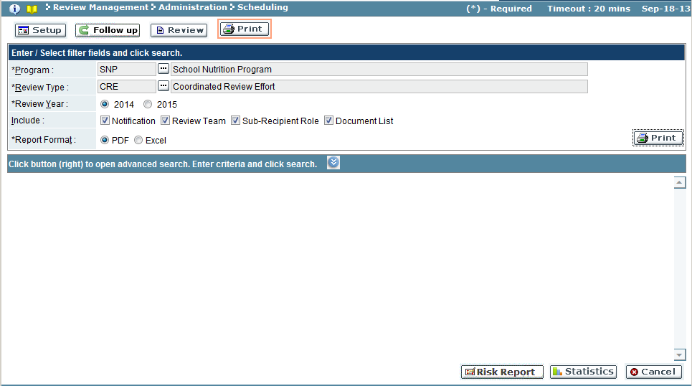

| Field Name | Action |
| --- | --- |
| Program | Select program from the look-up |
| Review Type | Select review type from the look-up |
| Review Year | Select review year |
| Include: | Click the checkboxes for each of the items to be included (Notification/Review Team/Sub-Recipient Role/Document List) |
| Report Format: | Select the desired output of the report (PDF/Excel) |

1. Click the ‘Print’ button.

Troubleshooting

| **#** | **Error** | **Description** | **Corrective Action** |
| --- | --- | --- | --- |
| 1 | Error Message: <Fieldname> cannot be empty | <Fieldname> is blank | The required fields are marked by asterisk *. Please enter / select value into the field and retry the operation. |

## Review

### OSR Agenda

The OSR Agenda refers to the schedule or outline of events which will take place during the on-site review. The OSR Agenda screen allows for uploading of an agenda, and sending a copy of the document to all individuals involved in the on-site review.

To access this functionality, navigate to the following menu:

**Review Management → Review → OSR Agenda**

This screen has the following functionality: Review, Upload.

|  |  |
| --- | --- |
| Predecessor | Submission |
| Who | MDE User |
| When | Review Process |
| Subsequent | Desk On Site Review |

Review

In this mode, you can view an attached OSR agenda, the date of the on-site review, as well as the notification list, including the names, roles, and e-mail addresses of the individuals taking part in the on-site review. You cannot make any changes in this mode.

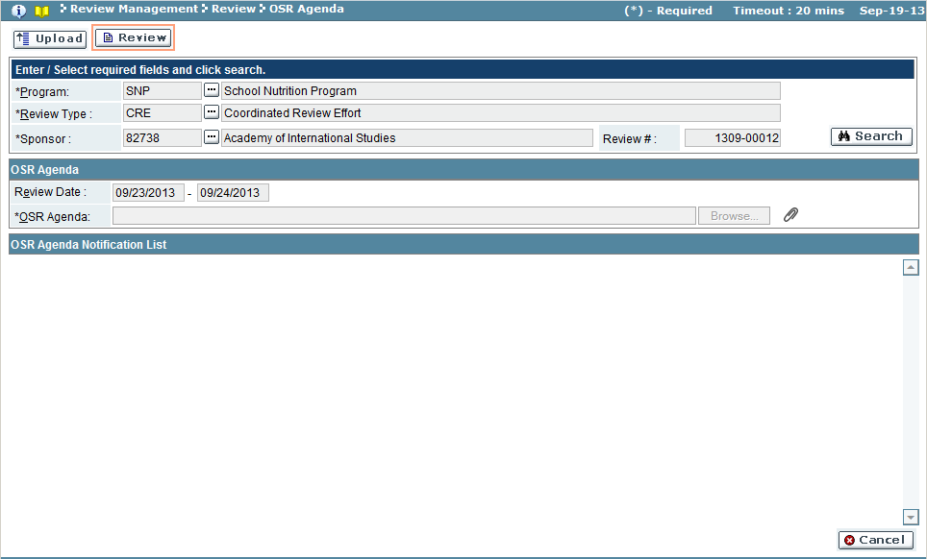

| Field Name | Action |
| --- | --- |
| Program | Select program from the look-up |
| Review Type | Select review type from the look-up |
| Sub-Recipient/Sponsor | Select sub-recipient/sponsor from the look-up |

1. Use the search feature to view the program.
2. The system will display the document(s) submitted as part of the OSR agenda, as well as a listing of individuals to be notified of the review.

Upload

In this mode, you can upload an on-site review agenda, as well as view the date of the on-site review, as well as the notification list, including the names, roles, and e-mail addresses of the individuals taking part in the on-site review.

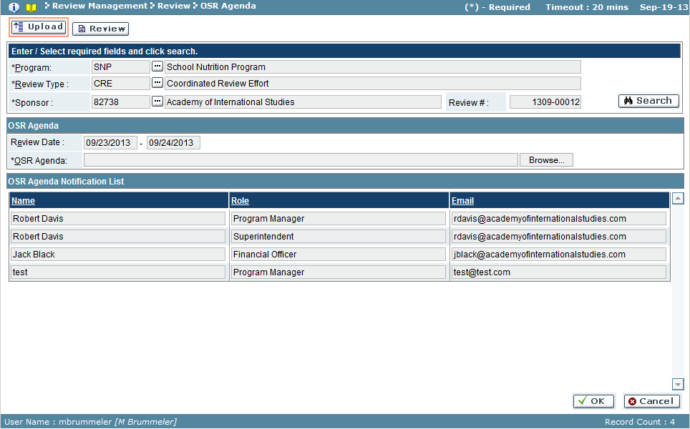

| Field Name | Description |
| --- | --- |
| *OSR Agenda Results Pane* | |
| Review Date | Date range of review |
| OSR Agenda | Agenda document to upload |
| *OSR Agenda Notification List Results Pane* | |
| Name | Site contact for sub-recipient/sponsor |
| Role | Contact role |
| Email | Email address for contact |

1. Use the search feature to view the sub-recipient/sponsor for the program review.
2. To upload an agenda, click the ‘Browse’ button in the OSR Agenda results pane.
3. The Choose a File to Upload browser window will appear.

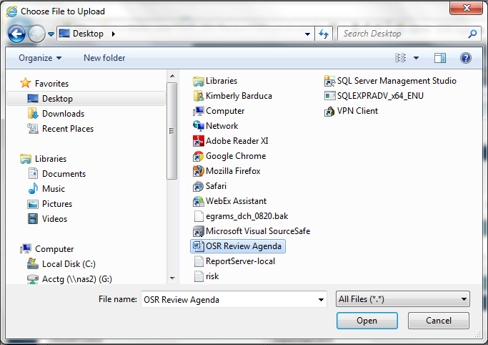

1. Navigate to the document to upload. Click ‘Open’ button to select the file (CANCEL will discard selection) and return to the OSR Agenda screen.
2. The filename will appear in the OSR Agenda field.

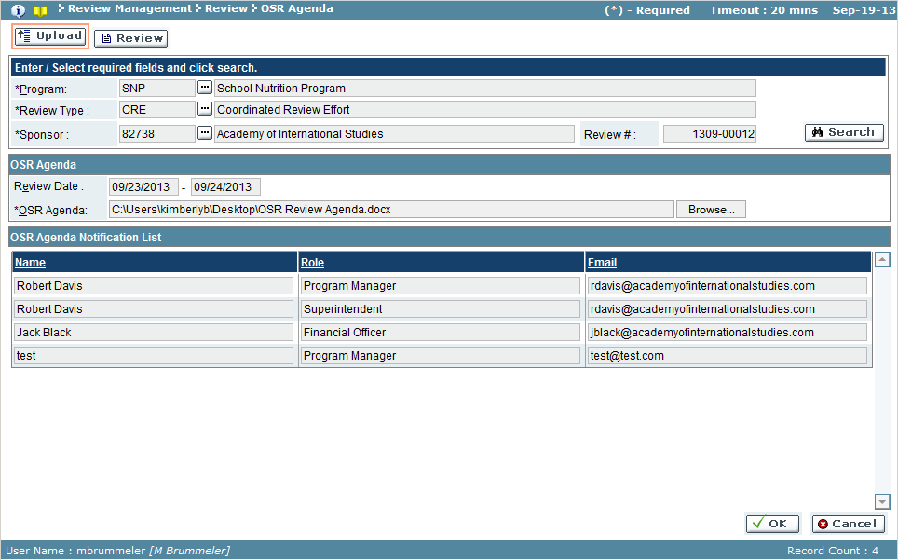

1. Click ‘OK’ to save the uploaded agenda (‘Cancel’ will discard change).
2. Once the system accepts the uploaded document, the document will appear as an attachment  icon in the OSR Agenda results pane.
   1. The delete **X** icon can be used to remove attachment, if necessary.

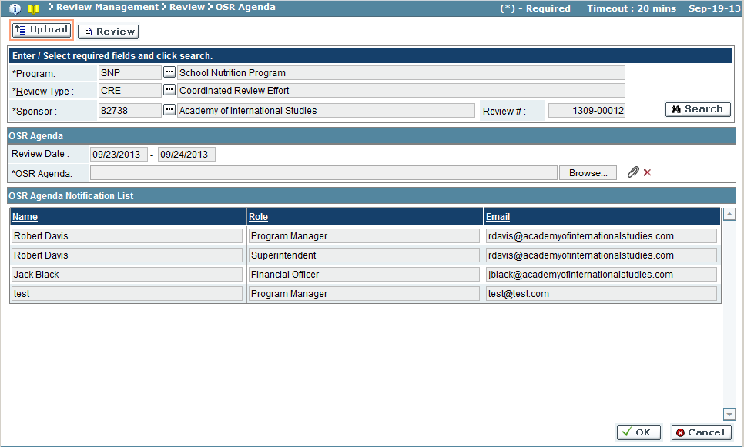

Troubleshooting

| **#** | **Error** | **Description** | **Corrective Action** |
| --- | --- | --- | --- |
| 1 | Error Message: <Fieldname> cannot be empty | <Fieldname> is blank | The required fields are marked by asterisk *. When one of these fields is not entered, the system prompts with the above error message. Please enter / select value into the field and retry the operation. |

### Assign Review Team

The review team is initially set-up during the Scheduling stage. In this screen, you can view and change the review team members and roles. The review team must consist of at least one individual assigned the Review Lead role.

To access this functionality, navigate to the following menu:

**Review Management → Review → Assign Review Team**

This screen has the following functionality: Admin, Setup and Review.

|  |  |
| --- | --- |
| Predecessor | Submission |
| Who | MDE User |
| When | Review Process |
| Subsequent | Desk/On-site Review |

Review

In this mode, you can view the review team information, including review role and reviewer name. You cannot make any changes in this mode.

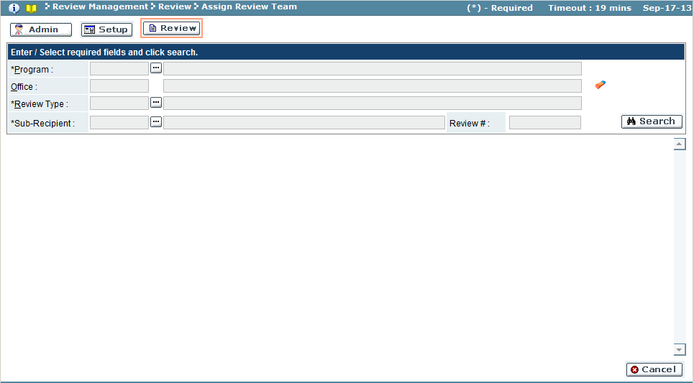

| Field Name | Action |
| --- | --- |
| Program | Select the program from the look-up (required field) |
| Office | *Defaulted value will populate |
| Review Type | Program’s review type (required field) |
| Sub-Recipient/Sponsor | Select the sub-recipient from the look-up (required field) |

1. Use the search feature to view the program.
2. The system will display the review team as defined in the Scheduling stage.

Setup

In this mode, a Review Lead can edit the review team, adding users and assigning review roles. The review team must consist of at least one individual with the Review Lead role. Only the individual assigned as Review Lead is able to access this mode.

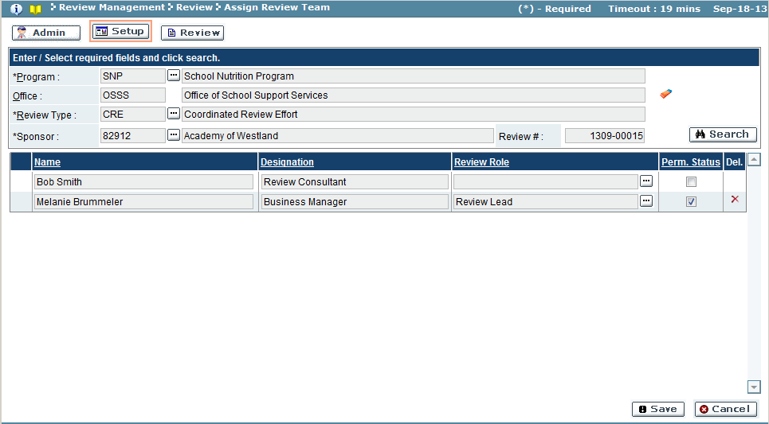

| Field Name | Description |
| --- | --- |
| Name | Reviewer name |
| Designation | Reviewer title |
| Review Role | Select review role from the look-up |
| Perm. Status | A check in the box signifies the reviewer has access to the review |
| Del | If the reviewer has been assigned a role, and the reviewer needs to be removed from the review team, click **X** to remove reviewer |

1. Use the search feature to locate the review team.
2. Identify the reviewers to assign to the sub-recipient/sponsor’s review team.
3. Select/change the Review Role for the reviewer.
4. Select/deselect the Perm Status for the reviewer.
5. Click the ‘Save’ button to accept the changes (‘Cancel’ button will discard changes).

Admin

In this mode, program administrators are able to modify the review teams. The functionality is the same as the Set up mode.

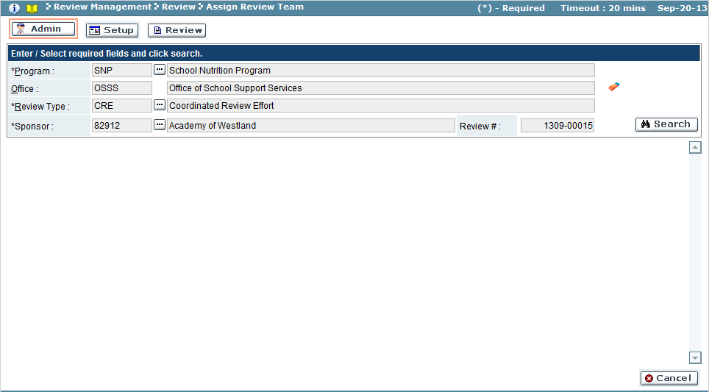

Troubleshooting

| **#** | **Error** | **Description** | **Corrective Action** |
| --- | --- | --- | --- |
| 1 | Error Message: <Fieldname> cannot be empty | <Fieldname> is blank | The required fields are marked by asterisk *. Please enter / select value into the field and retry the operation. |

### Desk/On-site Review

The Desk/On-site Review screen is utilized by all members of the review team with the Reviewer/Consultant and Review Lead roles to add comments and answer review criteria questions corresponding to the documents submitted by the sub-recipient.

To access this functionality, navigate to the following menu:

**Review Management → Review → Desk/On-site Review**

This screen has the following functionality: Setup and Review.

|  |  |
| --- | --- |
| Predecessor | Assign Review Team |
| Who | MDE User |
| When | Review Process |
| Subsequent | Review Consolidation |

Review

In this mode, you can view the documents uploaded by the sub-recipients along with related comments and document review statuses. You cannot make any changes in this mode.

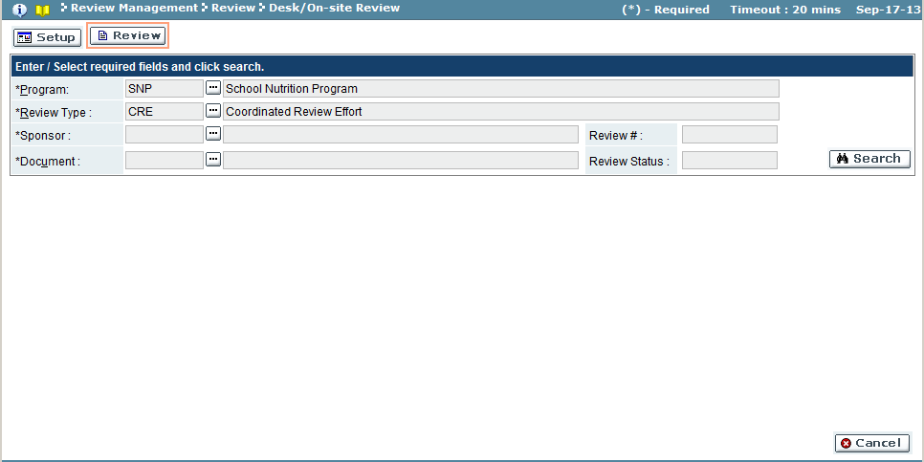

| Field Name | Action |
| --- | --- |
| Program | Select program from the look-up (required field) |
| Review Type | Select program’s review type from the look-up (required field) |
| Sub-Recipient/Sponsor | Select the sub-recipient/sponsor from the look-up (required field) |
| Document | Select the document from the look-up (required field)  NOTE: A sub-recipient/sponsor may have multiple documents |
| Review # | *populated when other search criteria is selected |
| Review Status | *populated when other search criteria is selected |

Setup

In this mode, each reviewer assigned to a sub-recipient’s/sponsor’s program review team will review documentation submitted, submit overall document comments, answer and comment on review criteria questions. The reviewer will review each document submitted for the sub-recipient/sponsor. Each document requires a document-level comment, and the document review status set to complete. A reviewer may also add overall review comments.

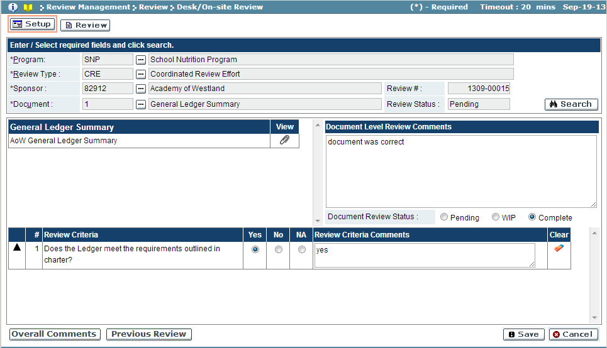

| Field Name | Description |
| --- | --- |
| *Top Left Results Pane* | |
| *Document | Document name (dynamically populated) |
| View | Link to view document |
| *Document Level Review Comments* | |
| Document Level Review Comments | Overall comments regarding the document (required) |
| Document Review Status | Status of document review (Pending/WIP/Complete) |
| *Review Criteria (optional)* | |
| # | Order of review criteria |
| Review Criteria | Review criteria for document |
| Yes | Populated button states the document reviewed meets review criteria |
| No | Populated button states the document reviewed does not meet review criteria |
| NA | Populated button states the review criteria is not applicable for the document reviewed |
| Review Criteria Comments | Reviewer’s comments regarding the document’s review criteria |
| Clear | Removes the review criteria comments (if Review Criteria Comments field is not null) |

1. Use the search feature to view the sub-recipient/sponsor’s documentation.
2. Click on the document attachment icon  to download and review.
3. Make Document Level Comments as appropriate (required).
4. Answer any Review Criteria (if exists). Insert comments related to review criteria, as appropriate.
5. Set the Document Review Status.
6. Click ’Save’ button to commit the review (‘Cancel’ will discard changes).

**OVERALL COMMENTS** buttonwill allow a reviewer to submit a comment for the entire sub-recipient/sponsor’s review. Overall comments can also be searched, using the search function in the window. The window will display the total number of comments.

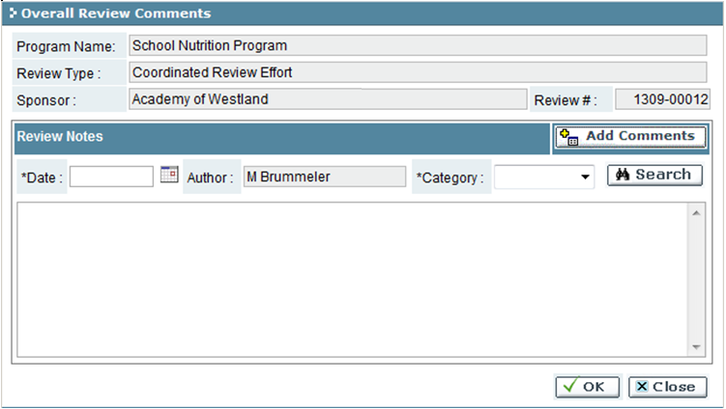

*Add an Overall Review Comment*

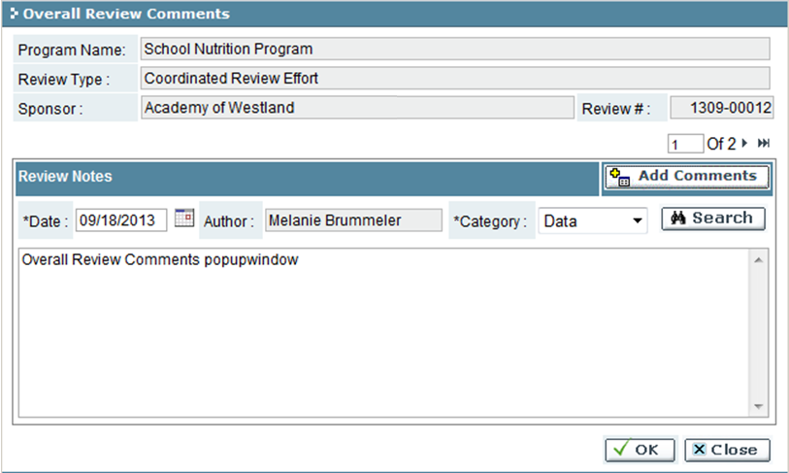

* + 1. Click the ‘Add Comments’ button.
    2. Enter the date, select a category and enter a comment.
    3. Click the ‘OK’ button to save the comment (‘Close’ button will discard changes)

‘Previous Review’ button will display any reviews performed earlier for the sub-recipient/sponsor. Use the search feature to retrieve any previous reviews.

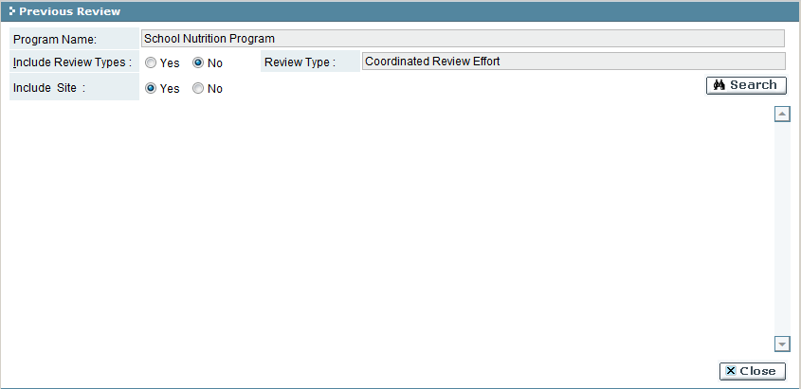

Troubleshooting

| **#** | **Error** | **Description** | **Corrective Action** |
| --- | --- | --- | --- |
| 1 | Error Message: <Fieldname> cannot be empty | <Fieldname> is blank | The required fields are marked by asterisk *. When one of these fields is not entered, the system prompts with the above error message. Please enter / select value into the field and retry the operation. |

### Team Document Status

The Team Document Status screen is used to query the status of a sub-recipient/sponsor in the review process. This screen displays the review team, list of documents assigned as part of the review, and status of each document review as broken down by reviewer. When a team review is complete, the Review Lead can promote the review to the next stage.

To access this functionality, navigate to the following menu:

**Review Management → Review → Team Document Status**

This screen has the following functionality: Review, Setup.

|  |  |
| --- | --- |
| Predecessor | Desk / Onsite Review |
| Who | Review Lead |
| When | After desk / onsite review of all documents is complete |
| Subsequent | Review Consolidation or Assign Findings |

Review

In this mode, you can view the breakdown of reviewers’ status on documents as part of the review. Additionally, you can view any comments reviewers have made as part of the review. You cannot make any changes in this mode.

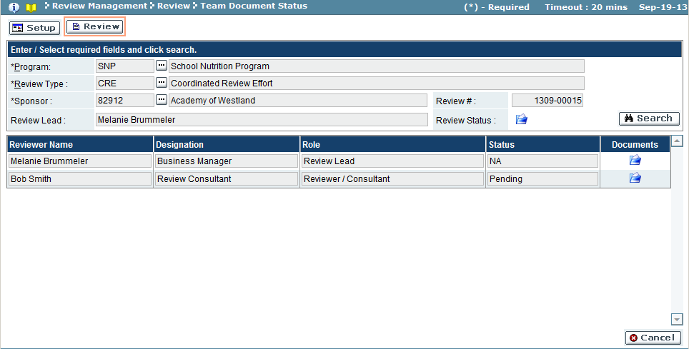

| Field Name | Action |
| --- | --- |
| Program | Select program from the look-up (required field) |
| Review Type | Select review type from the look-up (required field) |
| Sub-Recipient/Sponsor | Select the sub-recipient/sponsor from the look-up (required field) |
| Review Lead | Select the region from the look-up |
| Review # | *auto populated when sub-recipient/sponsor selected |

1. Use the search feature to view the sub-recipient/sponsor’s reviews.
2. The system will display the team review status information for the sub-recipient/sponsor.
3. The Team Documents Status  icon located in the search pane will display a matrix showing the status of each document and the document status for each reviewer.
4. The Team Documents Individual Status  icon (located in the results pane) in the row of the reviewer will display the reviewer’s status of each document, and the related document comment(s).

*Team Document Status window*

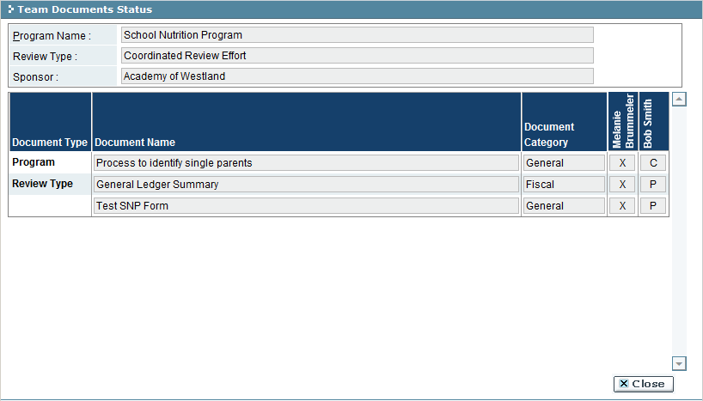

| Field Name | Description |
| --- | --- |
| Document Type | Document type |
| Document Name | Document name |
| Document Category | Document category |
| *Reviewer name(s) & document status | *column name will be auto populated for each reviewer assigned to the sub-recipient/sponsor’s program review. The reviewer’s document status is populated in the document row.  (C-Complete/P-Pending/W-Work in Progress/X-not available) |

*Team Documents Individual Status* 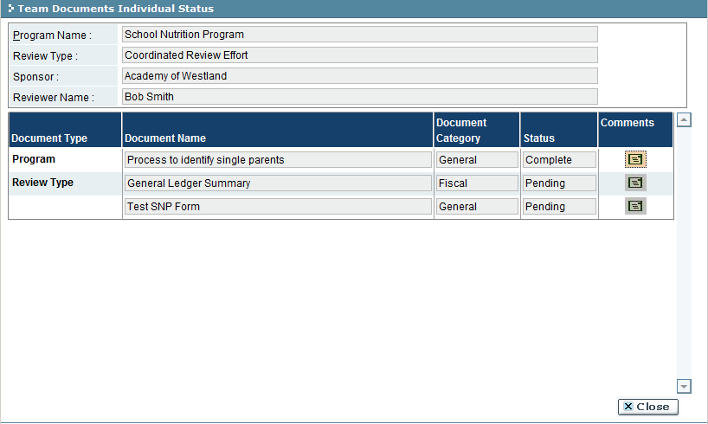

|  |  |
| --- | --- |
| Field Name | Description |
| Document Type | Document type |
| Document Name | Document name |
| Document Category | Document category |
| Status | Document status |
| Comments | When comment icon  is yellow, click link to view comment |

Setup

In this mode, the Review Lead is able to mark the review process as complete in order to promote the sub-recipient/sponsor’s program review to Review Consolidation.

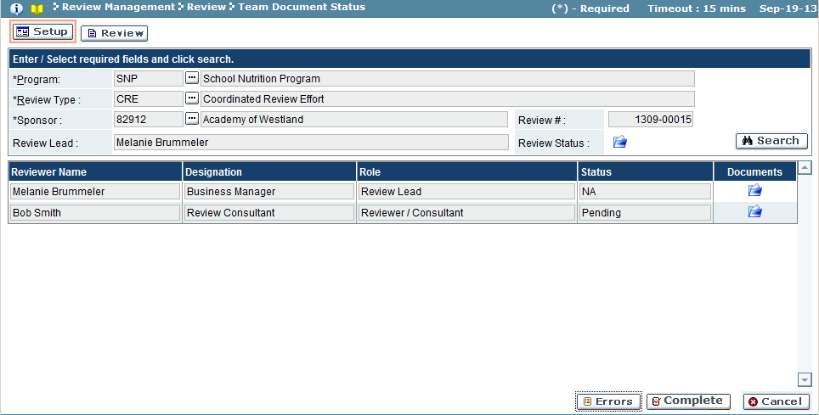

1. Use the search feature to view the sub-recipient/sponsor’s reviews.
2. Use the Team Document Review  icon (located in the search pane) to verify all sub-recipient/sponsor documents have been marked as Complete by at least one member of Review Team.
3. Click the ‘Complete’ button to promote the review (‘Cancel’ button will discard promotion).
   1. The system will perform run an error check before promotion.
   2. A message window will appear confirming validation will be performed. Click ‘OK’ button to run validation check (‘Cancel’ button will not save changes).

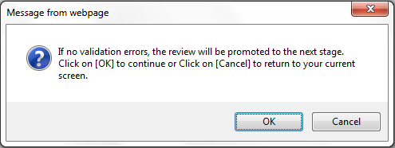

* 1. If the validation finds an error:
     1. A message window will appear. Click ‘OK’ button to close message window and return to the Team Document Status screen.

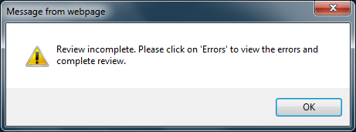

* + 1. Click the ‘Errors’ button to view the Errors and Warnings window.

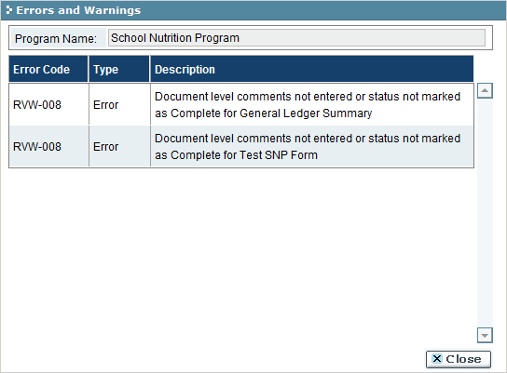

* + 1. Use the error messages to contact the reviewer with errors and correct.
    2. Ensure one member of the Review Team completes the missing information before repeating steps 1-3 again.
  1. If the validation is complete and error free:

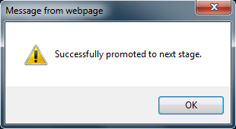

Troubleshooting

| **#** | **Error** | **Description** | **Corrective Action** |
| --- | --- | --- | --- |
| 1 | Error Message: <Fieldname> cannot be empty | <Fieldname> is blank | The required fields are marked by asterisk *. When one of these fields is not entered, the system prompts with the above error message. Please enter / select value into the field and retry the operation. |

### Review Consolidation

The Review Consolidation screen is utilized by the Review Lead of a review team consisting of multiple reviewers. The Review Lead is able to view all team members’ comments (including the questions and answers known as Review Criteria), and prepare a final observation for each document as part of the review.

To access this functionality, navigate to the following menu:

**Review Management → Review → Review Consolidation**

|  |  |
| --- | --- |
| Predecessor | Desk/On-site Review, Offline Review |
| Who | MDE User |
| When | Review Process |
| Subsequent | Assign Findings Team |

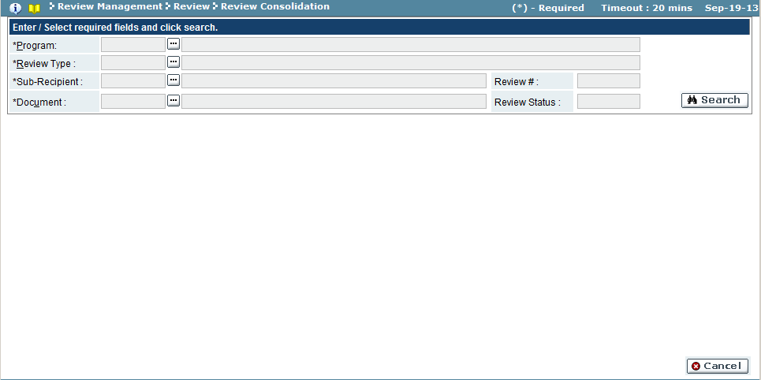

| Field Name | Action |
| --- | --- |
| Program | Select program from the look-up |
| Review Type | Select review type from the look-up |
| Sub-Recipient/Sponsor | Select the sub-recipient/building from the look-up |
| Document | Select the document from the look-up |

1. Use the search feature to view the sub-recipient/sponsor’s review document. Each document for the sub-recipient/sponsor must be individually reviewed before the entire review for the sub-recipient/sponsor will be consolidated.
2. The document’s information will be displayed.

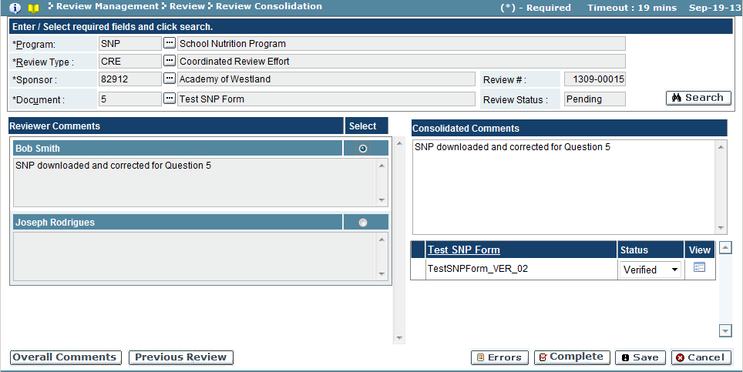

| Field Name | Description |
| --- | --- |
| Reviewer Comments | Each reviewer’s comments will be displayed. Use the radio button to select one of the reviewer’s comments to be added as the Consolidated Comment. (Optional) |
| Consolidated Comments | Enter the final comments pertaining to the document (may have been selected from the Reviewer Comments results section) |
| Document Status | Select the status of the document consolidation from the dropdown (Pending/Verified/Complete).  Use the attachment  or icon to download and view document. |

‘Overall Comments’ button will display any reviewer’s overall review comments.

‘Previous Review’ button will display any previous review for the sub-recipient/sponsor’s program.

1. Once the document’s review consolidation is considered complete, and the Document Status is set to Complete/Verified, click the ‘Save’ button to save the document changes.
2. Once *all* documents have been reviewed for the sub-recipient/sponsor, click the ‘Complete’ to finalize the review consolidation.
3. A system message will appear, confirming that a validation will be run on the review before the consolidation be completed.

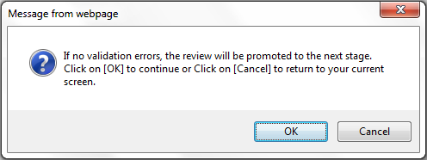

1. Click ‘OK’ button to allow the validation to run (‘Cancel’ will discard validation and return to Review Consolidation screen).
   1. If the validation locates any errors, a system message will appear:

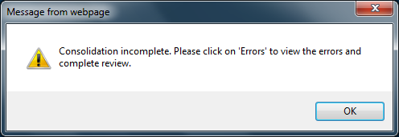

* + 1. Click ‘OK’ button to close the system message
    2. Click the ‘Errors’ button to review the corrections to make.

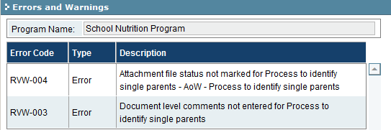

* + 1. Make the appropriate corrections and return to step 4 to complete the consolidation process.
  1. If the validation was error-free, the system message will acknowledge that the consolidation was completed and review promoted to the next stage.

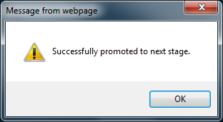

* + 1. Click ‘OK’ to close the system message.

Troubleshooting

| **#** | **Error** | **Description** | **Corrective Action** |
| --- | --- | --- | --- |
| 1 | Error Message: <Fieldname> cannot be empty | <Fieldname> is blank | The required fields are marked by asterisk *. When one of these fields is not entered, the system prompts with the above error message. Please enter / select value into the field and retry the operation. |

### Submit Documents

This screen allows documents to be submitted by MDE Users. This screen can only be accessed once the document list has been established and the review has been scheduled. This function is performed in the same manner as when submitted by the sub-recipient/sponsor. Files submitted on this screen can be either electronically added or noted as received as a hard copy.

To access this functionality, navigate to the following menu:

**Review Management → Review → Submit Documents**

This screen has the following functionality: Upload and Review.

|  |  |
| --- | --- |
| Predecessor | Submit Documents (by Sub-Recipient/Sponsor) |
| Who | MDE User |
| When | Review Process |
| Subsequent | Desk/On-Site Review |

Review

In this mode, you can view all the documents uploaded. No changes can be made in this mode.

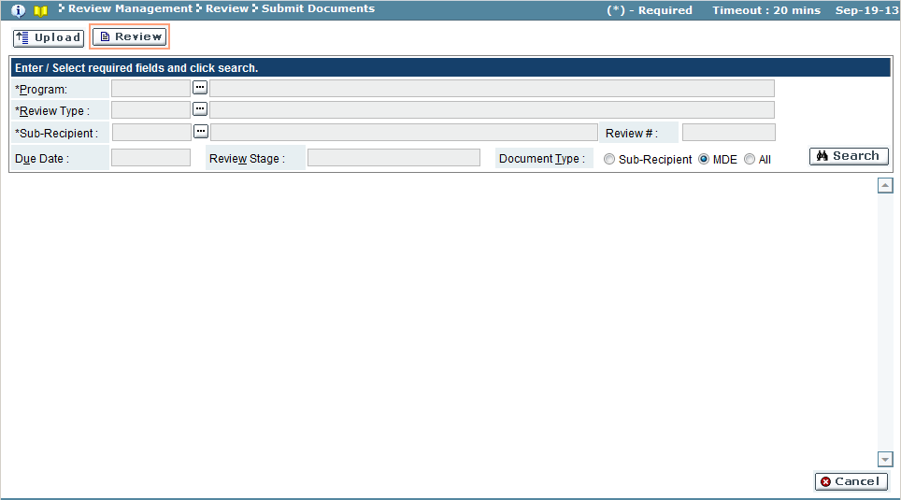

| Field Name | Action |
| --- | --- |
| Program | Select the program from the look-up (required field) |
| Review Type | Select the review type from the look-up (required field) |
| Sub-Recipient/Sponsor | Select the sub-recipient/sponsor from the look-up (required field) |
| Document Type | Select the document type (Sub-Recipient/MDE/All) (required field) |
| Review # | *auto populated once sub-recipient/sponsor is selected |
| Due Date | *auto populated once the sub-recipient/sponsor is selected |
| Review Stage | *auto populated once the sub-recipient/sponsor is selected |

1. Use the search feature to view the sub-recipient/sponsor’s review document.
2. Click the View Attachment  or  to view the attachment/form. Documents with a Hard Copy  icon were submitted as hard copies.

Upload

In this mode, you can upload electronic copies of documents. This option is used when either (a) the sub-recipient/sponsor is unable to upload a document or (b) MDE wishes to upload a document not specifically requested of the sub-recipient/sponsor but used in the review.

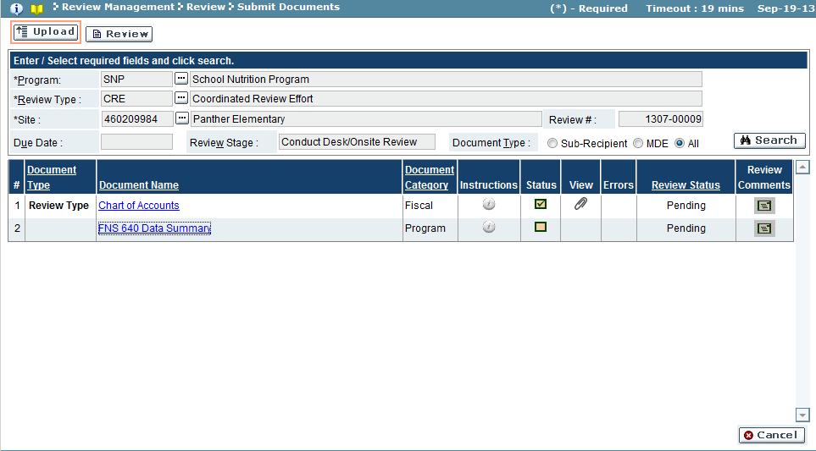

| Field Name | Description |
| --- | --- |
| # | Serial number of the document displayed |
| Document Type | Document Type |
| Document Name | Document Name (hyperlink to submit attachments) |
| Document Category | Document Category |
| Instruction | Click icon to view the instructions for the document |
| Status | Document status |
| View | If  or  exists, clicking icon will open the attachment or form |
| Errors | If error  icon exists, clicking icon will display the errors associated with the document/form |
| Review Status | Review status of the document |
| Review Comments | If comment  icon is yellow, clicking icon will open review comments |

1. Use the search feature to view the sub-recipient/sponsor’s review document.
2. To upload an attachment for the document, click on the name of the document to open the Attachments window.

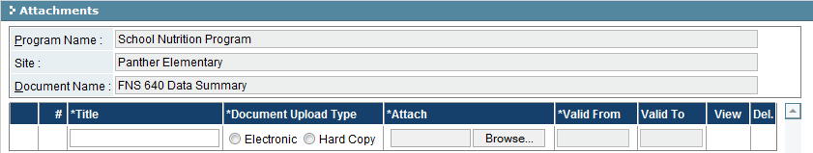

| Field Name | Description |
| --- | --- |
| Title | Enter the title of the document being uploaded |
| Document Upload Type | Select the appropriate option (Electronic/Hard Copy) |
| Attach | Click the ‘Browse’ button to select a file to be uploaded, if the above selected is ‘Electronic’ |
| Del | Click on the delete **X** icon to mark the record for deletion |

* 1. Enter information for the attachment, and use ‘Browse’ button to upload a document.
  2. Once complete, click ‘OK’ button to save attachment (’Cancel’ button will discard attachment) and return to Submit Documents screen.
     1. Repeat attachment process for each document to upload as necessary.

1. To enter information into a form, click the form  icon. The screen will display the form.

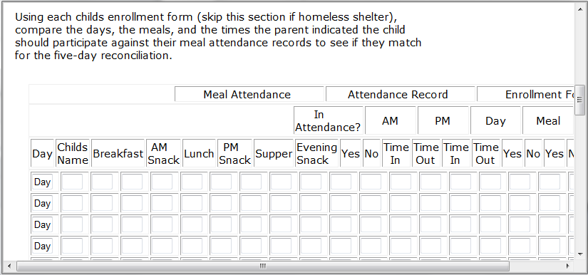

* 1. Enter data manually into the form, or use the form upload function to upload the related document in order to auto-populate the data.
  2. Click ‘Save’ button to commit the data entry (or uploaded form).
     1. Repeat step 3 for each document that has the form  icon.

1. Once document uploads or form entry is complete, click the ‘Validate’ button to check for errors.

* An error check will be performed against the Document List as well as the Review Team contacts. Click the ‘Errors’ button to view the list of items needing to be addressed prior to validation.

1. When all documents have been uploaded, marked as hard copy or forms entered, click the ‘Submit’ button to submit the documents for review (‘Cancel’ button will discard the changes).

Troubleshooting

| **#** | **Error** | **Description** | **Corrective Action** |
| --- | --- | --- | --- |
| 1 | Error Message: <Fieldname> cannot be empty | <Fieldname> is blank | The required fields are marked by asterisk *. When one of these fields is not entered, the system prompts with the above error message. Please enter / select value into the field and retry the operation. |

### Offline Package

The Offline Package screen is used to process document reviews locally on your PC when an internet connection is not available. Users can download an Excel file containing all the review information for the selected document(s) complete the review offline. When an internet connection is restored, the review information can be uploaded into the system.

To access this functionality, navigate to the following menu:

**Review Management → Review → Offline Package**

This screen has the following functionality: Upload and Download.

|  |  |
| --- | --- |
| Predecessor | Submission |
| Who | MDE User |
| When | Review Process |
| Subsequent |  |

Download

In this mode, you can download a package of files, including review criteria and documents uploaded by the sub-recipient.

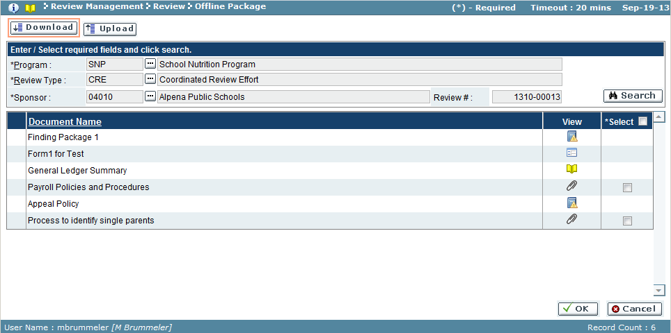

| Field Name | Action |
| --- | --- |
| Program | Select program from the look-up |
| Review Type | Select review type from the look-up |
| Sub-Recipient/Sponsor | Select sub-recipient/sponsor from the look-up |

1. Use the search feature to view the sub-recipient/sponsor’s review documents.
2. The system displays the list of documents.
3. Depending on the type of document, the View Document icons differ. Only documents with a checkbox in the Select column can be downloaded.
4. Place a check into box of the Select column for the document to download.
5. When all desired documents have been selected, click the ‘OK’ button.
   1. Depending on your browser settings, save the document as necessary.
6. Locate the downloaded file on your PC, and open the Excel document. Each document type (e.g. General, Program, etc.) will have a separate worksheet – or tab – at the bottom of the page.

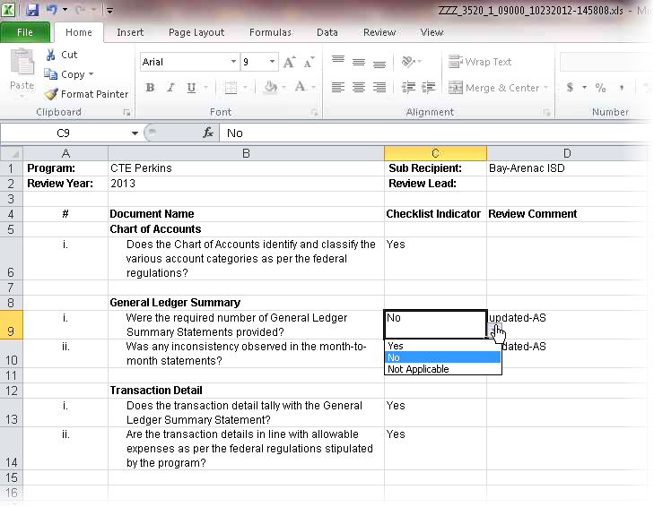

1. You can make the following changes:

| Field Name | Description |
| --- | --- |
| Checklist Indicator | Click on the corresponding cell and select the answer to the review criteria questions (Yes/No/Not Applicable) from the dropdown |
| Review Comment | Enter any additional comments if the status above selected is ‘No’ or ‘NA’ |

1. When the review is complete, save the Excel document for when an internet connection is restored.

Upload

In this mode, you can upload the offline file to be included as part of the review process. Changes made to a document review in the offline review will be overwritten when the package is uploaded.

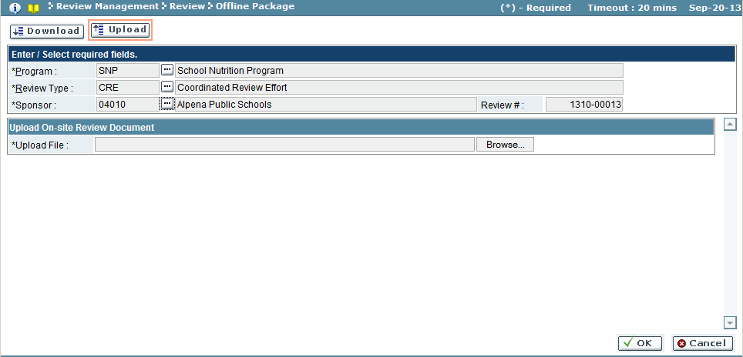

* 1. Use the search feature to view the sub-recipient/sponsor’s review documents.
  2. Click the ‘Browse’ button and use the File Directory window to navigate to the offline Excel document on your PC and upload it to the site.
  3. All responses to the review criteria and all comments made in the offline file will now be added to the document(s) on the Desk/On-Site Review screen.

Troubleshooting

| **#** | **Error** | **Description** | **Corrective Action** |
| --- | --- | --- | --- |
| 1 | Error Message: <Fieldname> cannot be empty | <Fieldname> is blank | The required fields are marked by asterisk *. When one of these fields is not entered, the system prompts with the above error message. Please enter / select value into the field and retry the operation. |

### Monitoring Stage Status

The Monitoring Stage Status screen is used to view (or print) the status of a sub-recipient/sponsor in the review process, or to search for a list of sub-recipient/sponsor in a given stage of review. The status log can also be used to view the start and end dates of the individual stages in the review as well as the user who completed each stage of the review.

To access this functionality, navigate to the following menu:

**Review Management → Review → Monitoring Stage Status**

|  |  |
| --- | --- |
| Predecessor |  |
| Who | MDE User |
| When | Review Process |
| Subsequent |  |

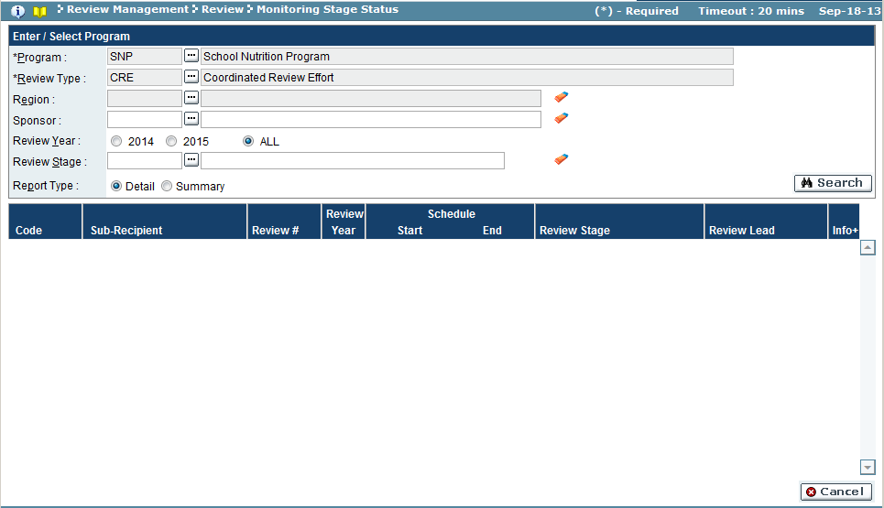

| Field Name | Action |
| --- | --- |
| Program | Select program from the look-up |
| Review Type | Select review type from the look-up |
| Region | Select region from the look-up |
| Sub-Recipient/Sponsor | Select sub-recipient/sponsor from the look-up (wildcard % feature also available to enter a partial field value or code to search) |
| Review Year | Select the year of the assigned review, or select ALL |
| Review Stage | Select review stage from the look-up (wildcard % feature also available to enter a partial field value or code to search) |
| Report Type | Select the type of report (Detail/Summary) |

1. Use the search feature to search records.
2. Sub-recipients/sponsor records will appear based on search criteria.
3. If Review Type = Detail, the records displayed will have a  on the far right. Click icon to display the individual stages of the review process, along with start and end dates and the name of the individual who completed each stage. Click the  icon to hide the detailed information.
4. Click the ‘Print’ button to print a copy of the screen (‘Cancel’ button to ignore).

 *Detail view*

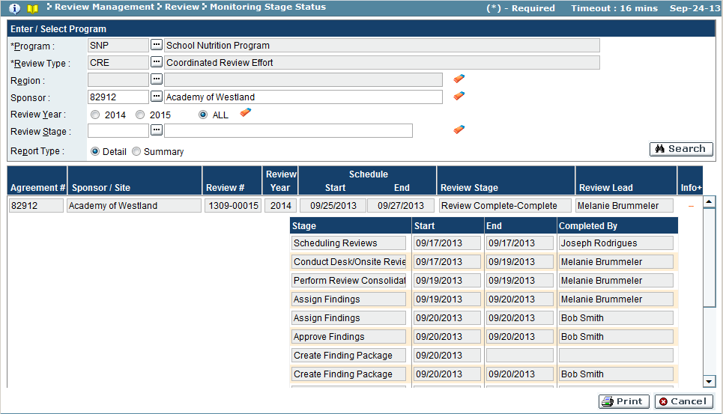

*Summary view*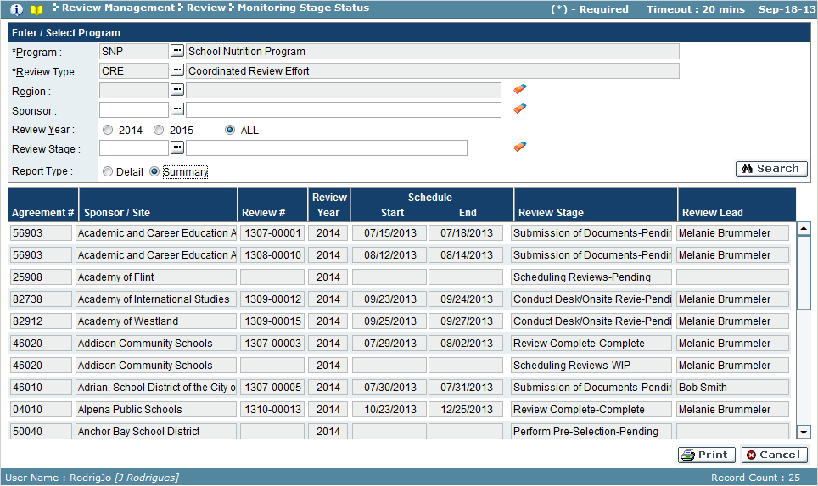

Troubleshooting

| **#** | **Error** | **Description** | **Corrective Action** |
| --- | --- | --- | --- |
| 1 | Error Message: <Fieldname> cannot be empty | <Fieldname> is blank | The required fields are marked by asterisk *. When one of these fields is not entered, the system prompts with the above error message. Please enter / select value into the field and retry the operation. |

### Search Documents

Within the Search Documents screen, users are able to query all the attachments which have been uploaded to the GEMS. On this screen, users can query by sub-recipient, document name, and other criteria in order to locate a document added to the GEMS.

To access this functionality, navigate to the following menu:

**Review Management → Review → Search Documents**

|  |  |
| --- | --- |
| Predecessor |  |
| Who | MDE |
| When | As Needed |
| Subsequent |  |

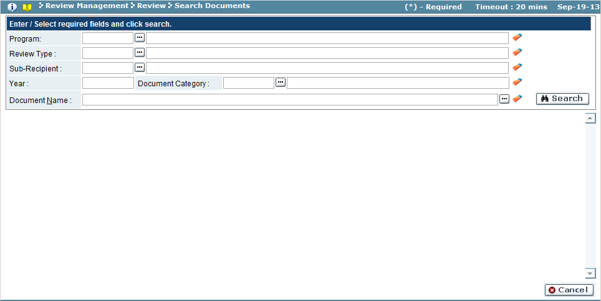

| Field Name | Action |
| --- | --- |
| Program | Select the program from the look-up |
| Review Type | Select the review type form the look-up |
| Sub-Recipient/Sponsor | Select the sub-recipient/sponsor from the look-up |
| Year | Enter the year for the document(s) |
| Document Category | Select the document category from the look-up |
| Document Name | Select the document name from the look-up |

1. Use the search feature to view the sub-recipient/sponsor’s review document. (Each search feature also uses the wildcard % feature to enter a partial field value or code to search)
2. The system will display the all documents related to the search criteria.

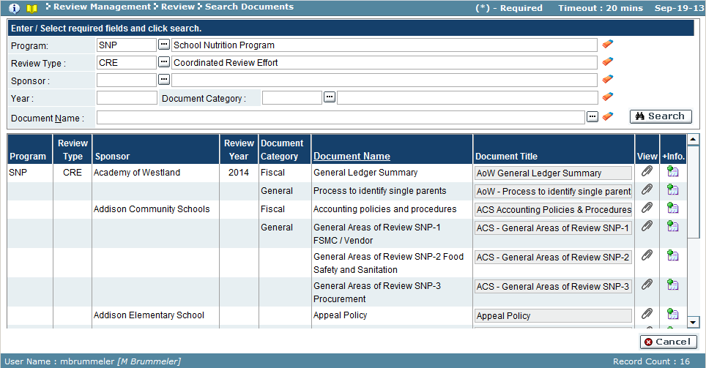

1. Click on the View Attachment  icon to view the document.
2. Click on the Additional Info  icon to view any additional information attached to the document.

Troubleshooting

| **#** | **Error** | **Description** | **Corrective Action** |
| --- | --- | --- | --- |
| 1 | Error Message: <Fieldname> cannot be empty | <Fieldname> is blank | The required fields are marked by asterisk *. When one of these fields is not entered, the system prompts with the above error message. Please enter / select value into the field and retry the operation. |

## Report

### Assign Findings Team

The findings team is initially set-up during the Scheduling stage. In this screen, you can view and change the findings team members and roles. The findings team must consist of at least one individual assigned the Review Manager role.

To access this functionality, navigate to the following menu:

**Review Management → Report → Assign Findings Team**

This screen has the following functionality: Admin, Setup and Review.

|  |  |
| --- | --- |
| Predecessor | Review (Desk On site Review or Review Consolidation) |
| Who | MDE User |
| When | Review Process |
| Subsequent | Assign Findings |

Review

In this mode, you can view the findings team information, including designation, findings role, and reviewer name. You cannot make any changes in this mode.

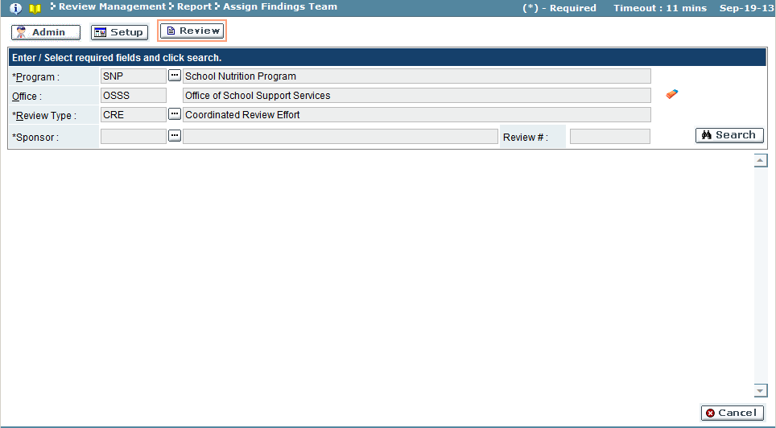

| Field Name | Action |
| --- | --- |
| Program | Select the program from the look-up |
| Office | *auto populated as program is selected |
| Review Type | Select the review type from the look-up |
| Sub-Recipient/Sponsor | Select the sub-recipient/sponsor from the look-up |

1. Use the search feature to view the sub-recipient/sponsor’s review document.
2. The system will display the findings team as defined in the Scheduling stage.

Setup

In this mode, only the user with the Review Lead role can edit the findings team, adding users and assigning findings roles. The review team must consist of at least one individual with the Review Lead role. Only the user with the Review Lead role will have access to this mode.

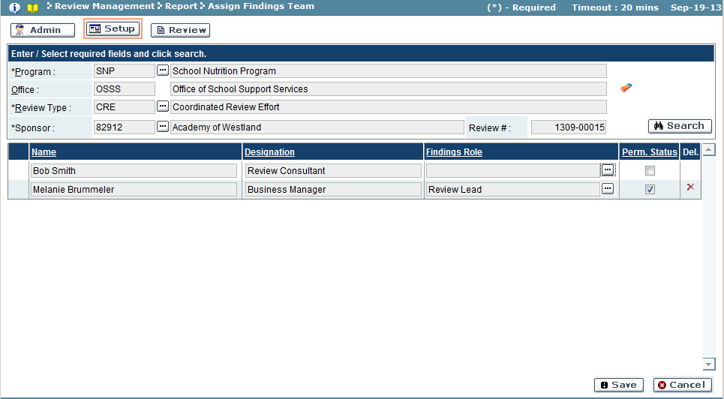

| Field Name | Description |
| --- | --- |
| Name | User |
| Designation | Designation/Title of user |
| Findings Role | Select the review role from the look-up |
| Perm. Status | A checkmark signifies the user is active |
| Del | If the delete **X** icon exists, the icon can be used to remove the user from the findings team |

1. Use the search feature to view the sub-recipient/sponsor’s review document.
2. The system will display the findings team as defined in the Scheduling stage.
3. Select a Findings Role for the user. Use the Perm Status field to mark the user active.
4. To commit the changes, click the ’Save’ button (‘Cancel’ button will discard the changes).

Admin

In this mode, only the user with the program administration role is able to edit the findings team, adding users and assigning findings roles. This mode functions the same as the Setup mode.

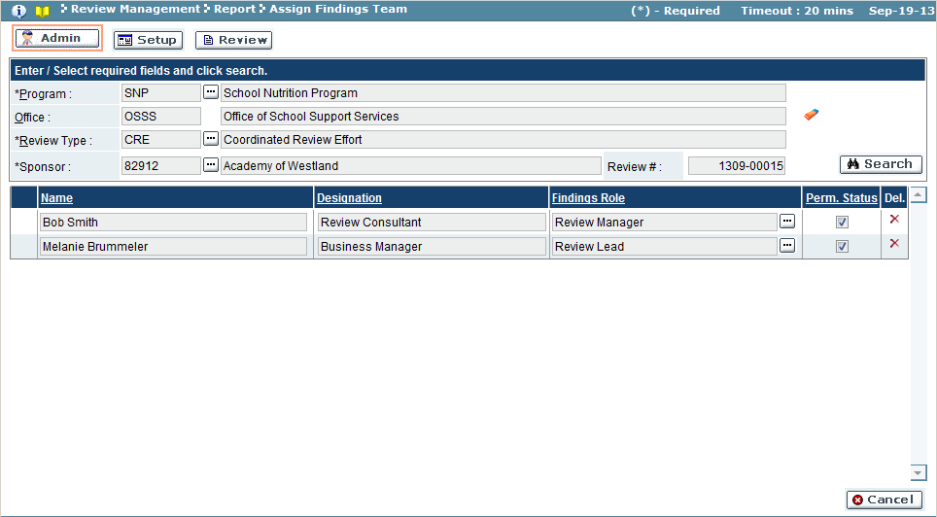

Troubleshooting

| **#** | **Error** | **Description** | **Corrective Action** |
| --- | --- | --- | --- |
| 1 | Error Message: <Fieldname> cannot be empty | <Fieldname> is blank | The required fields are marked by asterisk *. When one of these fields is not entered, the system prompts with the above error message. Please enter / select value into the field and retry the operation. |

### Assign Findings

During assign findings, findings team members enter their judgment of compliance based on the review process. In this screen, users view the consolidated comments from the prior stage, assign the actual finding and associated ARC item, as well as assign a priority to the finding.

To access this functionality, navigate to the following menu:

**Review Management → Report → Assign Findings**

This screen has the following functionality: Review, Setup.

|  |  |
| --- | --- |
| Predecessor | Assign Findings Team |
| Who | MDE User |
| When | Review Process |
| Subsequent | Approve Findings |

Review

In this mode, the findings are viewed, including the associated ARC and priority. You cannot make any changes in this mode.

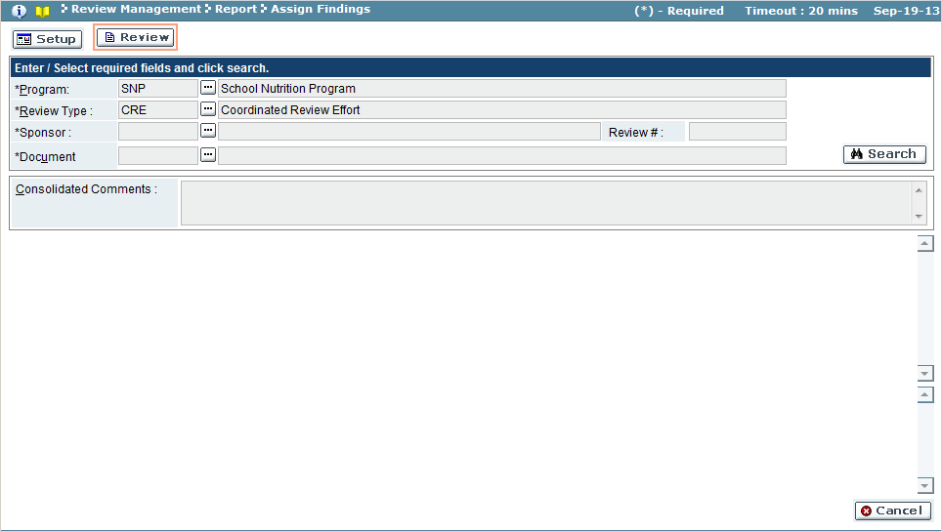

| Field Name | Action |
| --- | --- |
| Program | Select the program from the look-up |
| Review Type | Select the review type from the look-up |
| Sub-Recipient/Sponsor | Select the sub-recipient/sponsor from the look-up |
| Document | Select the document from the look-up |

Setup

In this mode, you can assign the findings and priority, adding any associated ARC items.

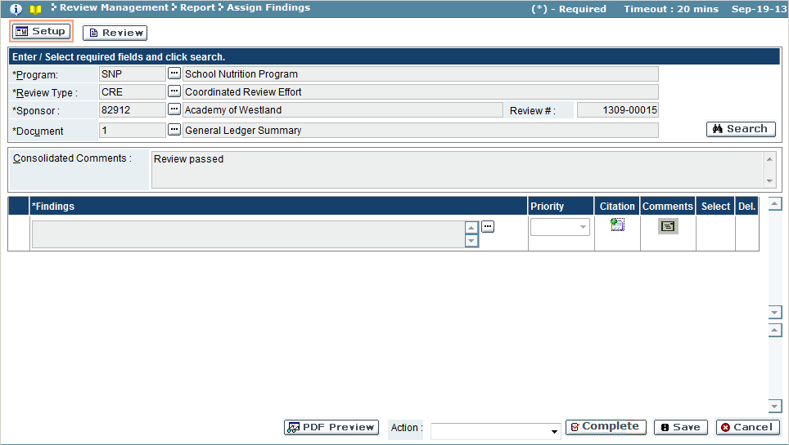

| Field Name | Description |
| --- | --- |
| Findings | Select the desired finding from the look-up |
| Priority | Select the desired priority from the dropdown (Low/Medium/High) if the finding is not in compliance. |
| Citation | Click the citation  icon to view the citation related to the finding selected. |
| Comments | Click the yellowed comments  icon to view the comments related to the findings. |
| Select | If the selection  icon exists, and the finding requires an ARC, click the icon to have the ARC section appear below. If the selected  icon exists, the ARC pane displayed below is related to the finding record. |
| Del. | If a finding exists for the document, the **X** icon can be used to remove the finding from the document. |

1. Use the search feature to view the sub-recipient/sponsor’s review documents.
2. Select a finding for the document using the Findings look-up feature.

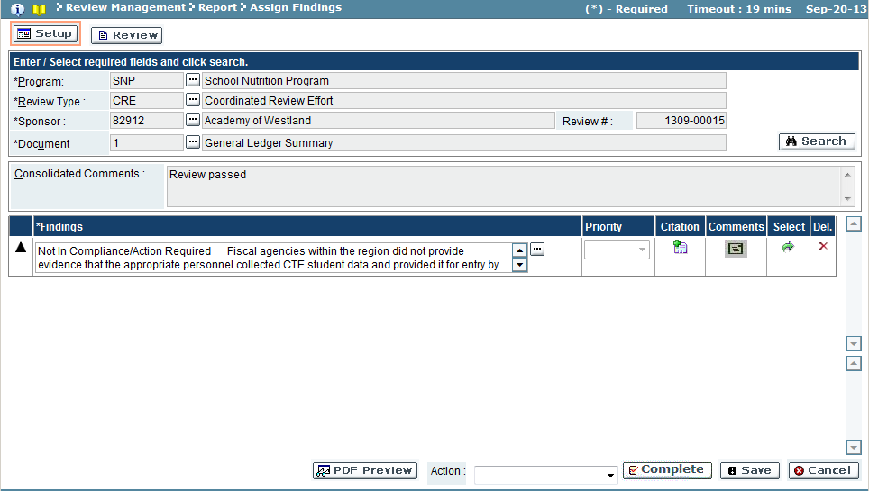

1. If the finding requires an ARC, click selection  icon to populate the ARC results pane.
2. Use the ARC look-up feature to select the required ARC.
3. The Priority drop down in the Findings results pane will be active. Select a priority level.

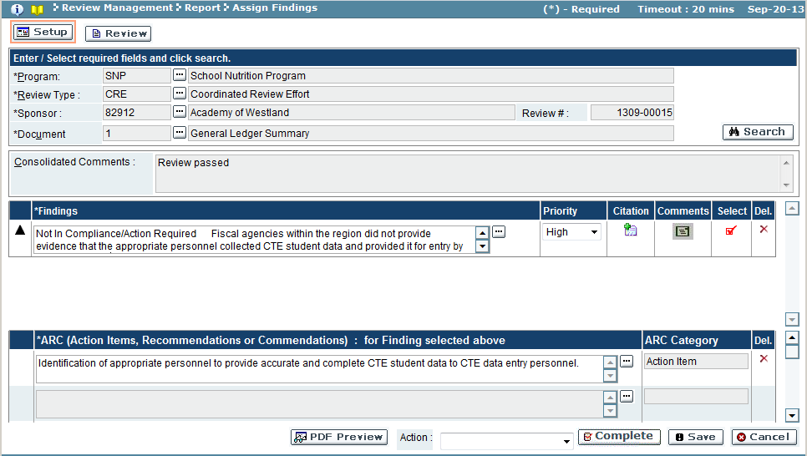

1. Click ‘Save’ button to save the finding for the document. A confirmation message will appear if the save was completed. Click the ‘OK’ button to close the message window.
   1. If another finding needs to be added to the document, repeat steps 2 – 6 as appropriate.

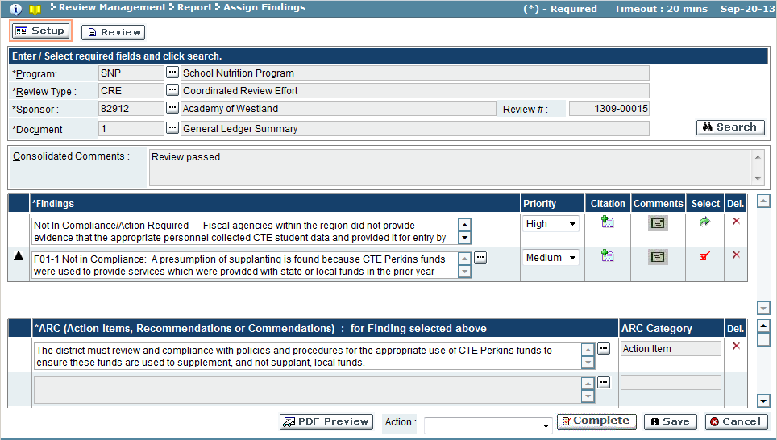

1. Repeat steps 1 – 6 to assign findings for each document associated with the sub-recipient/sponsor’s review.
2. When the findings are complete for each document for the sub-recipient/sponsor’s review, Select an action from the Action drop down window, and click ‘Complete’ button to submit the findings.

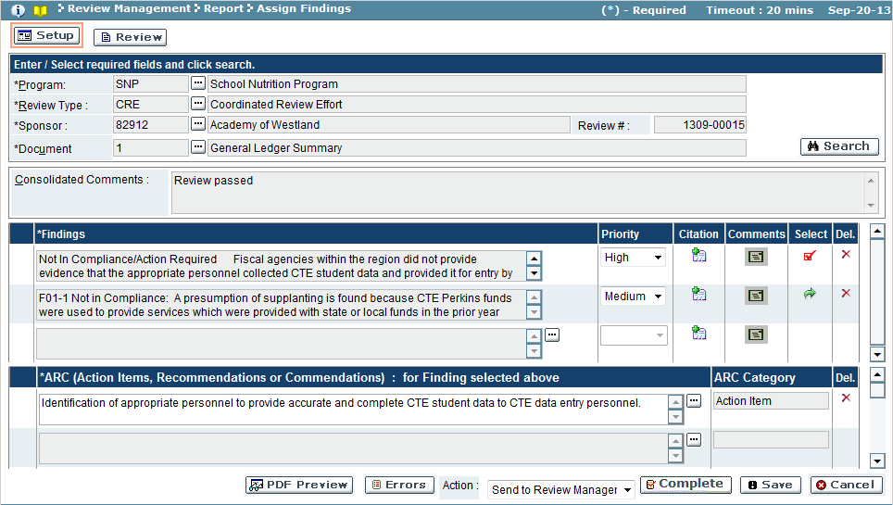

1. The system will validate the findings before committing. A message window will appear:

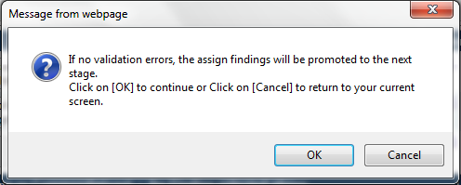

1. Click ‘OK’ button to continue validation (‘Cancel’ button to discard validation and return to assign findings screen).
   1. If the validation identifies errors, a message window will appear:

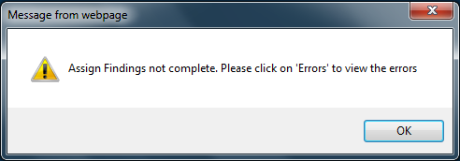

* + - 1. Click ‘OK’ button to close the message window.
      2. Click the ‘Errors’ button on the Assign Findings screen, and follow directions given to correct each error. Repeat step 8 to run validation again.

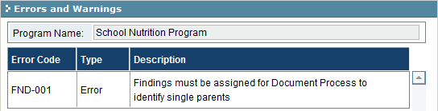

* 1. If the validation was completed and error free, the findings will be saved and the review will be promoted to the next stage. A confirmation message will appear:

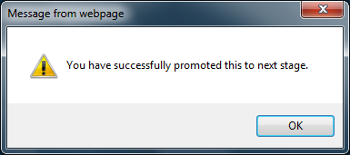

* + 1. Click ‘OK’ button to close the confirmation message.

1. Click the ‘PDF Preview’ button to preview the findings report.

Troubleshooting

| **#** | **Error** | **Description** | **Corrective Action** |
| --- | --- | --- | --- |
| 1 | Error Message: <Fieldname> cannot be empty | <Fieldname> is blank | The required fields are marked by asterisk *. When one of these fields is not entered, the system prompts with the above error message. Please enter / select value into the field and retry the operation. |

### Approve Findings

During approve findings, the Review Manager views the findings assigned by other members of the assign findings team. In this screen, you can view the consolidated comments and findings from the prior stages. The Review Manager can then approve the findings or send them back to the assign findings team members for revision.

To access this functionality, navigate to the following menu:

**Review Management → Report → Approve Findings**

This screen has the following functionality: Review, Approve.

|  |  |
| --- | --- |
| Predecessor | Assign Findings |
| Who | MDE User |
| When | Review Process |
| Subsequent | Compliance Plan |

Review

In this mode, you can view the findings team members’ findings, including the associated ARC and priority. You cannot make any changes in this mode.

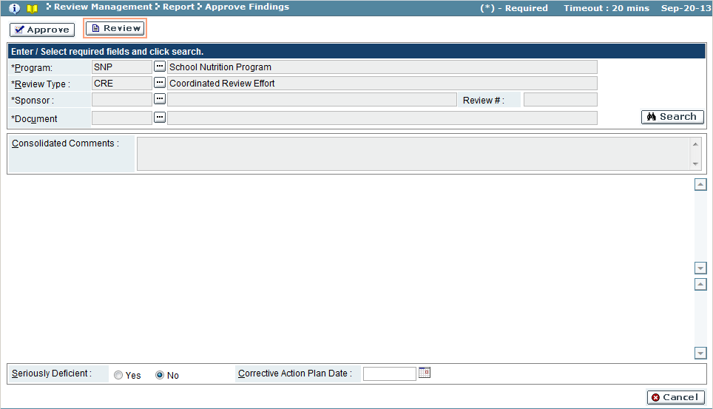

| Field Name | Action |
| --- | --- |
| Program | Select the program from the look-up (required field) |
| Review Type | Select the review type from the look-up (required field) |
| Sub-Recipient/Sponsor | Select the sub-recipient/sponsor from the look-up (required field) |
| Document | Select the document from the look-up (required field) |

Approve

In this mode, you can assign the findings and priority, adding any associated ARC items.

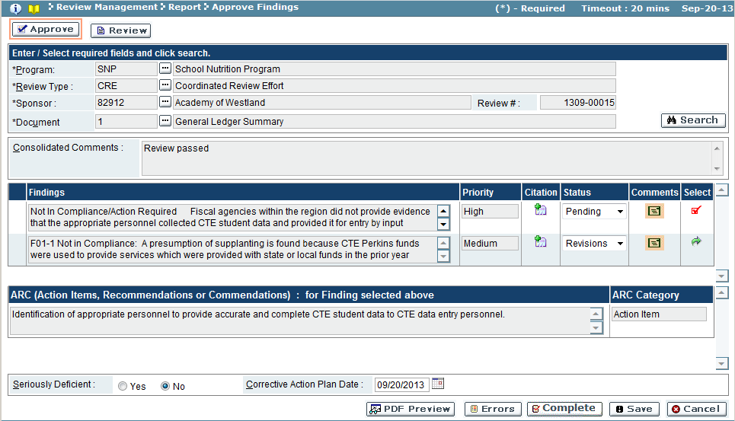

| Field Name | Description |
| --- | --- |
| *Findings Results Pane* | |
| Findings | Findings selected for the document at the Assign Findings stag |
| Priority | Priority set for the finding |
| Citation | Click the citation  icon to view the citation details |
| Status | Findings approval status (Pending/Approved/Revisions) |
| Comments | Click the yellowed comments  icon to add the comments when Status = Revision |
| Select | If the selection  icon exists, click the icon to change the Status and Comments for the finding record.  If the selected  icon exists, the finding record is selected for editing. |
| *ARC Results Pane* | |
| ARC | ARC Item for selected finding |
| ARC Category | ARC Category |

1. Use the search feature to view the sub-recipient/sponsor’s document review findings.
2. Click the selection  icon to select a document’s finding.
3. Change the Status of the finding.
   1. If the status = Revision, use the comment icon to enter comments regarding revision.
4. Click ‘Save’ button to save the findings status.
   1. Repeat steps 2 – 3 for each finding for the document.
5. Repeat steps 1 – 4 for each document for the sub-recipient/sponsor’s review.
6. When all documents findings are approved, the review will be need to be completed.
7. Determine if the sub-recipient/sponsor’s review is seriously deficient:
   1. If the sub-recipient/sponsor’s review is considered ‘Seriously Deficient’, set the radio button to ‘Yes’ and set a due date for the Corrective Action Plan Date field.
      1. Reviews promoted with this status will require a compliance plan to be submitted before the due date in order to avoid the review <> going to the Intent to Terminate process.
   2. If the review is not considered ‘Seriously Deficient’, leave the radio button set to ‘No’.
8. Click the ‘Complete’ button to submit the approved findings.
9. The system will validate the findings before committing. A message window will appear:



1. Click ‘OK’ button to continue validation (‘Cancel’ button to discard validation and return to assign findings screen).
   1. If the validation identifies errors, a message window will appear:

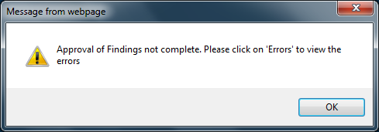

* + - 1. Click ‘OK’ button to close the message window.
      2. Click the ‘Errors’ button on the Assign Findings screen, and follow directions given to correct each error. Repeat step 8 to run validation again.

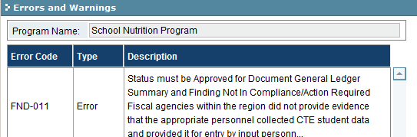

* 1. If the validation was completed and error free, the findings will be saved and the review will be promoted to the next stage – Compliance Plan. A confirmation message will appear:



* + 1. Click ‘OK’ button to close the confirmation message.

1. Click the ‘PDFPreview’ button to preview the findings report.

Troubleshooting

|  |  |  |  |
| --- | --- | --- | --- |
| **#** | **Error** | **Description** | **Corrective Action** |
| 1 | Error Message: <Fieldname> cannot be empty | <Fieldname> is blank | The required fields are marked by asterisk *. When one of these fields is not entered, the system prompts with the above error message. Please enter / select value into the field and retry the operation. |

### View Findings Report

The Finding Report screen is used to view the finalized Finding Reports. On this screen, MDE employees are able to view completed Finding Reports for all sub-recipients, regardless of Program or Office. Once a Finding Report has been generated, it will be searchable on this screen.

To access this functionality, navigate to the following menu:

**Review Management → Report → View Findings Report**

|  |  |
| --- | --- |
| Predecessor |  |
| Who | MDE |
| When | As Needed |
| Subsequent |  |

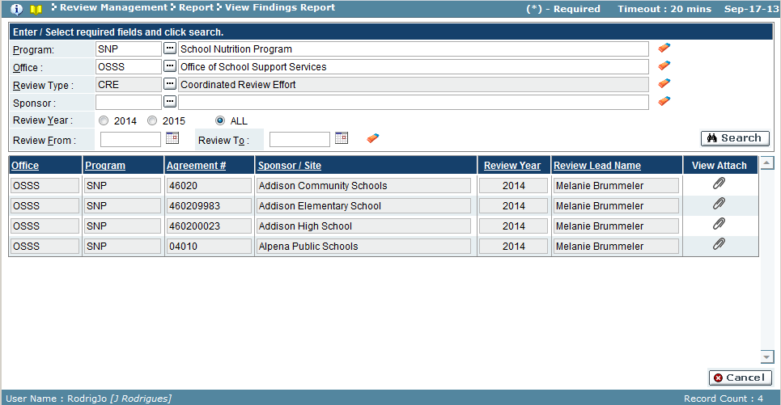

| Field Name | Action |
| --- | --- |
| *Search Pane* | |
| Program | Select program from the look-up (wildcard % feature also available to enter a partial field value or code to search) |
| Office | Select office from the look-up (wildcard % feature also available to enter a partial field value or code to search) |
| Review Type | Select review type from the look-up |
| Sub-Recipient/Sponsor | Select sub-recipient/sponsor from the look-up (wildcard % feature also available to enter a partial field value or code to search) |
| Review Year | Select review year, or choose ALL |
| Review From | Start date for review (use format MM/DD/YYYY or use calendar function) |
| Review To | End date for review (use format MM/DD/YYYY or use calendar function) |
| Results Pane | |
| Office | Office |
| Program | Program code |
| Agreement # | Sub-recipient/sponsor agreement number |
| Sub-Recipient/Sponsor / Building/Site | Sub-recipient/sponsor name |
| Review Year | Review year |
| Review Lead Name | Review lead name |
| View Attach | Attachment  icon, click to download documents |

1. Use the search feature to view the program review(s).
2. A list of finalized finding reports will appear for the search criteria.
3. Click on the View Attachment icon  to open the View Attachments window.

a. To download the finding report, click ‘Download’ button.

b. Click the ‘Close’ to close View Attachments window and return to View Findings Report screen.

Troubleshooting

| **#** | **Error** | **Description** | **Corrective Action** |
| --- | --- | --- | --- |
| 1 | Error Message: <Fieldname> cannot be empty | <Fieldname> is blank | The required fields are marked by asterisk *. Please enter / select value into the field and retry the operation. |

### Create Findings Package

The Create Findings Package feature allows a findings package to be created for a sub-recipient/sponsor’s review. Additional comments and documentation can be attached to the findings package. The final package will be sent to the sub-recipient/sponsor.

To access this functionality, navigate to the following menu:

**Review Management → Report → Create Findings Package**

This screen has the following functionality: Review and Setup

|  |  |
| --- | --- |
| Predecessor | Approve Findings |
| Who | MDE User |
| When | Review Process |
| Subsequent | Acknowledge Findings Package |

Review

In this mode, the findings packages are viewed. You cannot make any changes in this mode.

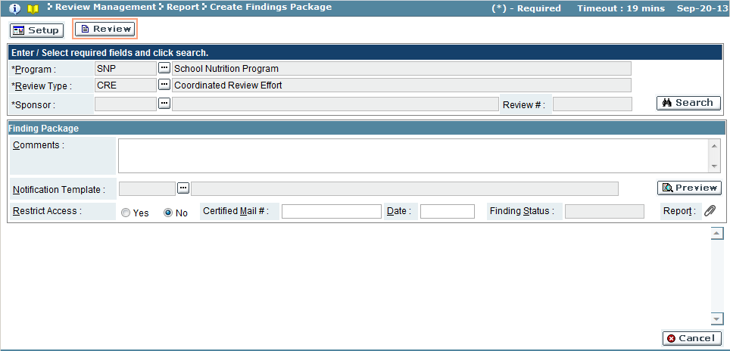

| Field Name | Action |
| --- | --- |
| Program | Select the program from the look-up (required field) |
| Review Type | Select the review type from the look-up (required field) |
| Sub-Recipient/Sponsor | Select the sub-recipient/sponsor from the look-up (required field) |

Setup

In this mode, MDE users can create the finding package, attach documents and comments related to the sub-recipient/sponsor’s review findings.

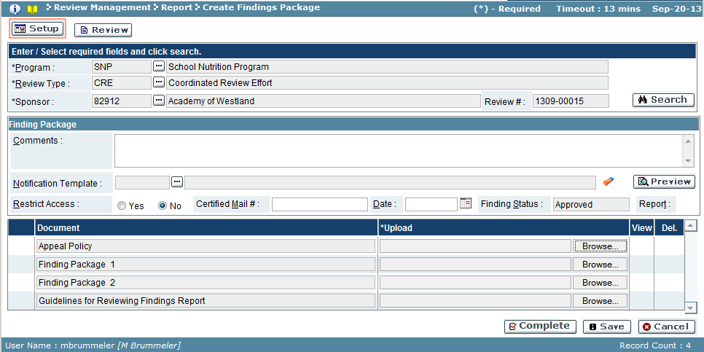

| Field Name | Description |
| --- | --- |
| *Finding Package Results Pane* | |
| Comments | Comments regarding the findings package |
| Notification Template | Letter used for the findings package. ‘Preview’ button will display the notification template |
| Restrict Access | Restrict Access |
| Certified Mail | If mailed via Certified Mail, enter # |
| Date | Package date |
| Finding Status | Finding package status |
| *Document Results Pane* | |
| Document | Name of additional documentation |
| Upload | File path/name of uploaded document |
| View | Click attachment  icon to download document |

* 1. Use the search feature to view findings package to create.
  2. Fill out any comments, the notification template, attach any additional documentation for the package.
  3. Click ‘Save’ button to save the package (‘Cancel’ button will discard changes).
  4. Click ‘Complete’ to send out the findings package.
     1. A confirmation window will appear if the save was successfully completed and the review promoted to the next stage.
     2. Click ‘OK’ button to close the confirmation window.

### Acknowledge Findings Package

Once a findings package is completed, the sub-recipient/sponsor will need to acknowledge the findings package. The findings package can be downloaded for viewing, and the user assigned to acknowledge the package can submit their signature for acknowledging their receipt of the findings.

To access this functionality, navigate to the following menu:

**Review Management → Report → Acknowledge Findings Package**

This screen has the following functionality: Review, Acknowledge.

|  |  |  |
| --- | --- | --- |
| Predecessor | Create Findings Package | |
| Who | Sub-Recipient User/MDE User |
| When | Review Process |
| Subsequent | Compliance Plan |

Review

In this mode, the findings packages created for a review can be viewed. Acknowledged packages will display who acknowledged the package and when. You cannot make any changes in this mode.

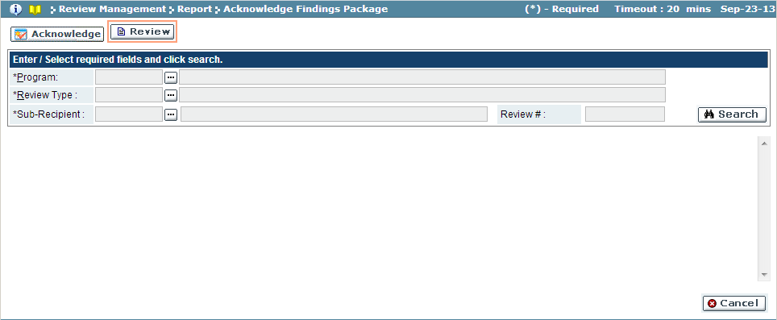

| Field Name | Action | |
| --- | --- | --- |
| Program | Select the program from the look-up |
| Review Type | Select the review type from the look-up |
| Sub-Recipient/Sponsor | Select the sub-recipient from the look-up |

Acknowledge

In this mode, the findings packages are acknowledged as viewed.

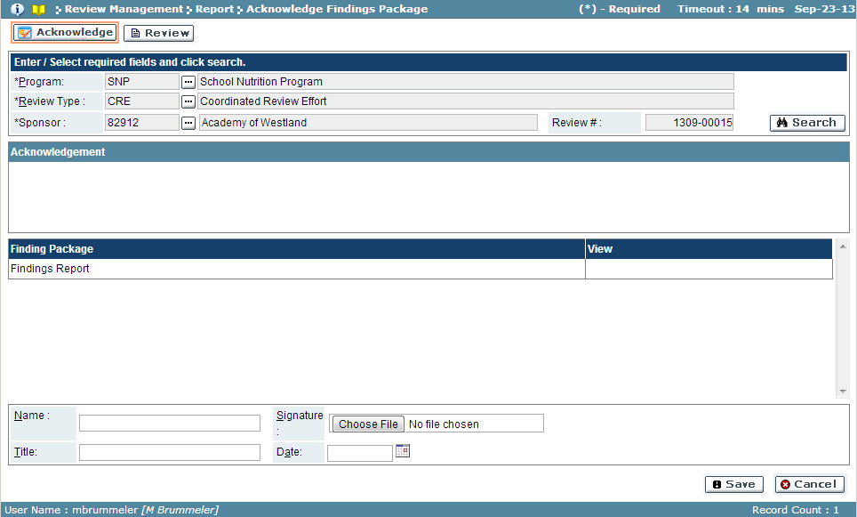

| Field Name | Description |
| --- | --- |
| Finding Package | Findings Report name |
| View | Click attachment  icon to view the findings report |
| Name | Enter name of the person acknowledging findings report |
| Title | Enter the title/position of the person acknowledging findings report |
| Date | Enter the date the report is acknowledged |
| Signature | User the ‘Choose File’ button to upload the signature file |

1. Use the search feature to view findings package.
2. Click the attachment  icon to download the findings package.
3. To acknowledge findings, enter the name, title and date.
4. Use the ‘Choose File’ button to upload the signature file.

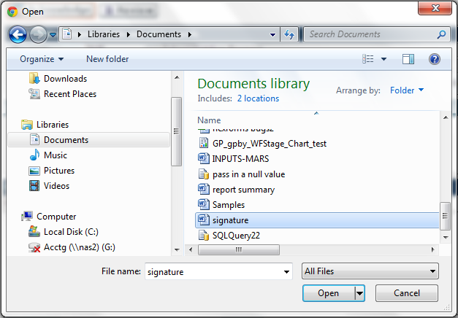

* 1. Browse to file location, click on file and click ‘Open’ button to upload file (‘Cancel’ button will discard upload) and return to Acknowledge Findings Package screen.

1. Click ‘Save’ button to acknowledge package (‘Cancel’ button will cancel).

### Search Findings

This screen allows users to search and review the sub-recipient/sponsors the findings and related status. No changes can be made in this mode.

To access this functionality, navigate to the following menu:

**Review Management → Report → Search Findings**

|  |  |
| --- | --- |
| Predecessor |  |
| Who | MDE User |
| When | Review Process |
| Subsequent |  |

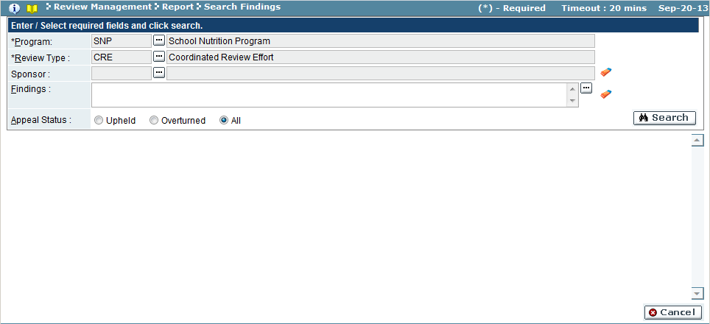

| Field Name | Action |
| --- | --- |
| Program | Select the program from the look-up (required field) |
| Review Type | Select the review type from the look-up (required field) |
| Sub-Recipient/Sponsor | Select the sub-recipient/sponsor from the look-up (required field) |

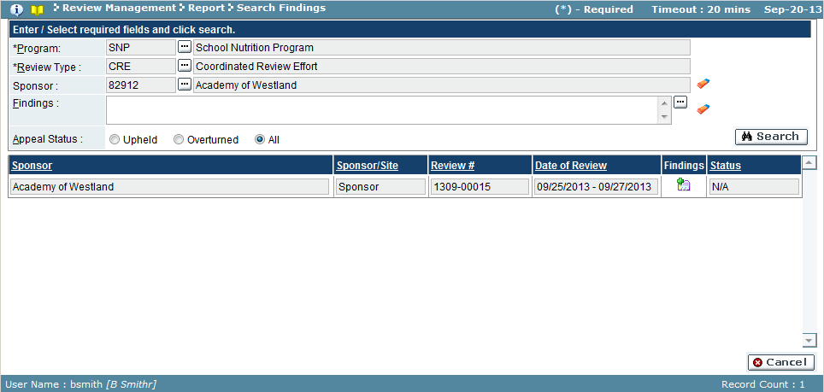

| Field Name | Description |
| --- | --- |
| Sub-Recipient/Sponsor | Sub-recipient/sponsor name |
| Sponsor/Site Type | Type of sub-recipient/sponsor |
| Review# | Review # for sub-recipient/sponsor |
| Date of Review | Date range for review |
| Findings | Click the findings  icon to review the findings |
| Status | Appeal status of the findings |

* 1. Use search feature to view the sub-recipient/sponsor’s document review findings.
  2. To view the detailed findings, click the findings  icon.

*Findings window*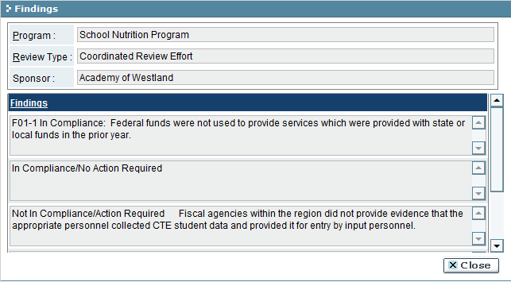

## Events

### Schedule Training

This screen allows MDE to schedule training for sub-recipients. The training topic, resources, including date, time, location and/or conference number, including the training instructor, the sub-recipient/sponsor’s contact person and training notification are configured here.

To access this functionality, navigate to the following menu:

**Review Management → Events → Schedule Training**

This screen has the following functionality: Review, Add, Change and Delete

|  |  |
| --- | --- |
| Predecessor | Review (Desk On site Review or Review Consolidation) |
| Who | MDE User |
| When | Review Process |
| Subsequent | Assign Findings |

Review

In this mode, you can view the details regarding the scheduled training. You cannot make any changes in this mode.

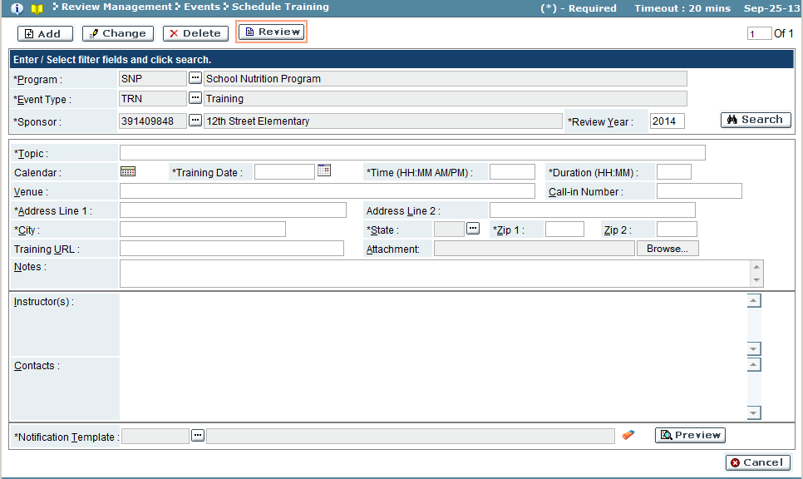

| Field Name | Action |
| --- | --- |
| Program | Select the program from the look-up |
| Event Type | Select the event type from the look-up |
| Sub-Recipient/Sponsor | Select the sub-recipient/sponsor from the look-up |
| Review Year | Enter the review year |

Add

In this mode, create the training to be scheduled. The screen allows users to schedule in-person training or teleconference trainings. Training materials and websites can be added, instructors assigned and the contact for the sub-recipient/sponsor.

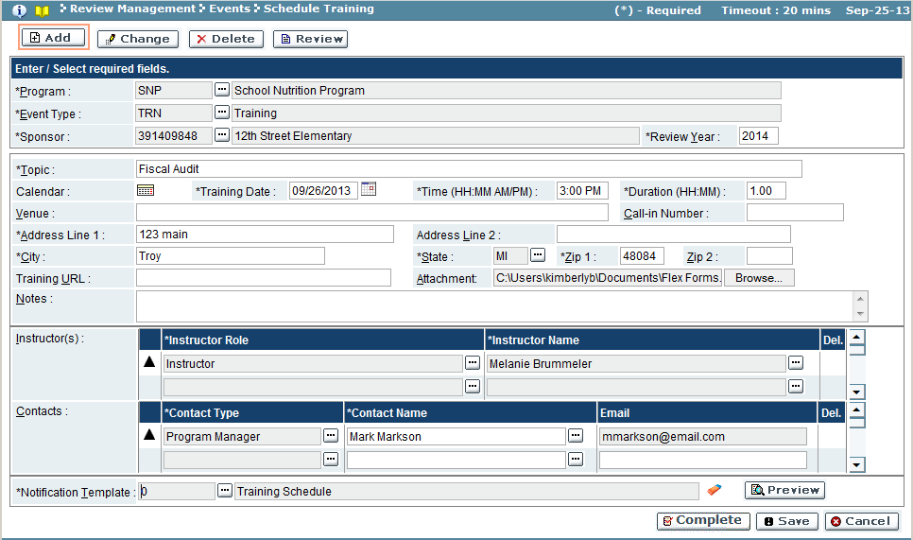

| Field Name | Description |
| --- | --- |
| *Training Results Pane* | |
| Topic | Description of the training |
| Calendar | Calendar  icon views the sub-recipient/sponsor’s calendar of scheduled items (reviews, holidays, trainings, etc) |
| Training Date | Training date. Click calendar  icon to use the date selector. |
| Time | Start time of the training |
| Duration | Duration of the training |
| Venue | Location of training |
| Call-in Number | Conference call phone number (if training is call-based) |
| Address Line 1 | Street address of training (*if training is at a location) |
| Address Line 2 | Street address 2 * |
| City | City of the training * |
| State | State of the training , use look-up to select * |
| Zip, Zip2 | Zip and Zip+4 of the training * |
| Training URL | Website of training (if training is web-based) |
| Attachment | Training documents. Click attachment  icon to view document |
| Notes | Additional information regarding training |
| *Contacts Results Pane* | |
| Instructor(s) |  |
| Instructor Role | Instructor role, use look-up to select |
| Instructor Name | Instructor name, use look-up to select |
| Del. | If ‘**X**’ exists, the instructor record can be deleted by selecting icon |
| Contacts |  |
| Contact Type | Sub-recipient/sponsor contact type, use look-up to select |
| Contact Name | Sub-recipient/sponsor contact name, enter name or use look-up to select |
| Email | Contact email address |
| Del. | If ‘**X**’ exists, the contact record can be deleted by selecting icon |
| *Notification Results Pane* | |
| Notification Template | Training notification, use look-up to select |

1. Enter program, event type and sub-recipient/sponsor in the search pane.
2. Enter the training details.
3. Select the instructor and instructor role (one instructor is required).
4. Select the sub-recipient/sponsor contact’s role, name and email.
5. Select the notification template to be used to notify contacts. Click ‘Save’ button to save training, but not schedule and notify contacts (‘Cancel’ will discard changes).
6. Click ‘Complete’ button to schedule training and send notification to contacts.
   1. A window will appear confirming training to be scheduled and promoted to next stage:

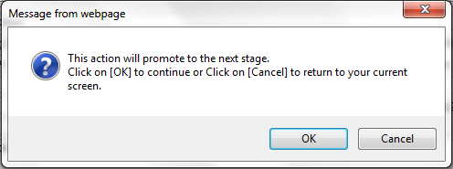

* 1. Click ‘OK’ to continue scheduling training (‘Cancel’ will discard save).
  2. If scheduling was completed, a confirmation window will appear. Click ‘OK’ button to close confirmation window and return to schedule training screen.

Change

In this mode, saved or scheduled trainings can be modified. Make necessary changes to the training. As in the ADD mode, ‘Save’ button will commit changes, but not send out notification. ‘Complete’ button will only appear in this mode only if the training had been saved but not completed (scheduled) previously.

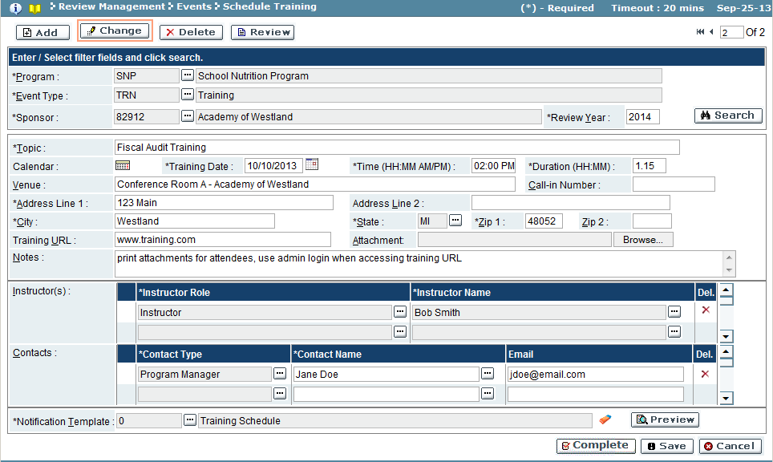

Delete

In this mode, training events can be deleted from the system.

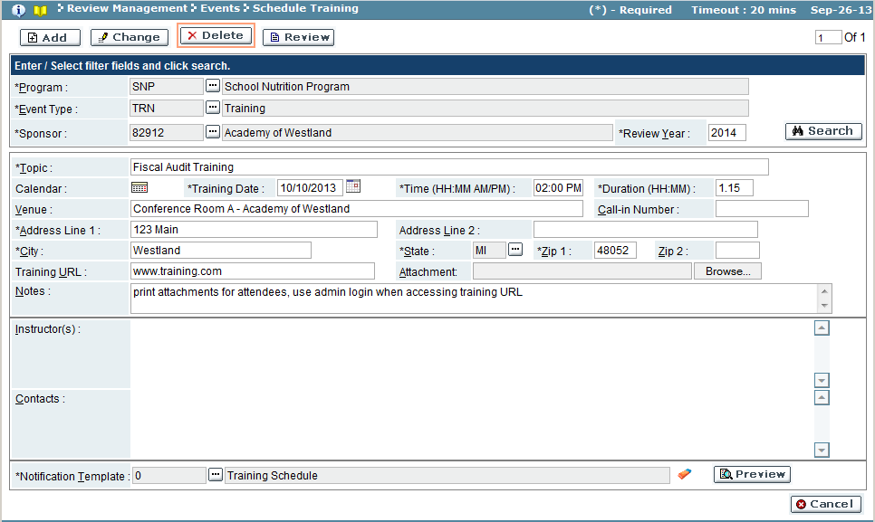

* + 1. Use the search feature to select the training event.
    2. Click ‘OK’ button to delete the training event (‘Cancel’ button will not delete event).
    3. A confirmation window will appear, confirming delete. Click ‘OK’ to close confirmation window and return to the schedule training screen.

Troubleshooting

| **#** | **Error** | **Description** | **Corrective Action** |
| --- | --- | --- | --- |
| 1 | Error Message: <Fieldname> cannot be empty | <Fieldname> is blank | The required fields are marked by asterisk *. When one of these fields is not entered, the system prompts with the above error message. Please enter / select value into the field and retry the operation. |

### Update Participant Details

Once a training event is complete, this screen can be used to capture attendance, and training feedback. The status of the training can be closed, or the results of the training could trigger that findings need to be addressed, and the findings process can be initiated from this screen.

To access this functionality, navigate to the following menu:

**Review Management → Events → Update Participant Details**

This screen has the following functionality: Review and Upload

|  |  |
| --- | --- |
| Predecessor |  |
| Who | MDE |
| When | As Needed |
| Subsequent |  |

Review

In this mode, the results of a training event (participants, feedback) can be viewed for reference purposes. No changes can be made in this mode.

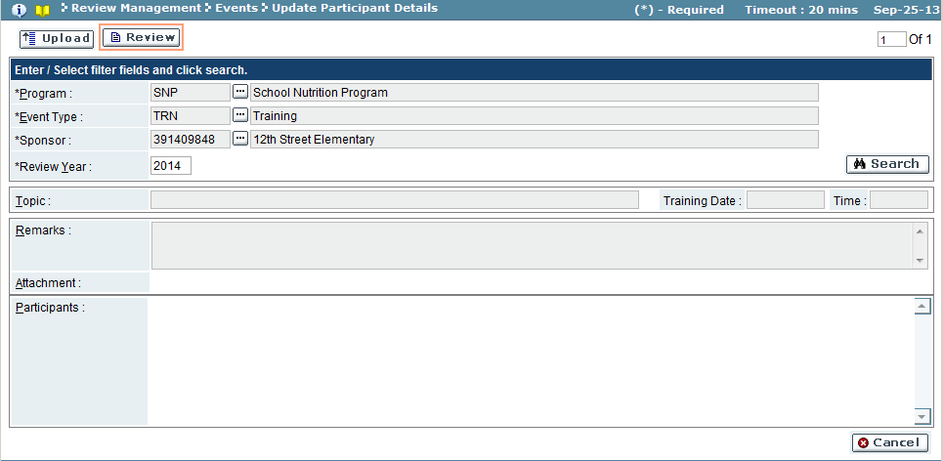

| Field Name | Action |
| --- | --- |
| Program | Select the program from the look-up |
| Event Type | Select the event type from the look-up |
| Sub-Recipient/Sponsor | Select the sub-recipient/sponsor from the look-up |
| Review Year | Enter the review year |

Upload

In this mode, overall training/event remarks and documentation can be attached, as well as noting the participants in the training, and their individual feedback/documentation regarding the training. Once all training/event information is entered, the status can be closed, or the findings process started.

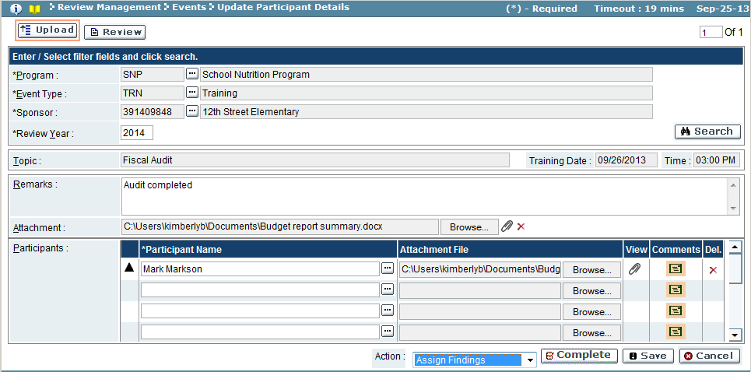

| Field Name | Description |
| --- | --- |
| *Training Results Pane* | |
| Topic | Event topic |
| Training Date | Event date |
| Time | Event time |
| *Training Remarks Results Pane* | |
| Remarks | Overall training/event remarks |
| Attachment | Overall training/event documentation. Click attachment  icon to view document |
| *Participants Results Pane* | |
| Participant Name | Attendee name |
| Attachment File | Attendee’s training/event documentation. Click ‘Browse’ button to upload document |
| View | Click attachment  icon to view document |
| Comments | Attendee’s training/event comments |
| Del. | If ‘**X**’ exists, the participant record can be deleted by selecting icon |

1. Use the search feature to view a sub-recipient/sponsor’s event.
2. Enter any training remarks or attachments.
3. Enter each participant.
4. Add an attachment for a participant by using the ‘Browse’ button to invoke the windows explorer window.
5. Insert any comments related to the participant.
6. Click ‘Save’ button to save the changes to the event and participant(s), but not promote to the next stage.
7. To promote the training to the next stage:
   1. Select an action from the ‘Action’ drop down (Complete - complete training/event or Assign Findings, to promote the event to the Assign Findings stage)
   2. A popup window appears, confirming the promotion of the training event.

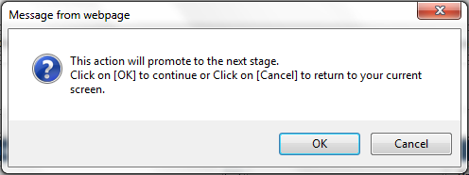

* 1. Click ‘OK’ to commit the change (‘Cancel’ button will discard commit).
  2. If the commit was successful, a confirmation window appears. Click ‘OK’ to close the confirmation window and return to the Update Participant Details screen.

Troubleshooting

| **#** | **Error** | **Description** | **Corrective Action** |
| --- | --- | --- | --- |
| 1 | Error Message: <Fieldname> cannot be empty | <Fieldname> is blank | The required fields are marked by asterisk *. When one of these fields is not entered, the system prompts with the above error message. Please enter / select value into the field and retry the operation. |

### Late Claims

If a sub-recipient/sponsor did not enter a claim within 60 days of the period, a late claim event can be created in order to submit request for payment. Late claims can be ‘In Control’ or ‘Out Control’ claims. An ‘In Control’ request can be made if and only if no similar claim has been made in the last 36 months. ‘Out Control’ requests can occur at any time and the disposition will be determined by the USDA without appeal, and at any time (no deadline for the disposition).

To access this functionality, navigate to the following menu:

**Review Management → Events → Late Claims**

This screen has the following functionality: Review, Add, Change and Delete

|  |  |
| --- | --- |
| Predecessor |  |
| Who | MDE |
| When | As Needed |
| Subsequent |  |

Review

In this mode, late claims can be viewed, including the related documentation submitted. No changes can be made in this mode.

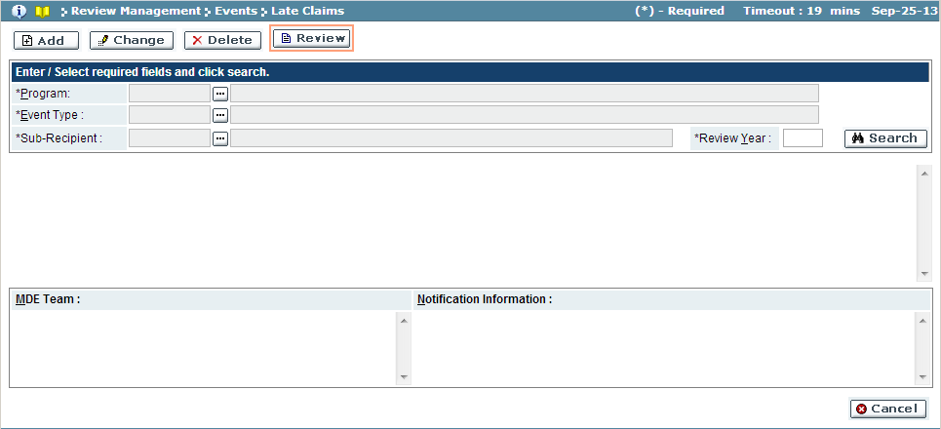

| Field Name | Action |
| --- | --- |
| Program | Select the program from the look-up |
| Event Type | Select the event type from the look-up |
| Sub-Recipient/Sponsor | Select the sub-recipient/sponsor from the look-up |
| Review Year | Enter the review year |

Add

In this mode, late claims are initiated. Enter the event’s requested amount, the supporting documentation, and selecting the MDE Team and the sub-recipient/sponsor’s contact for determination.

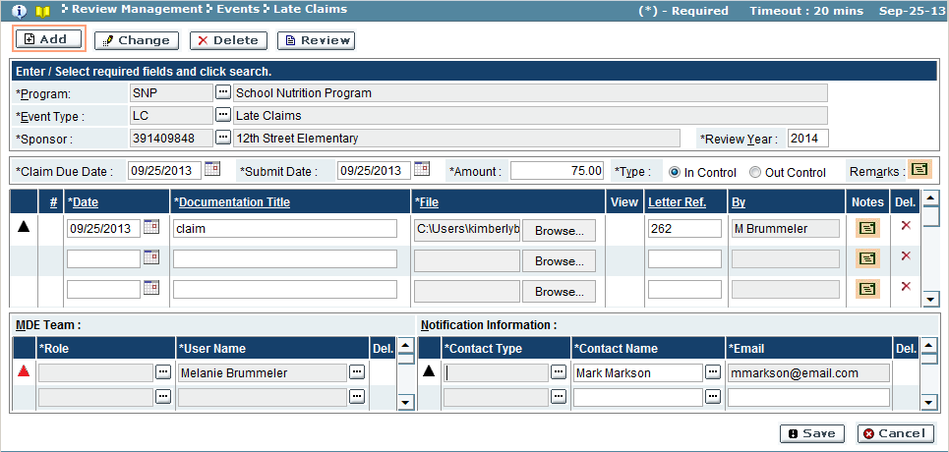

| Field Name | Description |
| --- | --- |
| *Claim Information Results Pane* | |
| Claim Due Date | Date claim made |
| Submit Date | Date claim submitted (current date) |
| Amount | Amount of claim |
| Type | Claim type (In Control/Out Control) |
| Remarks | Click the comments  icon to view comments for claim |
| *Documentation Results Pane* | |
| # | Serial number of the documentation |
| Date | Document date |
| Documentation Title | Name of document |
| File | File uploaded. Click ‘Browse’ button to upload document |
| View | Uploaded file. Click the attachment  icon to view file |
| Letter Ref. | Letter reference code |
| By | User who added document |
| Notes | Click the comments  icon to view comments for document |
| Del. | If ‘**X**’ exists, the document record can be deleted by selecting icon |
| *MDE Team Results Pane* | |
| Role | System role of the MDE team member |
| User Name | User name of MDE team member |
| Del. | If ‘**X**’ exists, the user record can be deleted by selecting icon |
| *Notification Information Results Pane* | |
| Contact Type | Contact type of the contact |
| Contact Name | Name of the contact (may use look-up or add a new user) |
| Email | Email address of the contact (auto-populate from contact name, or may add a new email) |
| Del. | If ‘**X**’ exists, the contact record can be deleted by selecting icon |

1. Use the search feature to select the program to create the late claim.
2. Enter the claim information, including amount and control type.
3. Add related document(s) for the claim, using the ‘Browse’ button to upload file(s).
4. Select the MDE Team members, as appropriate.
5. Select sub-recipient/sponsor contact’s to receive the late claim notification.
6. To save the late claim, click the ‘Save’ button.

Change

In this mode, late claims can be modified and also completed.

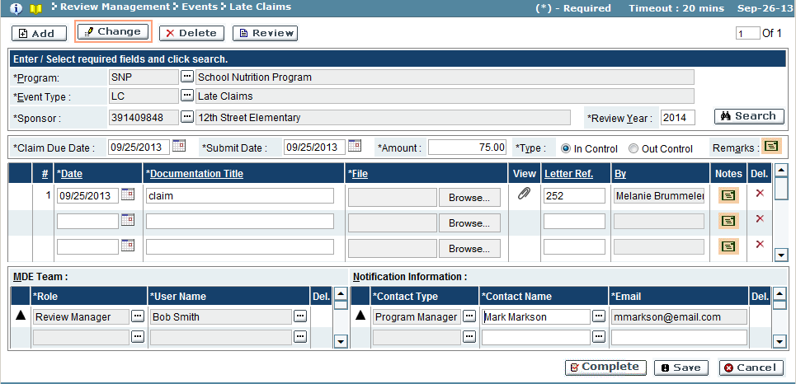

1. Use the search feature to select the late claim.
2. If changes are necessary, make changes and click ‘Save’ to save the changes.
3. To make the late claim complete, click the ‘Complete’ button. (Once complete, a late claim cannot be changed or deleted)
   1. A popup window will appear:

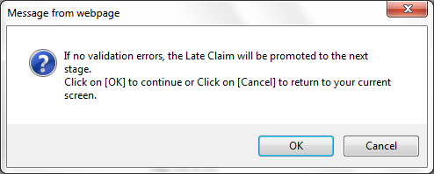

* 1. Click ‘OK’ button to complete submission (‘Cancel’ button will discard submission).
  2. If submission is complete, a confirmation window will appear. Click ‘OK’ to close confirmation window and return to the late claim screen.

Delete

In this mode, any late claims created but not completed can be deleted.

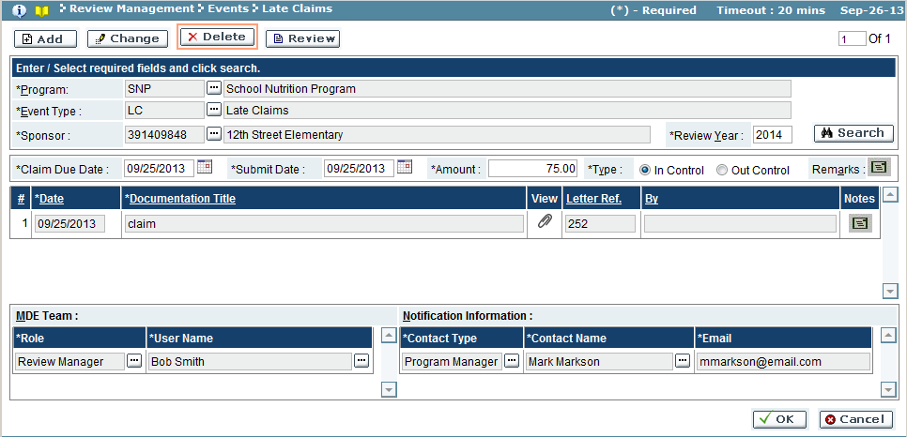

1. Use the search feature to select the late claim.
2. Click the ‘OK’ button to delete the late claim (‘Cancel’ button will not delete claim).
   1. A confirmation window will appear, confirming delete. Click ‘OK’ to close confirmation window and return to the late claim screen.

Troubleshooting

| **#** | **Error** | **Description** | **Corrective Action** |
| --- | --- | --- | --- |
| 1 | Error Message: <Fieldname> cannot be empty | <Fieldname> is blank | The required fields are marked by asterisk *. When one of these fields is not entered, the system prompts with the above error message. Please enter / select value into the field and retry the operation. |

### Amount Disregard

The Amount Disregard screen is used to submit claim event(s) totaling under $600.00 for the fiscal year. More than one claim event can be submitted, as long as total claims submitted are less than $600.00 for the year.

To access this functionality, navigate to the following menu:

**Review Management → Events → Amount Disregard**

This screen has the following functionality: Review, Add, Change and Delete

|  |  |
| --- | --- |
| Predecessor |  |
| Who | MDE |
| When | As Needed |
| Subsequent |  |

Review

In this mode, amount disregard events can be reviewed. No changes can be made in this mode.

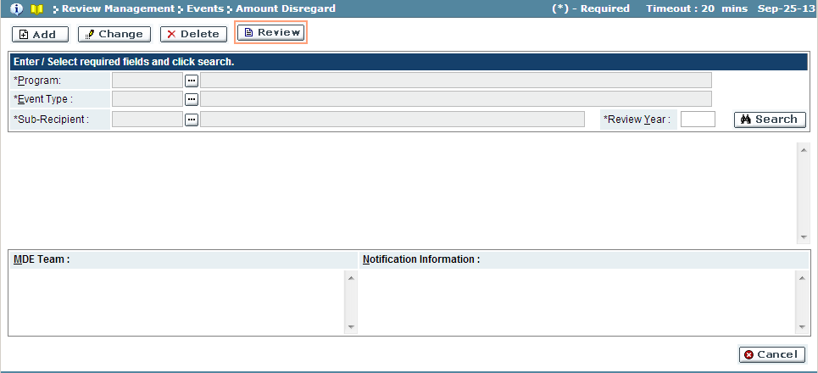

| Field Name | Action |
| --- | --- |
| Program | Select the program from the look-up |
| Event Type | Select the event type from the look-up |
| Sub-Recipient/Sponsor | Select the sub-recipient/sponsor from the look-up |
| Review Year | Enter the review year |

Add

In this mode, amount disregard events can be initiated. Enter the event’s disregarded amount, the supporting documentation, and selecting the MDE Team and the sub-recipient/sponsor’s contact for determination.

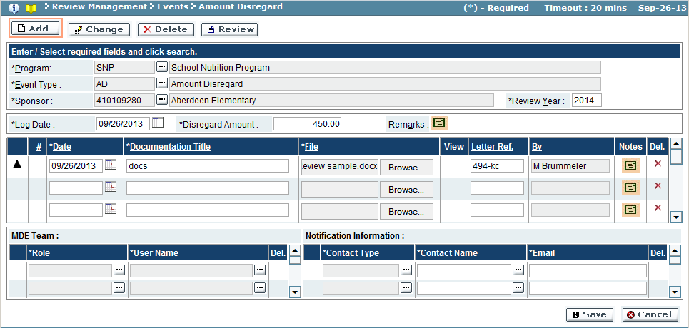

| Field Name | Description |
| --- | --- |
| *Claim Information Results Pane* | |
| Log Date | Date claim made |
| Disregard Amount | Disregarded amount |
| Remarks | Click the comments  icon to view comments for claim |
| *Documentation Results Pane* | |
| # | Serial number of the documentation |
| Date | Document date |
| Documentation Title | Name of document |
| File | File uploaded. Click ‘Browse’ button to upload document |
| View | Uploaded file. Click the attachment  icon to view file |
| Letter Ref. | Letter reference code |
| By | User who added document |
| Notes | Click the comments  icon to view comments for document |
| Del. | If ‘**X**’ exists, the document record can be deleted by selecting icon |
| *MDE Team Results Pane* | |
| Role | System role of the MDE team member |
| User Name | User name of MDE team member |
| Del. | If ‘**X**’ exists, the user record can be deleted by selecting icon |
| *Notification Information Results Pane* | |
| Contact Type | Contact type of the contact |
| Contact Name | Name of the contact (may use look-up or add a new user) |
| Email | Email address of the contact (auto-populate from contact name, or may add a new email) |
| Del. | If ‘**X**’ exists, the contact record can be deleted by selecting icon |

1. Use the search feature to select the program to create the amount disregarded event.
2. Enter the event information, including amount.
3. Add related document(s) for the claim, using the ‘Browse’ button to upload file(s).
4. Select the MDE Team members, as appropriate.
5. Select sub-recipient/sponsor contact’s to receive the event notification.
6. To save the claim, click the ‘Save’ button.

Change

In this mode, changes can be made to the amount disregard event, as well as the event can be promoted to the next stage, either completing the event or assigning findings.

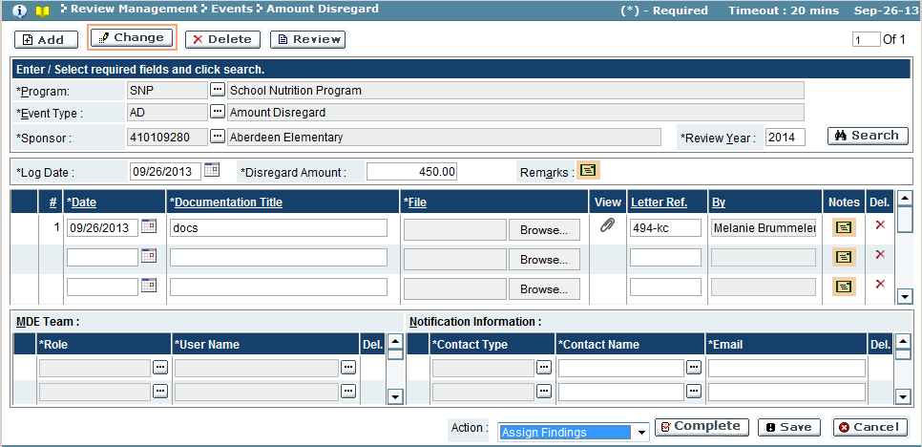

1. Use the search feature to select the amount disregard claim event.
2. If changes are necessary, make changes and click ‘Save’ to save the changes.
3. To complete the claim event, select the action appropriate (Complete – event complete, Assign Findings – create findings for event) and click the ‘Complete’ button. (Once complete, a late claim cannot be changed or deleted)
   1. A popup window will appear:

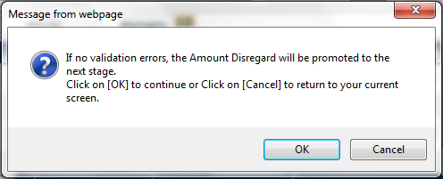

* 1. Click ‘OK’ button to promote the claim event to the next stage (‘Cancel’ button will discard submission)
  2. If the request is complete, a confirmation window will appear. Click ‘OK’ to close the confirmation window and return to the amount disregard screen.

Delete

In this mode, amount disregard events can be deleted from the system.

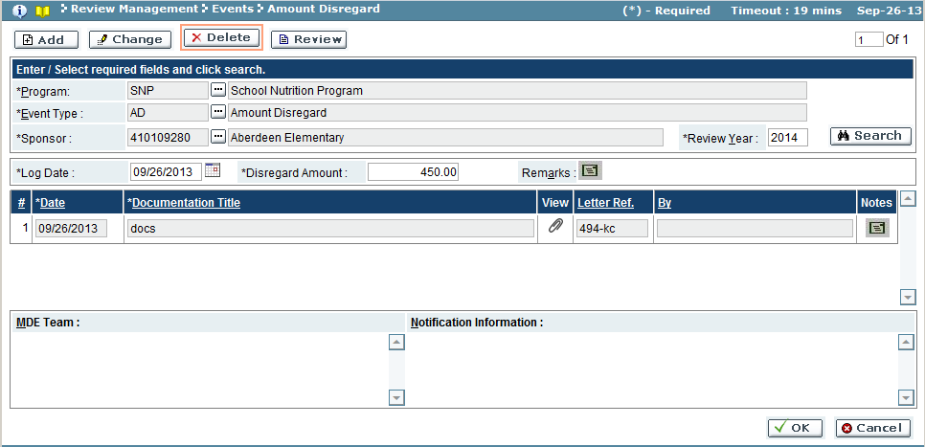

* + 1. Use the search feature to select the amount disregard claim.
    2. Click ‘OK’ button to delete the amount disregard claim event (‘Cancel’ button will not delete claim event).
    3. A confirmation window will appear, confirming delete. Click ‘OK’ to close confirmation window and return to the amount disregard screen.

Troubleshooting

| **#** | **Error** | **Description** | **Corrective Action** |
| --- | --- | --- | --- |
| 1 | Error Message: <Fieldname> cannot be empty | <Fieldname> is blank | The required fields are marked by asterisk *. When one of these fields is not entered, the system prompts with the above error message. Please enter / select value into the field and retry the operation. |

### Seriously Deficient

The seriously deficient events can be created in similar format to late claims. These event types can also be completed (closed) or promoted to the assign finding process, and a reason for the deficiency assigned.

To access this functionality, navigate to the following menu:

**Review Management → Events → Seriously Deficient**

This screen has the following functionality: Review, Add, Change and Delete

|  |  |
| --- | --- |
| Predecessor |  |
| Who | MDE |
| When | As Needed |
| Subsequent |  |

Review

In this mode, seriously deficient events can be viewed. No changes can be made in this mode.

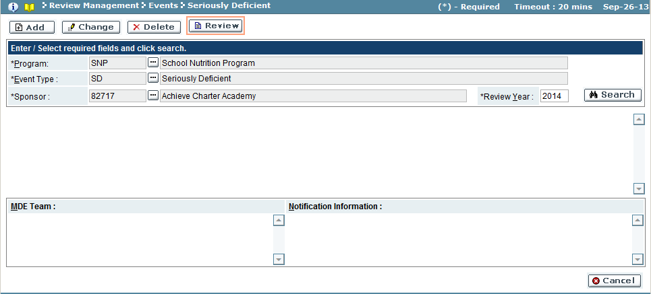

| Field Name | Action |
| --- | --- |
| Program | Select the program from the look-up |
| Event Type | Select the event type from the look-up |
| Sub-Recipient/Sponsor | Select the sub-recipient/sponsor from the look-up |
| Review Year | Enter the review year |

Add

In this mode, the seriously deficient events can be initiated.

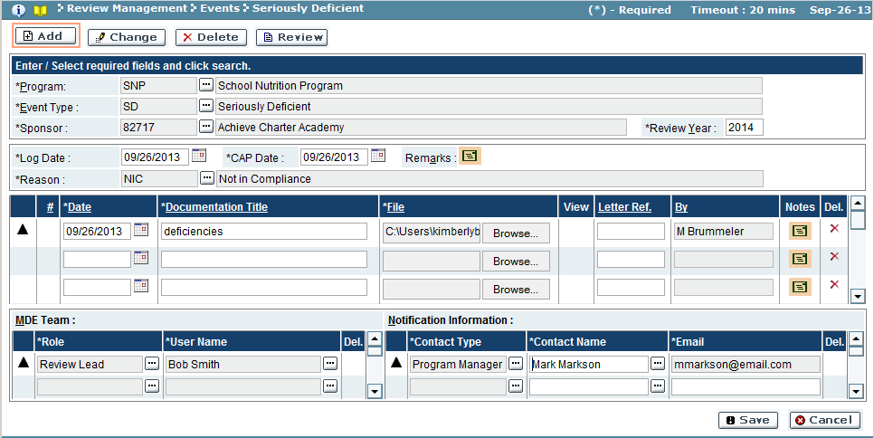

| Field Name | Description |
| --- | --- |
| *Claim Information Results Pane* | |
| Log Date | Date of deficiency |
| CAP Date | Compliance Action Plan date |
| Remarks | Click the comments  icon to view comments for claim |
| Reason | Use the look-up function to select the deficiency reason |
| *Documentation Results Pane* | |
| # | Serial number of the documentation |
| Date | Document date |
| Documentation Title | Name of document |
| File | File uploaded. Click ‘Browse’ button to upload document |
| View | Uploaded file. Click the attachment  icon to view file |
| Letter Ref. | Letter reference code |
| By | User who added document |
| Notes | Click the comments  icon to view comments for document |
| Del. | If ‘**X**’ exists, the document record can be deleted by selecting icon |
| *MDE Team Results Pane* | |
| Role | System role of the MDE team member |
| User Name | User name of MDE team member |
| Del. | If ‘**X**’ exists, the user record can be deleted by selecting icon |
| *Notification Information Results Pane* | |
| Contact Type | Contact type of the contact |
| Contact Name | Name of the contact (may use look-up or add a new user) |
| Email | Email address of the contact (auto-populate from contact name, or may add a new email) |
| Del. | If ‘**X**’ exists, the contact record can be deleted by selecting icon |

1. Use the search feature to select the program to create the event.
2. Enter the deficiency information, including the reason for event.
3. Add related document(s) for the seriously deficient event, using the ‘Browse’ button to upload file(s).
4. Select the MDE Team members, as appropriate.
5. Select sub-recipient/sponsor contact’s to receive the event notification.
6. To save the claim, click the ‘Save’ button.

Change

In this mode, changes can be made to the seriously deficient event, as well as the event can be promoted to the next stage, either completing the event or assigning findings.

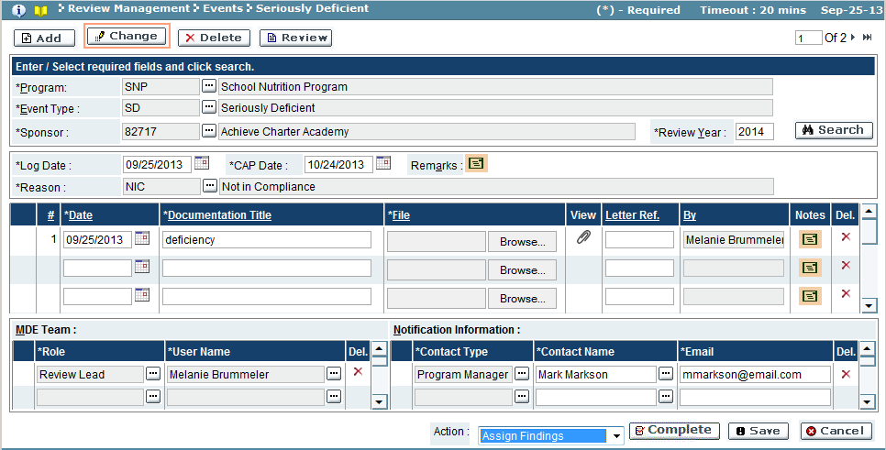

1. Use the search feature to select the seriously deficient event.
2. If changes are necessary, make changes and click ‘Save’ to save the changes.
3. To complete the claim event, select the action appropriate (Complete – event complete, Assign Findings – create findings for event) and click the ‘Complete’ button. (Once complete, a late claim cannot be changed or deleted)
   1. A popup window will appear:

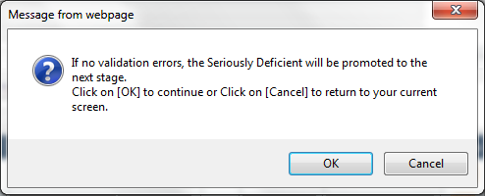

* 1. Click ‘OK’ to complete the action (‘Cancel’ button will discard action).
  2. If the action is completed, a confirmation window will appear. Click ‘OK’ to close the confirmation window and return to the seriously deficient screen.

Delete

In this mode, seriously deficient events can be deleted from the system.

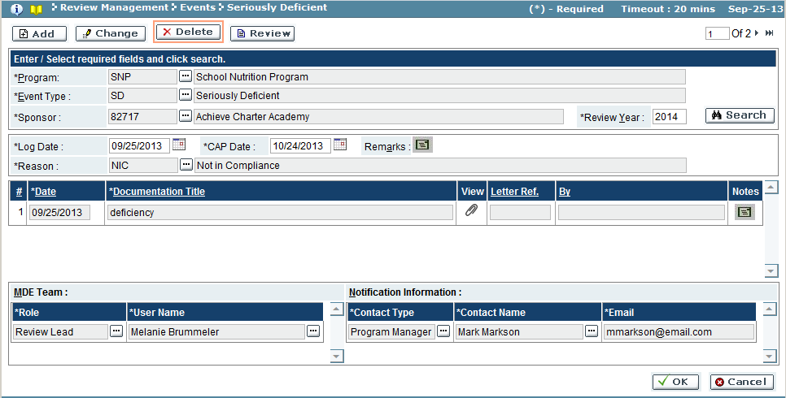

* + 1. Use the search feature to select the seriously deficient event.
    2. Click ‘OK’ button to delete the seriously deficient event (‘Cancel’ button will not delete event).
    3. A confirmation window will appear, confirming delete. Click ‘OK’ to close confirmation window and return to the seriously deficient screen.

Troubleshooting

| **#** | **Error** | **Description** | **Corrective Action** |
| --- | --- | --- | --- |
| 1 | Error Message: <Fieldname> cannot be empty | <Fieldname> is blank | The required fields are marked by asterisk *. When one of these fields is not entered, the system prompts with the above error message. Please enter / select value into the field and retry the operation. |

### Miscellaneous

The miscellaneous screen allows users to log miscellaneous events, with related documentation, MDE Team members and sub-recipient/sponsor notification contact(s).

To access this functionality, navigate to the following menu:

**Review Management → Events → Miscellaneous**

This screen has the following functionality: Review, Add, Change and Delete

|  |  |
| --- | --- |
| Predecessor |  |
| Who | MDE |
| When | As Needed |
| Subsequent |  |

Review

In this mode, miscellaneous events can be viewed. No changes can be made in this mode.

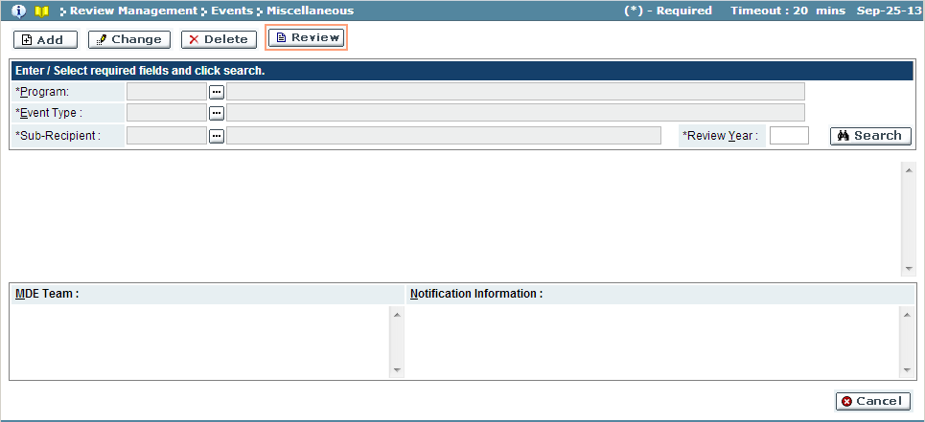

| Field Name | Action |
| --- | --- |
| Program | Select the program from the look-up |
| Event Type | Select the event type from the look-up |
| Sub-Recipient/Sponsor | Select the sub-recipient/sponsor from the look-up |
| Review Year | Enter the review year |

Add

In this mode, the miscellaneous events can be initiated.

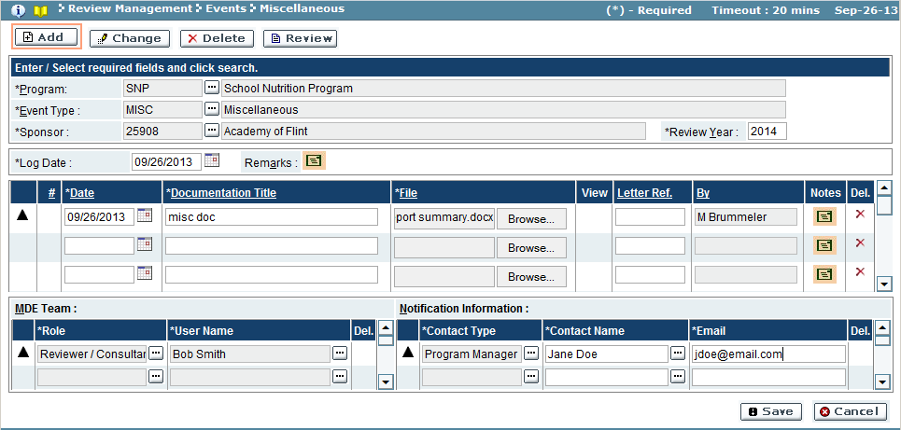

| Field Name | Description |
| --- | --- |
| *Claim Information Results Pane* | |
| Log Date | Log Date of event |
| Remarks | Click the comments  icon to view comments for event |
| *Documentation Results Pane* | |
| # | Serial number of the documentation |
| Date | Document date |
| Documentation Title | Name of document |
| File | File uploaded. Click ‘Browse’ button to upload document |
| View | Uploaded file. Click the attachment  icon to view file |
| Letter Ref. | Letter reference code |
| By | User who added document |
| Notes | Click the comments  icon to view comments for document |
| Del. | If ‘**X**’ exists, the document record can be deleted by selecting icon |
| *MDE Team Results Pane* | |
| Role | System role of the MDE team member |
| User Name | User name of MDE team member |
| Del. | If ‘**X**’ exists, the user record can be deleted by selecting icon |
| *Notification Information Results Pane* | |
| Contact Type | Contact type of the contact |
| Contact Name | Name of the contact (may use look-up or add a new user) |
| Email | Email address of the contact (auto-populate from contact name, or may add a new email) |
| Del. | If ‘**X**’ exists, the contact record can be deleted by selecting icon |

1. Use the search feature to select the program to create the miscellaneous event.
2. Enter event log date and any remarks.
3. Add related document(s) for the miscellaneous event, using the ‘Browse’ button to upload file(s).
4. Select the MDE Team members, as appropriate.
5. Select sub-recipient/sponsor contact’s to receive the event notification.
6. To save the event, click the ‘Save’ button.

Change

In this mode, changes can be made to miscellaneous event, as well as promoting the event to the next stage, by either completing the event.

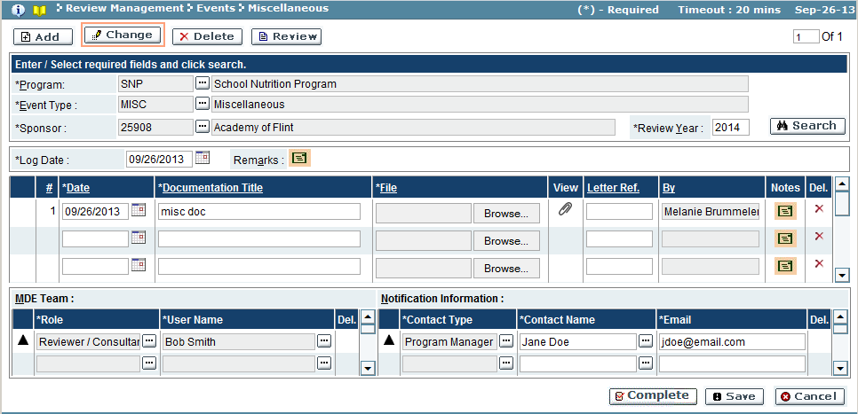

1. Use the search feature to select the miscellaneous event.
2. If changes are necessary, make changes and click ‘Save’ to save the changes.
3. To complete the event, click the ‘Complete’ button.

Delete

In this mode, miscellaneous events can be deleted from the system.

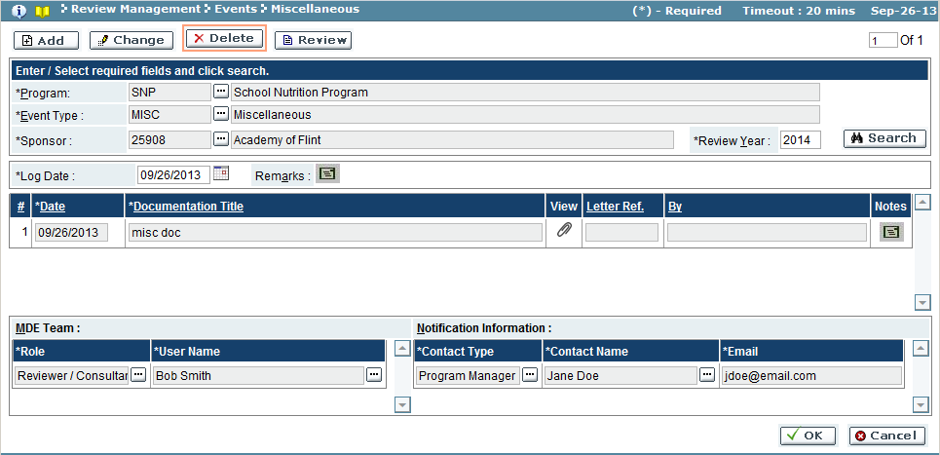

* + 1. Use the search feature to select the miscellaneous event.
    2. Click ‘OK’ button to delete the event (‘Cancel’ button will not delete event).
    3. A confirmation window will appear, confirming delete. Click ‘OK’ to close confirmation window and return to the miscellaneous screen.

Troubleshooting

| **#** | **Error** | **Description** | **Corrective Action** |
| --- | --- | --- | --- |
| 1 | Error Message: <Fieldname> cannot be empty | <Fieldname> is blank | The required fields are marked by asterisk *. When one of these fields is not entered, the system prompts with the above error message. Please enter / select value into the field and retry the operation. |

# Follow-up

## Approve Compliance Plan

Approve Compliance Plan is used to determine the approval status of the compliance plan information submitted by the sub-recipient/sponsor. In this screen, you can set the status of the compliance action, approving, rejecting, or sending the item back to the sub-recipient/sponsor, requesting additional information.

To access this functionality, navigate to the following menu:

**Follow-up → Approve Compliance Plan**

This screen has the following functionality: Review, Approve.

|  |  |
| --- | --- |
| Predecessor | Compliance Plan |
| Who | MDE User |
| When | Review Process |
| Subsequent | Completion Evidence |

Review

In this mode, you can view the compliance plans submitted by the sub-recipient/sponsor for each action item found in the Assign Findings stage. No changes can be made in this mode.

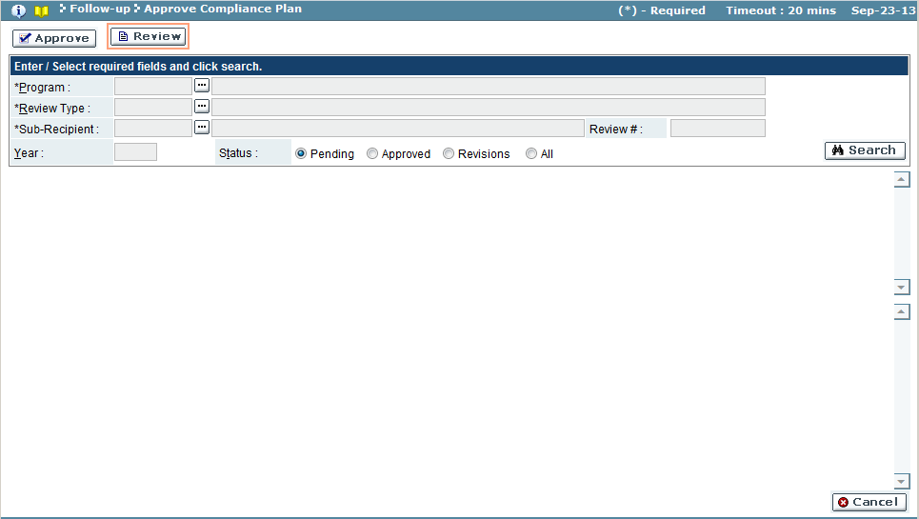

| Field Name | Action |
| --- | --- |
| Program | Select the program from the look-up |
| Review Type | Select review type from the look-up |
| Sub-Recipient/Sponsor | Select the sub-recipient/sponsor from the look-up |
| Status | Select the status (Pending/Approved/Revisions/Rejected/All) |

Approve

In this mode, you can assign the status of the compliance plan, approving the plan for completion evidence, or sending the item back to the sub-recipient.

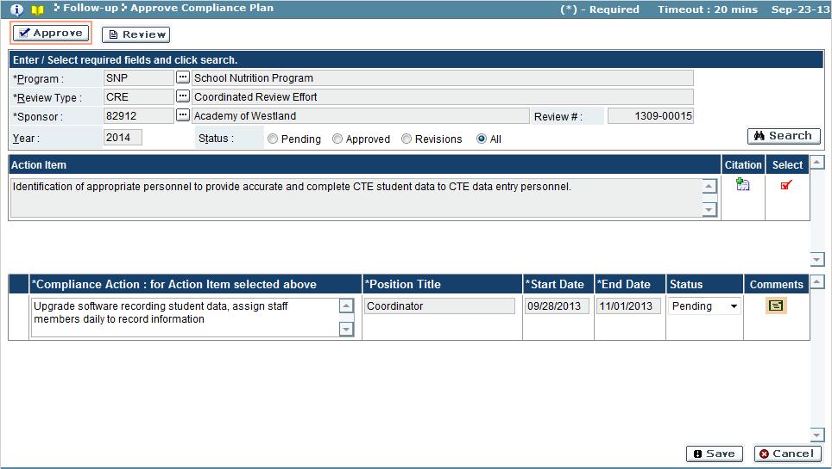

| Field Name | Description |
| --- | --- |
| *Action Item Results Pane* | |
| Action Items | Action item |
| Citation | Click the details  icon to view the citation and findings details |
| Select | Click the section  icon to view the compliance action plan for the action item. Icon will change to the selected icon when results are displayed in lower results pane |
| *Compliance Action Plan Results Pane* | |
| Compliance Action | Compliance action submitted by sub-recipient/sponsor |
| Position Title | Position responsible for compliance action |
| Start Date | Start date of the action |
| End Date | End date of the action |
| Status | Approval status of the compliance action plan (Pending/Approved/Revisions/Rejected) |
| Comments | If Status is ‘Revisions’ or ‘Rejected’, additional comments are added using the comments  icon. |

1. Use the search feature to view compliance plan(s) to approve.
2. The system will display the compliance plans for the sub-recipient/sponsor selected.
3. Click on the Show Status icon () to select a document. Selected document shows the icon against it.

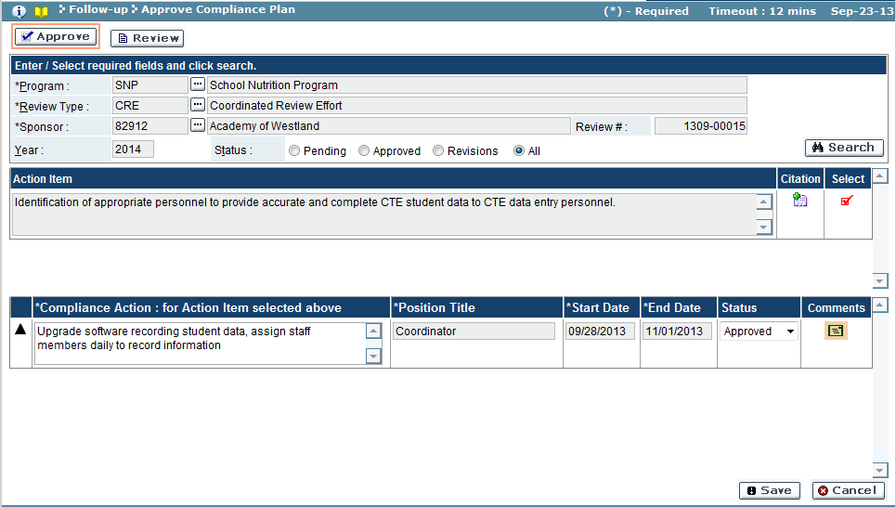

1. Determine if the compliance action plan’s status, change Status field.
   1. If compliance action plan is not approved, change Status to ‘Revisions’ or ‘Rejected’. The sub-recipient/sponsor will need to modify the compliance action based on notations made in the comments icon, and re-submit for approval.
   2. If compliance action plan is approved, change Status to ‘Approved. Item will be promoted to next stage where sub-recipient/sponsor will be able to submit Completion Evidence.
   3. If determination has not been made, leave Status set at ‘Pending’.
2. Click ‘Save’ button to commit changes (‘Cancel’ button will discard changes).
3. A confirmation window will appear. Click ‘OK’ to submit changes.

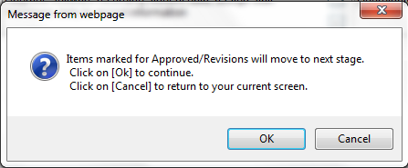

1. A confirmation window will appear confirming the changes. Click ‘OK’ button to close window.

Troubleshooting

| **#** | **Error** | **Description** | **Corrective Action** |
| --- | --- | --- | --- |
| 1 | Error Message: <Fieldname> cannot be empty | <Fieldname> is blank | The required fields are marked by asterisk *. When one of these fields is not entered, the system prompts with the above error message. Please enter / select value into the field and retry the operation. |

## Approve Completion Evidence

Approve Completion Evidence is used to determine the approval status of the completion evidence submitted by the sub-recipient/sponsor, as per the compliance plan. In this screen, you can set the status of the completion evidence; approving evidence for the compliance plan (thereby closing the compliance plan item for the review), or rejecting evidence where the item will return to the sub-recipient/sponsor for revisions to the evidence.

To access this functionality, navigate to the following menu:

**Follow-up → Approve Completion Evidence**

This screen has the following functionality: Review, Approve.

|  |  |
| --- | --- |
| Predecessor | Completion Evidence |
| Who | MDE User |
| When | Review Process |
| Subsequent |  |

Review

In this mode, you can view the completion evidence submitted by the sub-recipient/sponsor for each approved compliance plan. You cannot make any changes in this mode.

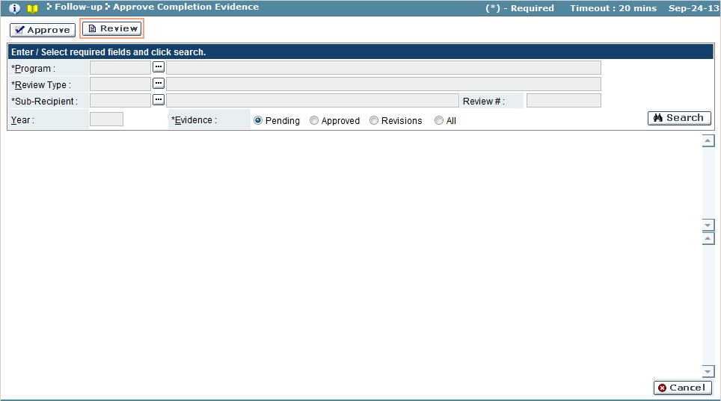

| Field Name | Action |
| --- | --- |
| Program | Select the program from the look-up |
| Review Type | Select the review type from the look-up |
| Sub-Recipient | Select the sub-recipient/sponsor from the look-up |
| Evidence | Select the status (Pending/Approved/Revisions/Rejected/All) |

Approve

In this mode, you can assign the status of the completion evidence, either approving the evidence as proof of compliance, or returning the item back to the sub-recipient for revision.

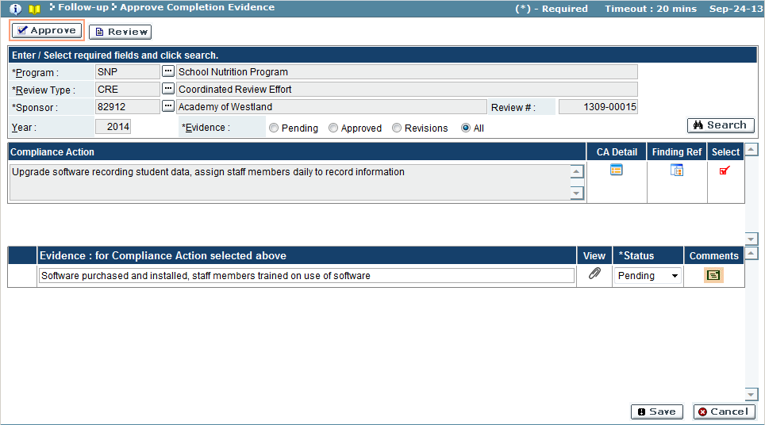

| Field Name | Description |
| --- | --- |
| *Compliance Action Results Pane* | |
| Compliance Action | Compliance action detailed by sub-recipient/sponsor |
| CA Detail | Compliance action details (position responsible, dates) |
| Finding Ref | Finding reference details (Citation, Findings, Action Item) |
| Select | Show selection icon, when clicked will display the results in the evidence results pane. Icon will change to  when record is selected for viewing |
| *Evidence Results Pane* | |
| Evidence | Information on how the compliance plan was adhered to, bringing the item into compliance, submitted by sub-recipient/sponsor |
| View | Click the attachment  icon to view the evidence documents |
| Status | Approval status of the evidence (Pending, Approved, Revisions) |
| Comments | Comments  icon has comments for evidence in ‘Revision’ status |

1. Use the search feature to view compliance evidence(s) to approve.
2. The system will display the compliance evidence for the sub-recipient/sponsor selected.
3. Click the show status icon in the Select column, to view the evidence for the compliance action item. A selected compliance action item will have the icon.
4. View the document submitted for the evidence by clicking the attachment icon.
5. Make a determination on the completion evidence, update the Status field.

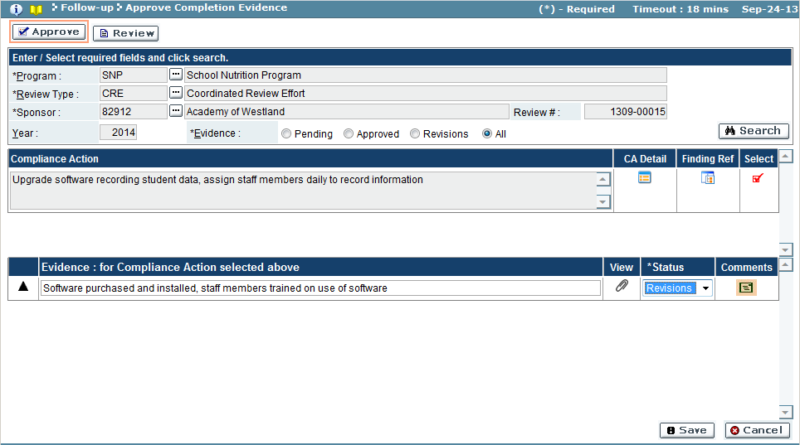

* 1. Approved, the completion evidence was approved and accepted.
  2. Revision, the completion evidence required revisions and is not accepted.
     1. If the evidence requires revision, use the comments icon to insert comments regarding revisions to be made.

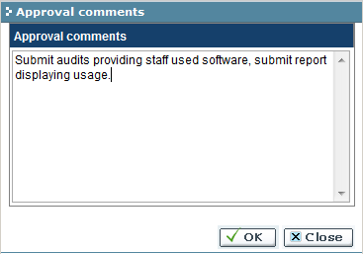

* 1. Pending, the determination has not been made for the completion evidence.

1. When determination is complete, click the ‘Save’ button to submit the status for the evidence (‘Cancel’ button will discard changes).
2. A confirmation window appears:

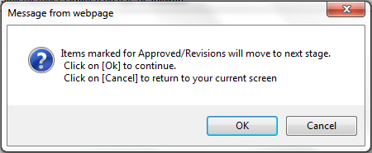

* 1. Click ‘OK’ button to submit items (‘Cancel’ button will discard submission).

1. If the submission is accepted, a confirmation window appears. Click ‘OK’ button to close the confirmation window.

Troubleshooting

| **#** | **Error** | **Description** | **Corrective Action** |
| --- | --- | --- | --- |
| 1 | Error Message: <Fieldname> cannot be empty | <Fieldname> is blank | The required fields are marked by asterisk *. When one of these fields is not entered, the system prompts with the above error message. Please enter / select value into the field and retry the operation. |

## Appeal Finding(s)

A review’s findings can be placed through an appeal process. This screen allows users to start an appeal on a review’s finding(s), or make a determination on a submitted appeal.

To access this functionality, navigate to the following menu:

**Follow-up → Appeal Finding(s)**

This screen has the following functionality: Review, Setup.

|  |  |
| --- | --- |
| Predecessor | Create Findings Package |
| Who | MDE User |
| When | Review Process |
| Subsequent | Compliance Plan |

Review

In this mode, the appeals made for a review’s findings packages are viewable. Detailed information regarding each finding will be displayed, as well as the appeals submitted for the finding(s). No changes can be made in this mode.

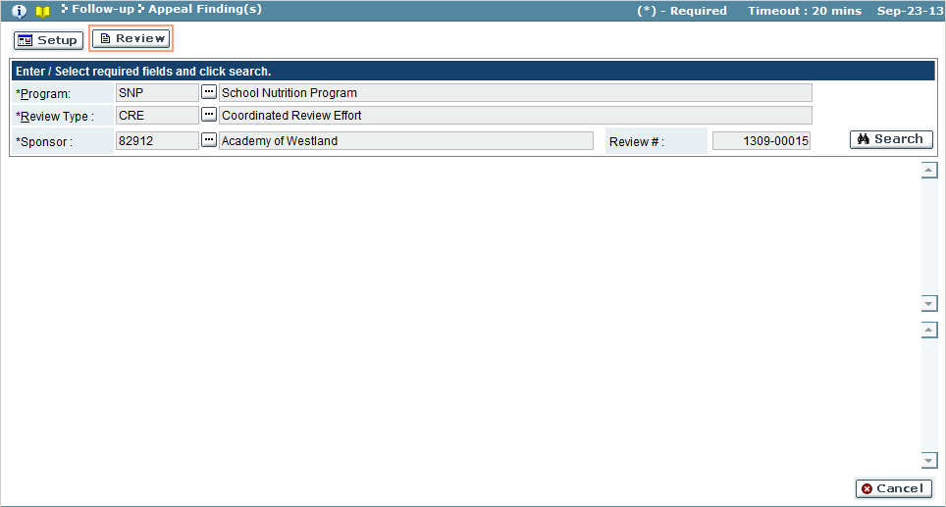

| Field Name | Action |
| --- | --- |
| Program | Select the program from the look-up |
| Review Type | Select the review type from the look-up |
| Document | Select the document from the look-up |

Setup

In this mode, the findings requiring a compliance plan will be displayed. Each finding(s) details will be displayed, including the citation, ARC and appeal status, appeal notification template used. The middle pane (Findings) is used to determine the appeal status. Start an appeal in the lower results pane (Appeals) by uploading supporting appeal documentation, and adding notes.

If an appeal is overruled, finding will be moved to the next stage, Create Compliance Plan. If the appeal was upheld, the finding will be moved to the stage, Review Complete.

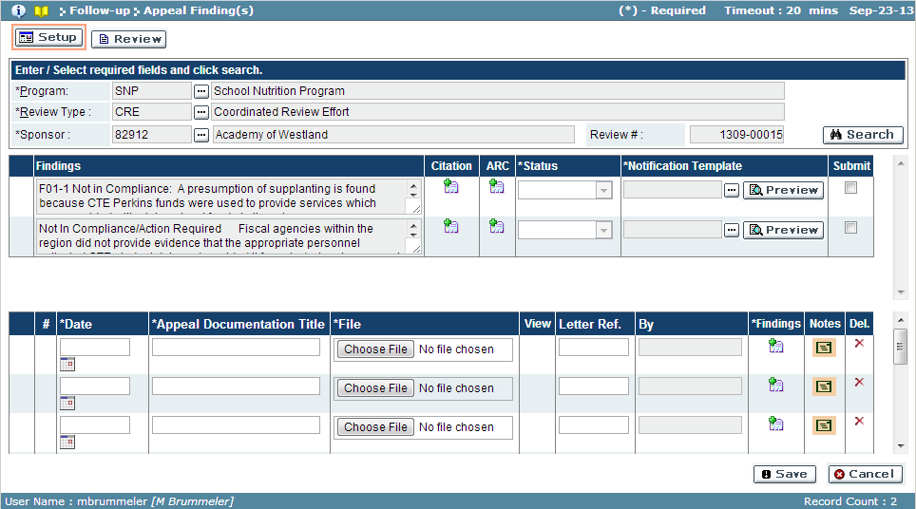

| Field Name | Description |
| --- | --- |
| *Findings Results Pane* | |
| Findings | Description of each finding reported for the review |
| Citation | Click details  icon to view the citation for the finding |
| ARC | Click details  icon to view the ARC for the finding |
| Status | Status of the finding’s appeal |
| Notification Template | Notification Template, click ‘Preview’ button to view notification |
| Submit | A check in the box of this column denotes the finding is to be submitted |
| *Appeal Results Pane* | |
| # | Serial number of the appeal document |
| Date | Date of the appeal. Click the calendar  icon to use calendar to select a date |
| Appeal Documentation Title | The name given for the appeal’s attachment |
| File | Uploaded filename of the appeal. ‘Choose File’ button will invoke the steps to select file for upload |
| View | Click the attachment  icon to download the appeal document |
| Letter Ref. | Letter reference number |
| By | Name of the user who submitted the appeal |
| Findings | Click the details  icon to select the finding related to appeal |
| Notes | Click the notes  icon to view notes related to the appeal documentation |
| Del. | If the ‘**X**’ icon appears, this appeal can be deleted. Click the ‘**X**’ to remove the appeal from this review’s findings |

1. Use the search feature to view the review finding(s).
2. A list of finding(s) and any submitted appeals will appear for the search criteria.
3. *To submit an appeal:*
   1. In the Appeals pane (lowest pane), enter the date of the appeal, a document name for the document to be submitted.
   2. Click ‘Choose File’ button to open the windows explorer browser.

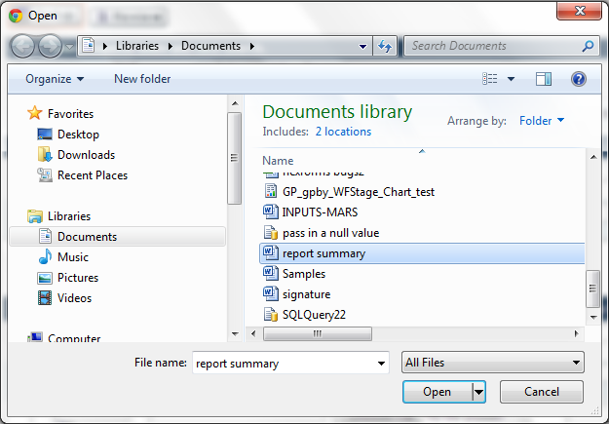

* 1. Select the file to upload
  2. Click ‘OK’ button to select file (‘Cancel’ will discard file) and return to Appeal Findings screen.
  3. Enter a Letter Reference Number, as appropriate.
  4. Click the details  icon to select the finding(s) the documentation is related to.

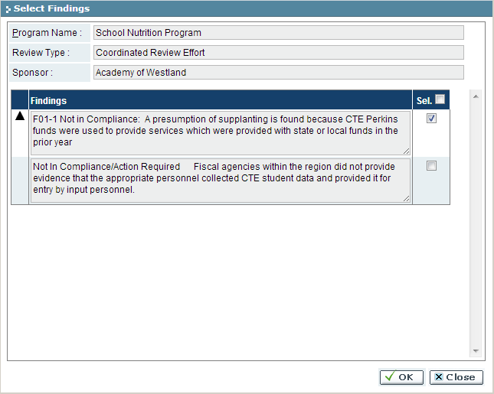

* 1. Place a check in the box of the Sel. Column for the finding(s) related to the document.
  2. Click ‘OK’ to save the finding(s) and (‘Cancel’ will discard changes) and return to Appeal Finding(s) screen.
  3. Click the notes  icon to enter any additional notes regarding the appeal.

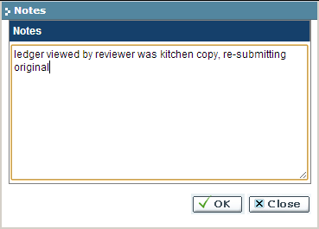

* 1. Click ‘OK’ to save the notes (‘Cancel’ will discard notes) and return to Appeal Finding(s) screen.
  2. Click ‘Save’ button to save the appeal.

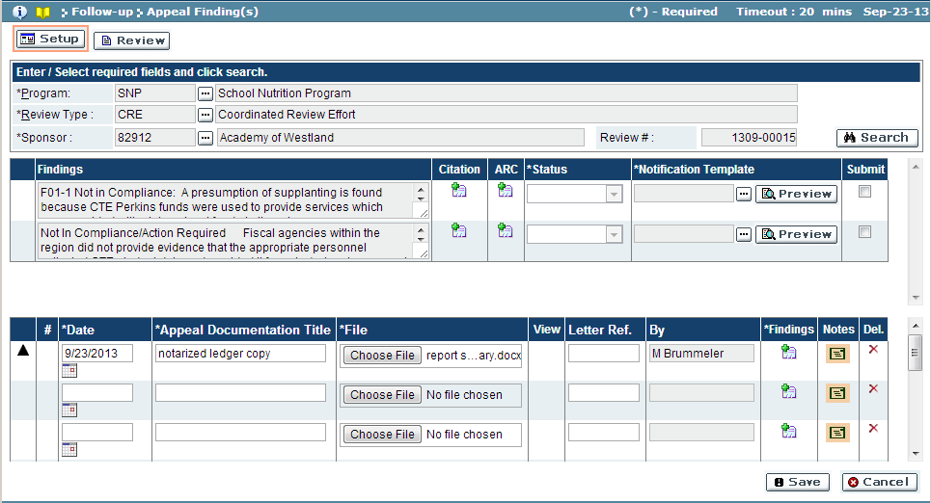

1. *To make a determination on an appeal:*
   1. In the lower pane (Appeals), click the attachment  icon to download and review the attachment for the appeal.
   2. Click the details  icon to view the finding related to the appeal.
   3. Click the notes  icon to view the additional notes submitted for the appeal.
   4. When a determination has been made, use the middle pane (Findings) to update the appeal status of the finding.

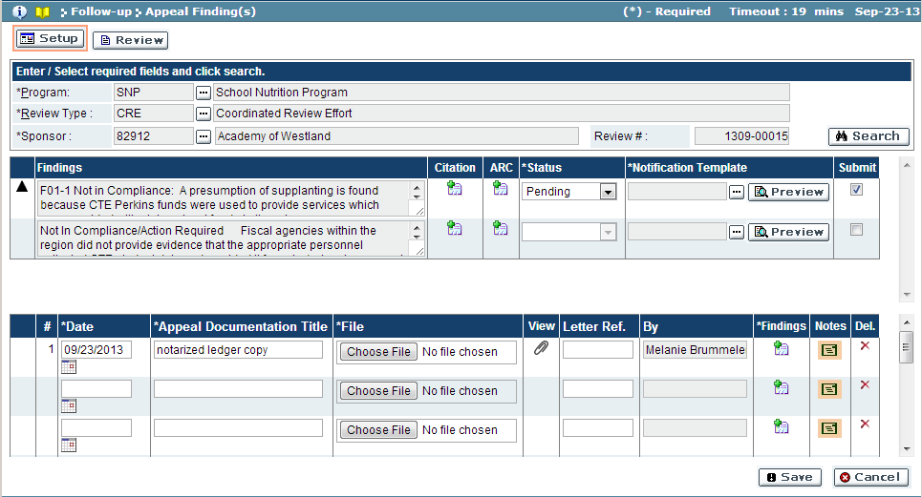

* 1. Update the Status field. If the appeal was overruled, select ‘Overruled’. If the appeal was upheld, select ‘Upheld’. If the decision has not yet been made, select ‘Pending’.
  2. If the Status was set to Overruled or Upheld, select the notification template from the lookup that will be sent to sub-recipient. (Click ‘Preview’ button to view the notification, optional).
  3. Place a check in the box of the Submit column to select the finding.

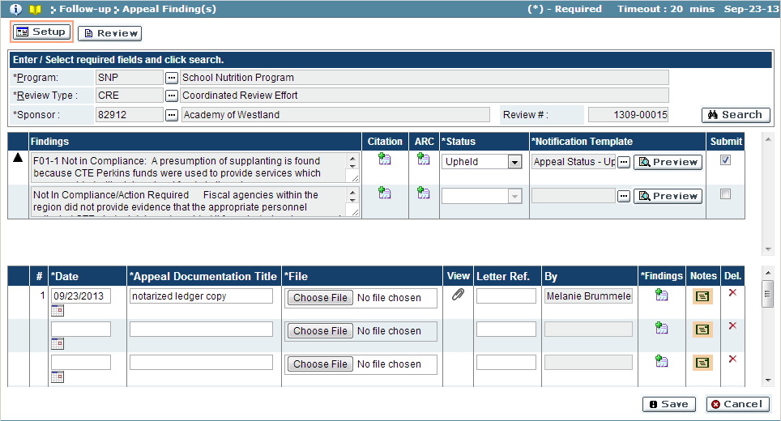

* 1. Click ‘Save’ button to save determination (Cancel will discard changes). The notification will be sent to sub-recipient, and the finding(s) will be promoted to the next stage.

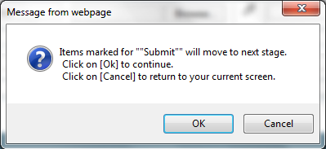

* 1. Click ‘OK’ button to complete submission (‘Cancel’ button will discard submission).
  2. If the submission was completed and error free, a confirmation window will appear. Click ‘OK’ button to close window.

## Intent to Terminate

If a review’s findings require a sub-recipient/sponsor to submit a compliance plan, and the compliance plan is not submitted by the Compliance Plan Action Date (*see section Approve Findings*), the sub-recipient/sponsor contract may come into jeopardy of being terminated. This screen allows users to view reviews in the Intent to Terminate status, as well as allow a user to terminate a sub-recipient/sponsor’s contract due to non-compliance.

To access this functionality, navigate to the following menu:

**Follow-up → Intent to Terminate**

This screen has the following functionality: Review, Setup.

|  |  |
| --- | --- |
| Predecessor | Create Findings Package |
| Who | MDE User |
| When | Review Process |
| Subsequent | Compliance Plan/Terminate |

Review

In this mode, sub-recipient/sponsor(s) review(s) with findings requiring a compliance plan that have passed the Compliance Plan Action Date and are in jeopardy of termination, or those that have been terminated are viewable. The finding(s) for each review are viewable.

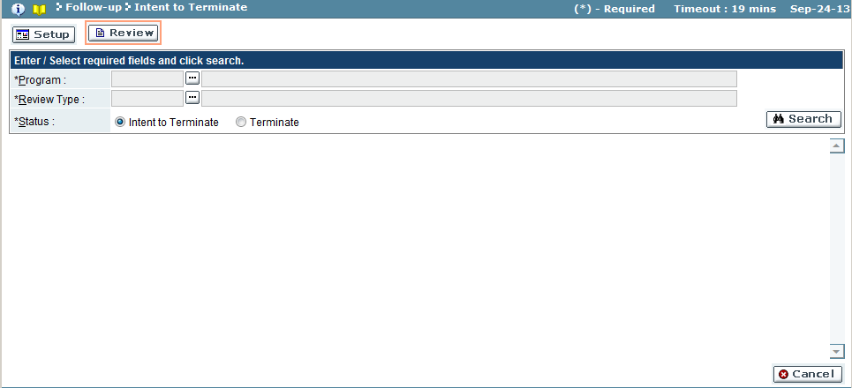

| Field Name | Action |
| --- | --- |
| Program | Select the program from the look-up |
| Review Type | Select the review type from the look-up |
| Status | Select the termination status (Intent to Terminate/Terminate) |

Setup

In this mode, contracts can be terminated.

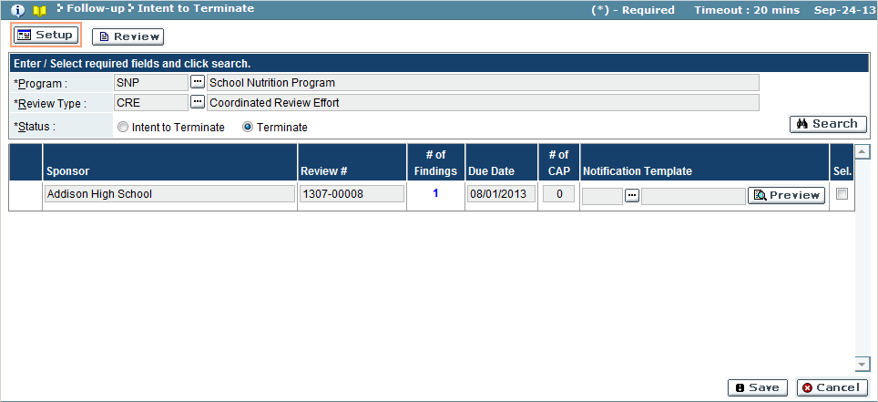

| Field Name | Description |
| --- | --- |
| Sub-Recipient/Sponsor | Sub-recipient/sponsor name |
| Review # | Review number not in compliance |
| # of Findings | Number of finding(s) for the review. Click the hyperlink to view each finding and citation |
| Due Date | The compliance plan due date |
| # of CAP | Number of compliance action plan(s) in place for the review |
| Notification Template | Template used to notify sub-recipient/sponsor of the termination |
| Sel. | When checked, the action in the Status search field will be executed |

1. Use the search feature to view contract(s) to terminate. Sub-recipient/sponsor will need to be in the Intent to Terminate status, in order to terminate, select the Terminate status.
2. View the sub-recipient/sponsor’s with contracts to terminate.
3. Select the notification template. Click ‘Preview’ to view the template selected.
4. Place a check in the box of the Sel. column to denote the contract will be terminated.

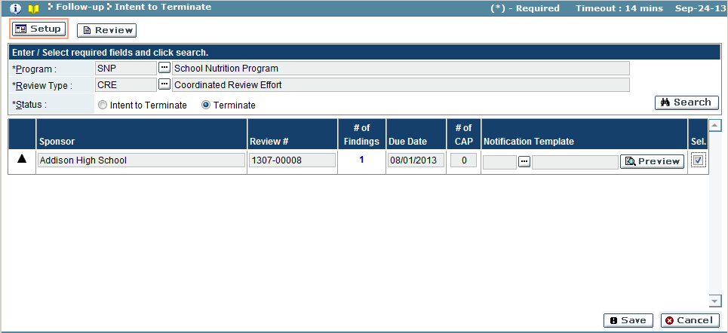

## Appeal Intent to Terminate

An Intent to Terminate can be appealed allowing a sub-recipient/sponsor complete actions necessary come back into compliance.

To access this functionality, navigate to the following menu:

**Follow-up → Appeal Intent to Terminate**

This screen has the following functionality: Review, Setup.

|  |  |
| --- | --- |
| Predecessor |  |
| Who | Sub-Recipient/Sponsor User |
| When | Review Process |
| Subsequent |  |

Review

In this mode,

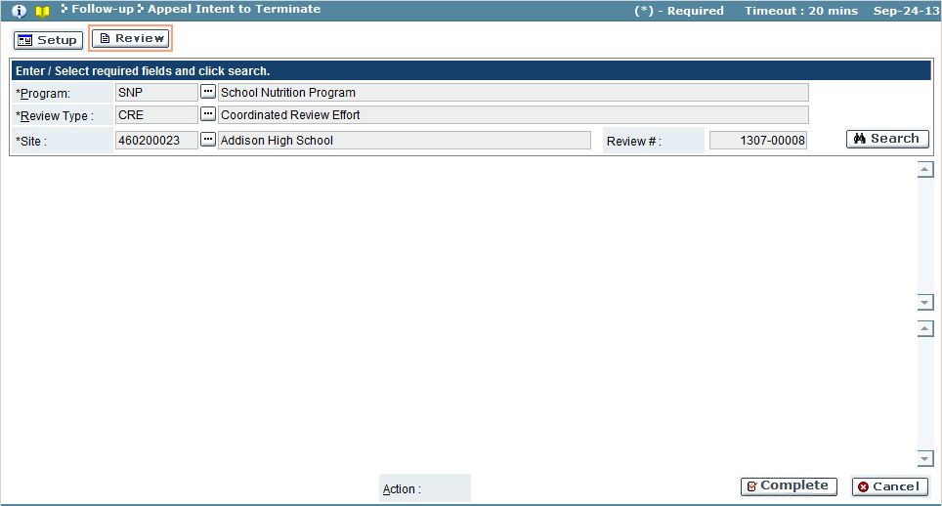

| Field Name | Action |
| --- | --- |
| Program | Select the program from the look-up |
| Review Type | Select the review type from the look-up |
| Site/Building | Select the site/building from the look-up |

Setup

In this mode, users can submit their appeal

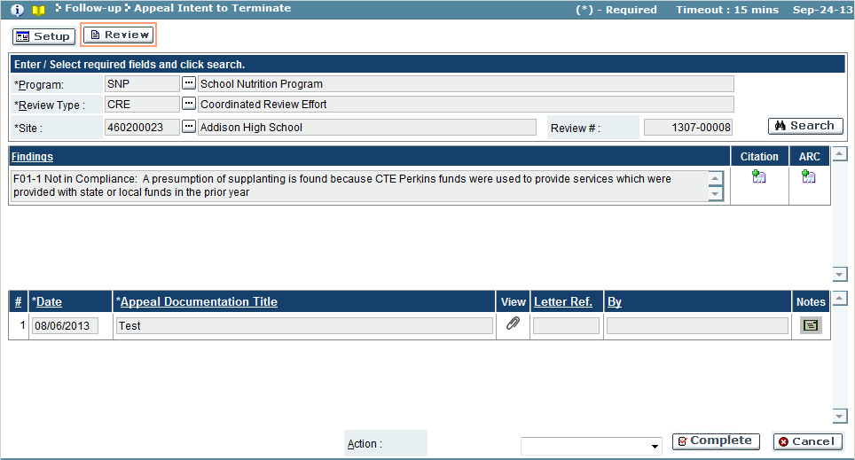

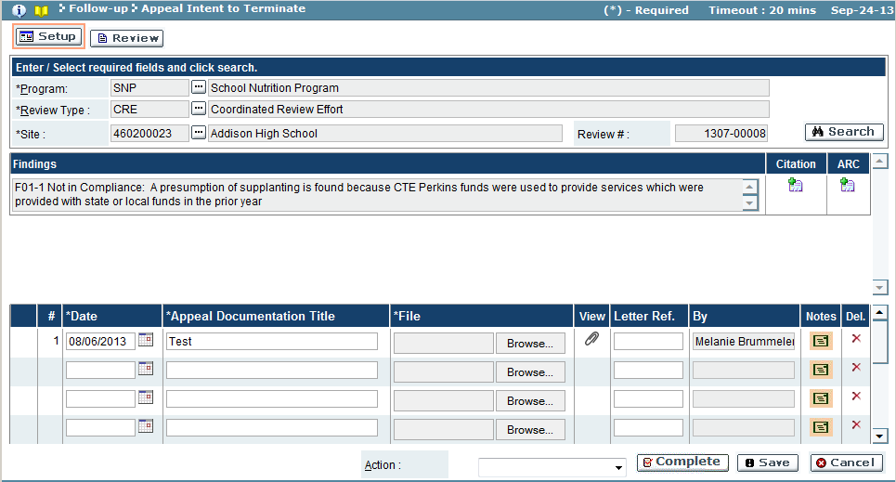

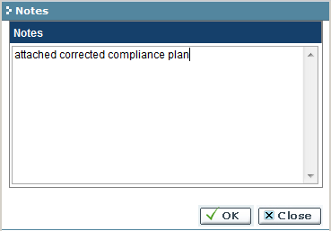

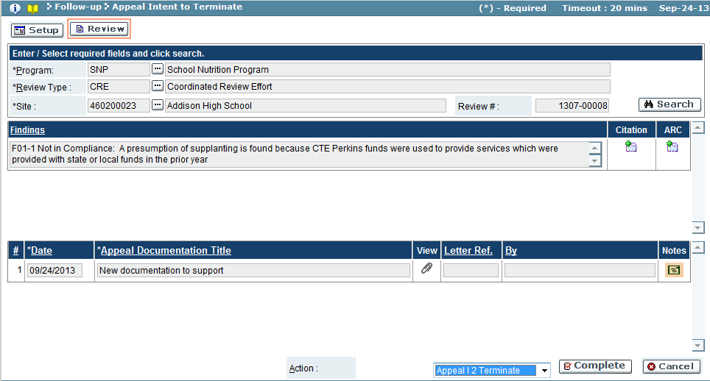

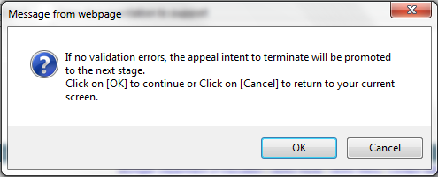

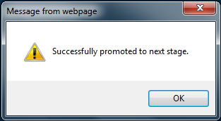

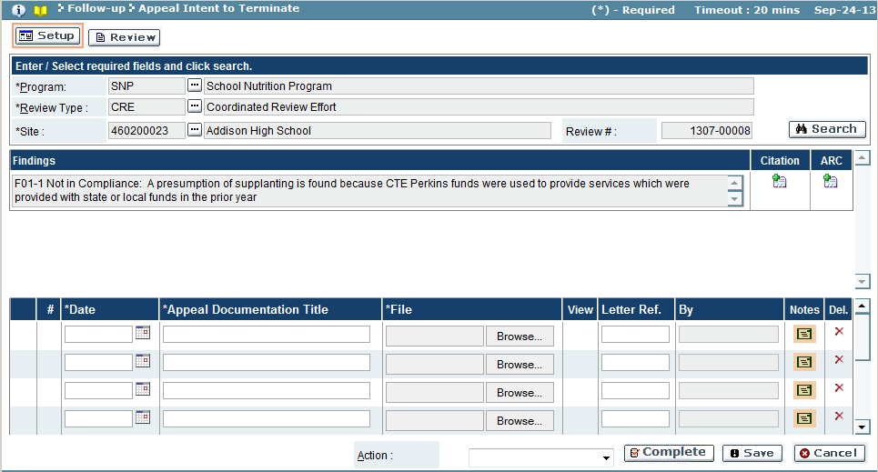

# Documentation

## Program Documents

Program Documents are used to provide sub-recipients with additional information which can aid them in the review process.

To access this functionality, navigate to the following menu:

**Documentation → Program Documents**

This screen has the following functionality: Review, Delete, Change, Add.

|  |  |
| --- | --- |
| Predecessor | Program |
| Who | Program Administrator |
| When | Initial setup and as needed |
| Subsequent |  |

Review

In this mode, you can view the program documents uploaded to the GEMS. You cannot make any changes in this mode.

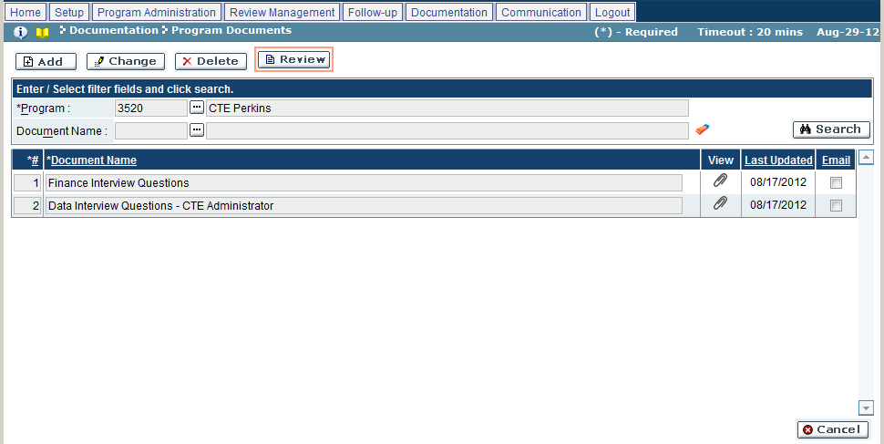

| Field Name | Action |
| --- | --- |
| Program | Select the desired program from the look-up |
| Document | Select the desired document from the look-up |

1. Use search function to view documents.
2. The system will display the list of program documents selected above.
3. Click the  icon to view the attachment.

Delete

In this mode, you can delete program documents previously uploaded to the GEMS.

1. Click on ‘Delete’ mode.
2. Enter the search criteria as per the Review mode.
3. Click on the ‘**X**’ icon to delete the program documents.
4. Once changed, click on ‘OK’ to save or ‘Cancel’ to discard the changes.

Change

In this mode, you can change the program documents information previously uploaded to the GEMS.

1. Click on ‘Change’ mode.
2. Enter the search criteria as per the Review mode.
3. Make changes to the fields as per the following:

| Field Name | Action |
| --- | --- |
| # | Enter the desired numeric position for the document |
| Document Name | Enter the desired name for the document |
| Attach Document | Click on the ‘Browse’ button to select a file to be uploaded as assessment |
| Email | Click the checkbox to include as an email |

1. Once changed, click on ‘Save’ to save or ‘Cancel’ to discard the changes.

Add

In this mode, you can add new program documents to the GEMS.

1. Click on ‘Change’ mode.
2. Enter the search criteria, as per the following:

| Field Name | Action |
| --- | --- |
| Program | Select the desired program from the look-up |

1. Make changes to the fields as per the following:

| Field Name | Action |
| --- | --- |
| # | Enter the desired numeric position for the document |
| Document Name | Enter the desired name for the document |
| Attach Document | Click on the ‘Browse’ button to select a file to be uploaded as assessment |
| Email | Click the checkbox to include as an email |

1. Once changed, click on ‘Save’ to save or ‘Cancel’ to discard the changes.

Troubleshooting

| **#** | **Error** | **Description** | **Corrective Action** |
| --- | --- | --- | --- |
| 1 | Error Message: <Fieldname> cannot be empty | <Fieldname> is blank | The required fields are marked by asterisk *. When one of these fields is not entered, the system prompts with the above error message. Please enter / select value into the field and retry the operation. |

## Q&A Responses

Q&A Responses are used to provide answers to questions submitted by sub-recipients. Questions can be grouped into specific categories and added to a list of frequently asked questions (FAQ).

To access this functionality, navigate to the following menu:

**Documentation → Q&A Responses**

This screen has the following functionality: Review, Response.

|  |  |
| --- | --- |
| Predecessor | Program |
| Who | Program Administrator |
| When | Initial setup and as needed |
| Subsequent |  |

Review

In this mode, you can view questions submitted to the GEMS. You cannot make any changes in this mode.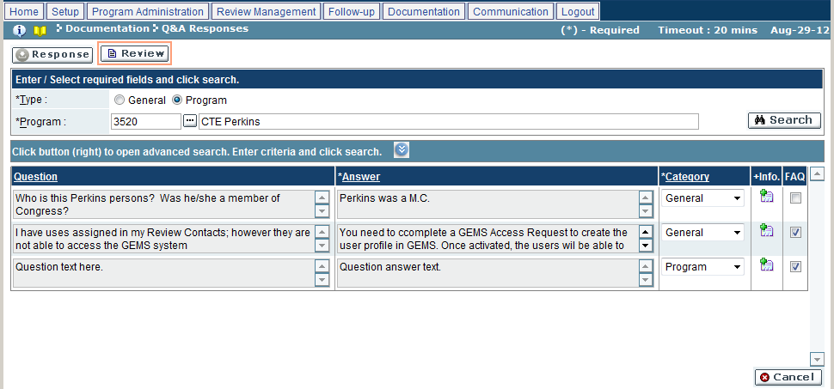

|  |  |
| --- | --- |
| Field Name | Action |
| Type | Select the question type (General/Program) |
| Program | Select the program from the look-up, if the above selected is ‘Program’ |

1. Use the search function to view the questions.
2. The system will display the list of submitted questions along with any answers that may have been provided.

Response

In this mode, you can answer questions submitted to the GEMS, change answers, or delete questions.

1. Click on ‘Response’ mode.
2. Enter the search criteria as per the Review mode.
3. Click the  icon to view additional question information.
4. Make changes to the fields as per the following:

| Field Name | Action |
| --- | --- |
| Answer | Enter or edit the answer to the question |
| Category | Select the desired category from the dropdown (Fiscal/General/Program) |
| FAQ | Click the checkbox to add the selected question to the list of frequently asked questions (FAQ) |

1. You can delete a question by clicking on the ‘X’ icon.
2. Once changed, click on ‘Save’ to save or ‘Cancel’ to discard the changes.

Troubleshooting

| **#** | **Error** | **Description** | **Corrective Action** |
| --- | --- | --- | --- |
| 1 | Error Message: <Fieldname> cannot be empty | <Fieldname> is blank | The required fields are marked by asterisk *. When one of these fields is not entered, the system prompts with the above error message. Please enter / select value into the field and retry the operation. |

## FAQ

The FAQ screen is used to add questions and answers to the list of frequently asked questions. Questions and answers can be added from the list of questions submitted through the Q&A screen or added manually ad hoc.

To access this functionality, navigate to the following menu:

**Documentation → FAQ**

This screen has the following functionality: Review, Delete, Change, Add.

|  |  |
| --- | --- |
| Predecessor | Program |
| Who | Program Administrator |
| When | Initial setup and as needed |
| Subsequent |  |

Review

In this mode, you can view the list of questions which compromises the frequently asked questions. You cannot make any changes in this mode.

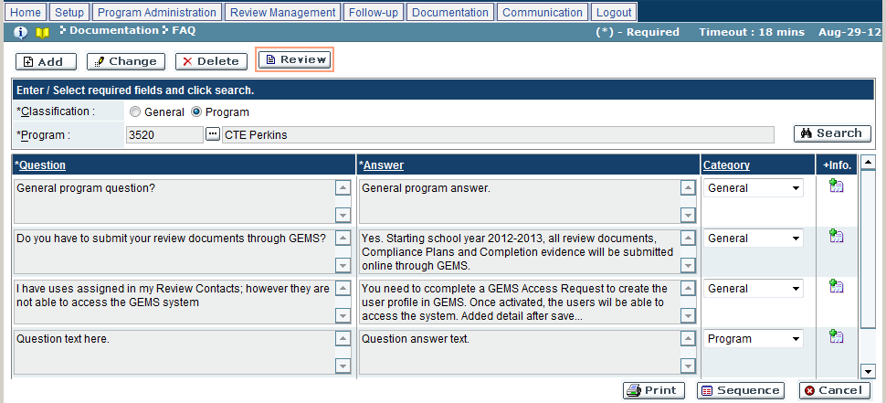

| Field Name | Action |
| --- | --- |
| Classification | Select the desired question classification (General/Program) |
| Program | Select the desired program from the look-up, if the above selected is ‘Program’ |

1. Use the search function to view the question(s).
2. The system will display the list of questions which make up the frequently asked questions.
3. Click the ‘Sequence’ button to open the Sequence FAQ window.
4. Make changes to the fields as per the following:

| Field Name | Action |
| --- | --- |
| # | Enter the desired numeric position for the question in the FAQ list |

1. Once changed, click on ‘OK’ to save or ‘Cancel’ to discard the changes.

Delete

In this mode, you can delete a question from the list of frequently asked questions.

1. Click on ‘Delete’ mode.
2. Enter the search Enter the search criteria as per the Review mode.
3. Click on the ‘X’ icon to delete the program documents.
4. Once changed, click on ‘OK’ to save or ‘Cancel’ to discard the changes.

Change

In this mode, you can change the FAQ information, including question and answer text and question category, on a case-by-case basis.

1. Click on ‘Change’ mode.
2. Enter the search Enter the search criteria as per the Review mode.
3. Make changes to the fields as per the following:

| Field Name | Action |
| --- | --- |
| Question | Edit the question text, as needed |
| Answer | Edit the answer text, as needed |
| Category | Select the desired category from the dropdown (Fiscal/General/Program) |

1. Once changed, click on ‘OK’ to save or ‘Cancel’ to discard the changes.

Add

In this mode, you can enter question and answer text to be included in the list of frequently asked questions.

1. Click on ‘Add’ mode.
2. Enter the search Enter the search criteria as per the Review mode.
3. Select a category from the dropdown (Fiscal/General/Program).
4. Make changes to the fields as per the following:

| Field Name | Action |
| --- | --- |
| Question | Edit the question text of the question(s) |
| Answer | Edit the answer text of the question(s) |

1. Once changed, click on ‘Save’ to save or ‘Cancel’ to discard the changes.

Troubleshooting

| **#** | **Error** | **Description** | **Corrective Action** |
| --- | --- | --- | --- |
| 1 | Error Message: <Fieldname> cannot be empty | <Fieldname> is blank | The required fields are marked by asterisk *. When one of these fields is not entered, the system prompts with the above error message. Please enter / select value into the field and retry the operation. |

## Best Practices

The Best Practices screen is used to best practices documents to the GEMS. Best practices documents serve as examples of ideal documents after which sub-recipients can model their work.

To access this functionality, navigate to the following menu:

**Documentation → Best Practices**

This screen has the following functionality: Review, Delete, Change, Add.

|  |  |
| --- | --- |
| Predecessor | Program |
| Who | Program Administrator |
| When | Initial setup and as needed |
| Subsequent |  |

Review

In this mode, you can view the list of best practices documents which have been uploaded to the GEMS. You cannot make any changes in this mode.

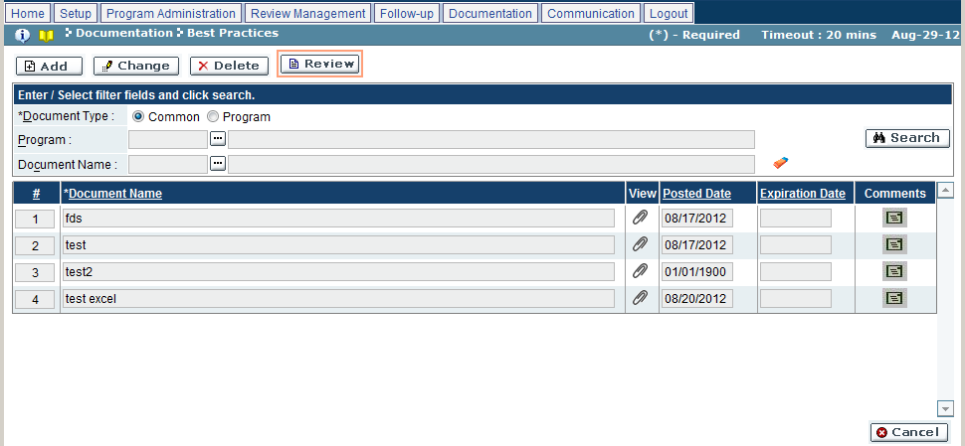

1. Click on ‘Review’ mode.
2. Enter the search criteria, as per the following:

| Field Name | Action |
| --- | --- |
| Document Type | Select the desired document type (Common/Program) |
| Program | Select the desired program from the look-up, if the above selected is ‘Program’ |
| Document Name | Select the desired document from the look-up |

1. Click the ‘Search’ button.
2. The system will display the list of best practices documents selected above.
3. Click the  icon to view the attachment.

Delete

In this mode, you can delete a best practices document from the GEMS.

1. Click on ‘Delete’ mode.
2. Enter the search Enter the search criteria as per the Review mode.
3. Click on the ‘X’ icon to delete the best practices documents.
4. Once changed, click on ‘OK’ to save or ‘Cancel’ to discard the changes.

Change

In this mode, you can change the FAQ information, including question and answer text and question category, on a case-by-case basis.

1. Click on ‘Change’ mode.
2. Enter the search Enter the search criteria as per the Review mode.
3. Make changes to the fields as per the following:

| Field Name | Action |
| --- | --- |
| Document Name | Edit the name of the document |
| Attachment File | Click on the ‘Browse’ button to select a file to be uploaded |
| Posted Date | Enter the date in the format MM/DD/YYYY or select a date from the calendar |
| Expiration Date | Enter the date in the format MM/DD/YYYY or select a date from the calendar |
| Comments | Click on the comments icon and add any additional comments |

1. Once changed, click on ‘Save’ to save or ‘Cancel’ to discard the changes.

Add

In this mode, you can add best practice documents, including any helpful comments.

1. Click on ‘Add’ mode.
2. Enter the search Enter the search criteria as per the Review mode.
3. Make changes to the fields as per the following:

| Field Name | Action |
| --- | --- |
| Document Name | Enter the name of the document |
| Attachment File | Click on the ‘Browse’ button to select a file to be uploaded |
| Posted Date | Enter the date in the format MM/DD/YYYY or select a date from the calendar |
| Expiration Date | Enter the date in the format MM/DD/YYYY or select a date from the calendar |
| Comments | Click on the comments icon and add any additional comments |

1. Once changed, click on ‘Save’ to save or ‘Cancel’ to discard the changes.

Troubleshooting

| **#** | **Error** | **Description** | **Corrective Action** |
| --- | --- | --- | --- |
| 1 | Error Message: <Fieldname> cannot be empty | <Fieldname> is blank | The required fields are marked by asterisk *. When one of these fields is not entered, the system prompts with the above error message. Please enter / select value into the field and retry the operation. |

# Communication

## My Pending Tasks

My Pending Tasks displays all the items currently awaiting your action. The list of pending tasks will appear on the home screen, above the New Messages On this screen you can read and organize all pending tasks.

To access this functionality, navigate to the following menu:

**Home Screen → My Pending Tasks**

|  |  |
| --- | --- |
| Predecessor |  |
| Who | MDE |
| When | As Needed |
| Subsequent |  |

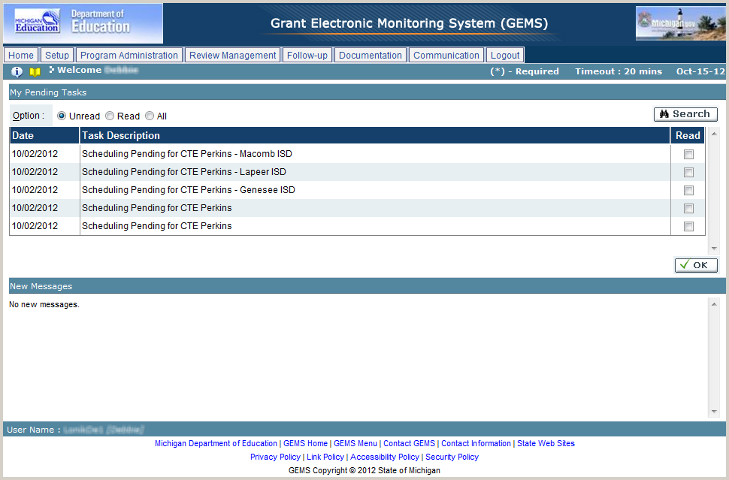

* 1. Enter the search criteria as per the following:

| Field Name | Action |
| --- | --- |
| Option | Select the desired view option (Unread/Read/All) |

* 1. Click on the ‘Search’ button.
  2. The system will display the list of pending tasks, as per the search criteria.
  3. Click on the checkbox next to any record to mark it as to be being read.
  4. Once changed, click on ‘OK’ to save.
  5. The selected tasks will be marked as read.

Troubleshooting

| **#** | **Error** | **Description** | **Corrective Action** |
| --- | --- | --- | --- |
| 1 | Cannot see task item in the list of my pending task | Item is not visible in the list because it’s not assigned to login user or has been marked as “read” | Change filter condition to read and click on search |

## Email Log

Email Log is the list of all the emails sent or received by the users to or from other users and sub-recipients regarding the GEMS process. In this screen you can view the emails sent or received by the users about the notifications and other communication between them.

To access this functionality, navigate to the following menu:

**Communication → Email Log**

|  |  |
| --- | --- |
| Predecessor |  |
| Who | MDE User |
| When | As needed |
| Subsequent |  |

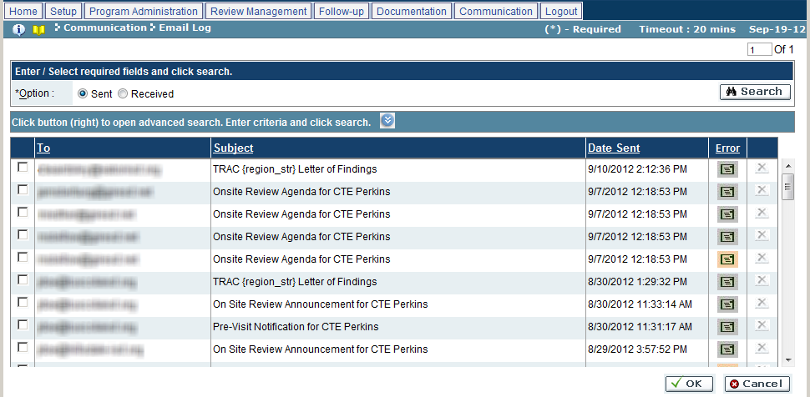

* 1. Enter the search criteria as per the following:

| Field Name | Action |
| --- | --- |
| Option | Select the desired view option (Sent/Received)  To refine the list, click on the  button and follow the next steps |

* 1. Click on the ‘Search’ button.
  2. The system will display the list of emails, as per the search criteria.
  3. Click on any record to view the sent or received email.
  4. To delete an email, click on the ‘X’ icon.
  5. Once changed, click on ‘OK’ to save or ‘Cancel’ to discard the changes.

Troubleshooting

| **#** | **Error** | **Description** | **Corrective Action** |
| --- | --- | --- | --- |
| 1 | Error Message: <Fieldname> cannot be empty | <Fieldname> is blank | The required fields are marked by asterisk *. When one of these fields is not entered, the system prompts with the above error message. Please enter / select value into the field and retry the operation. |

## Print Notifications

Print Notifications allows the user to view the notifications sent to sub-recipients throughout the review process. Notifications can be viewed and printed individually or as a group.

To access this functionality, navigate to the following menu:

**Communication →** ‘Print’ **Notifications**

This screen has the following functionality: Review, Print.

|  |  |
| --- | --- |
| Predecessor |  |
| Who | MDE |
| When | As Needed |
| Subsequent |  |

Review

In this mode, you can view the notifications created in GEMS. You cannot make any changes in this mode.

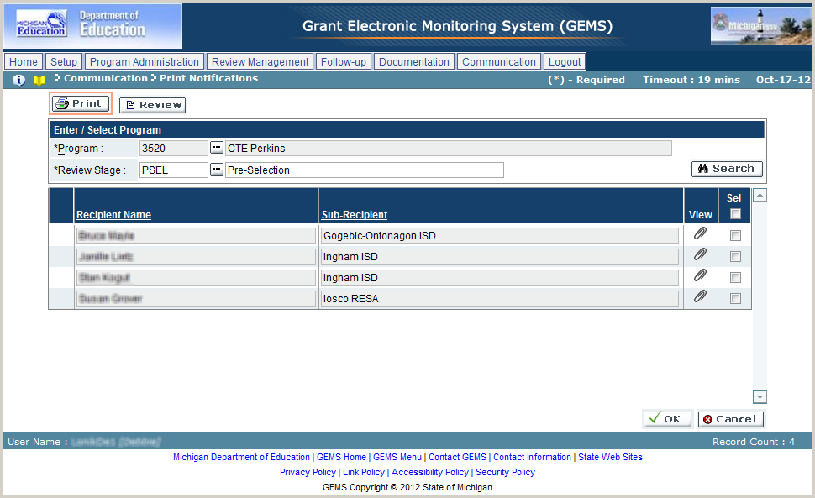

* 1. Click on ‘Review’ button.
  2. Enter the search criteria as per the following:

| Field Name | Action |
| --- | --- |
| Program | Select the desired program from the look-up |
| Review Stage | Select the desired review stage from the look-up |

* 1. Click on the ‘Search’ button.
  2. The system will display the list of notifications as per the search criteria.

‘Print’

In this mode, you can view and print notifications. Notifications can be opened independently or multiple notifications can be grouped together for a single print job.

* 1. Click on ‘Print’ button.
  2. Enter the search criteria as per the Review mode.
  3. Select one or more documents:
* Click on the View icon () to view an individual notification
* Click the checkbox in the Sel column, then click ‘OK’ to select multiple notifications
  1. From the new window, click the ‘Print’ button to print the notification(s), or click ‘Close’ to cancel.
  2. Click the ‘Cancel’ button to close the screen.