
321 East Ohio Street, Marquette MI 49855
PH: 906.226.5165 FAX: 906.226.5168
www.maresa.org

SCHOOL DISTRICT/LOCAL CONTACT NUMBER:

PHYSICIAN OR OTHER LICENSED PRACTITIONER*:
ADDRESS:
STUDENT NAME:
DATE OF BIRTH: |  |  |  |  | Begin & End Dates:

Dear

In accordance with Michigan’s School Based Medicaid procedures, we are seeking your assistance in determining the health care needs of the student listed above relative to his/her personal care needs as referenced in his/her Individualized Educational Plan (IEP). The checked list below indicates the personal care services we feel are necessary to provide throughout the school day from to .
m/d/yr m/d/yr
Please review the attached list and, if you are in agreement with our instructional aides providing these services for the above named student, please sign below and return this form to:

Personal Care Services
 | Eating/Feeding |  |  | Mobility / Positioning
 | Respiratory Assistance |  |  | Meal Preparation
 | Toileting |  |  | Skin Care
 | Grooming |  |  | Bathing
 | Dressing |  |  | Maintaining Continence
 | Transferring |  |  | Assistance with Self Administered Medications
 | Ambulation |  |  | Redirection and Intervention for Behavior
 | Personal Hygiene |  |  | Health Related Functions Through Hands On Assistance, Supervising and Cueing

Sincerely,

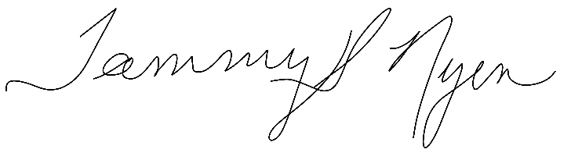
Tammy Nyen, Ed.D
Executive Director of Special Education

I agree that the student listed above should be receiving the services checked above.

Physician/Other Licensed Practitioner ’s Signature

* Licensed practitioner operating within the scope of their practice, including Registered Nurses (RN), Occupational Therapists (OT), Physical Therapists (PT), Master of Social Work (MSW) and Speech-language Pathologists (SLP).

